|  |  |
| --- | --- |
|  | **MINISTRY OF EDUCATION AND TRAINING** |

**FPT UNIVERSITY**

|  |
| --- |
| Capstone Project Document |
| PET DATING |
| **VERSION 1.0** |
| |  |  | | --- | --- | |  | | | **Supervisor** | **Phan Duy Hùng** | | **Group Members** | **Nguyễn Đức Thịnh – SE06149**  **Nguyễn Đỗ Anh Khương – SE05608**  **Khương Trung Hiếu– SE06020**  **Trịnh Văn Anh – SE05308**  **Nguyễn Hoàng Phong – SE05668** | | **Capstone Project code** | **PD** | |
|  |

Ha Noi, May 31, 2020

Contents

CHAPTER 1: INTRODUCTION 4

1.1. The problem 4

1.2. Existing solutions 5

1.3. Proposal 6

1.3.1. The idea 6

1.3.2. The Proposal 7

1.3.3. Business flow 7

CHAPTER 2: SOFTWRE PROJECT MANAGEMENT PLAN (SPMP) 8

2.1. Purpose 8

2.2. Software Process Model 9

2.2.1. About the SCRUM 9

2.2.2. Advantages and disadvantages of SCRUM 10

2.3. Project Organization 11

2.3.1. Organization structure 11

2.3.2. Roles and responsibilities 11

2.4. Tools and Techniques 13

2.5. Project Management Plan 14

2.5.1. Project schedule 14

2.5.2. Meeting minutes 14

2.5.3. Risk management plan 15

2.5.4. Communication plan 16

2.5.5. Coding convention 17

CHAPTER 3: SOFTWARE REQUIREMENT SPECIFICATION 17

3.1. Purpose 17

3.2. Functional Requirement 18

3.2.1. Use case diagram 18

.2.2. Business rules 20

3.2.3. Use case list 20

3.2.4. Use case specification 22

3.3. Non-functional Requirement 62

3.3.1. Security 62

3.3.2. Availability 62

3.3.3. Usability 63

CHAPTER 4: SPOFTWARE DESIGN 63

4.1. Purpose 63

4.2. Overview of System Architecture 63

4.2.1. Diagram 63

4.2.2. Component Explanation 64

4.3. Application Custom MVC Design 66

4.4. Database Design 66

4.4.1. Entity relationship diagram 66

4.4.2. Database diagram 69

4.5. Detailed Design 76

4.5.1. Login 76

s4.5.2. Logout 79

4.5.3. Matching 81

4.5.4. Chat 85

4.5.5. Ranking 93

4.5.6. Feedback 96

4.5.7. React pet 99

4.5.8. View other user 103

4.5.9. View other user’s pet 105

4.5.10. Hide profile 109

4.5.11. Edit user’s profile 112

4.5.12. Delete user’s profile 115

4.5.13. Create new pet 118

4.5.14. Edit pet’s profile 121

4.5.15. Delete pet’s profile 124

4.5.16. Find 127

4.5.17. Get next generation pet 130

4.5.18. Login/Logout for Admin 132

4.5.20. Enable/Disable Account for Admin 136

4.5.22. Delete Images for Admin 139

4.5.23. Manage system for Admin 141

4.5.24. Receive Feedback for Admin 144

CHAPTER 5: Software Testing Document 147

5.1. Introduction 147

5.1.1. Purpose 147

5.1.2. Scope of testing 147

5.1.3. Range of testing 147

5.2. Test plan 147

5.2.1. Testing Tools and Environment 147

5.2.2. Resources and Responsibilities 147

5.2.3. Test Strategy 147

5.2.4. Features to be tested 148

5.3. Test case 148

5.3.1. Unit test 148

5.3.2. System testing 148

5.3.3. Acceptance test 148

5.3.4. Defect Log 148

5.4. Test Report 148

5.4.1. Unit test 148

5.4.2. Integration and system tests 148

CHAPTER 6: USER MANUAL 148

6.1. Development and deployment guidelines 148

6.1.1.1. Environment for development 148

# CHAPTER 1: INTRODUCTION

## The problem

Most of people who own pets always care about life of their pets such as food, morale and mates. However, the network where puppies can find a friend or partner is very rare in Viet Nam. Facebook – a social network that is popular had a lot of groups about this problem. But in there, we also lack of specific features that focus in users that have pets. Some other communities are not really popular or have stopped working. In conclusion, there are not really any online place or community for people that have pets in Vietnam right now.

## Existing solutions

We consulted some websites/application about pet before give our proposal. Each website/application has a lot of advantages but still has some limitations.

* **App Get Bone**

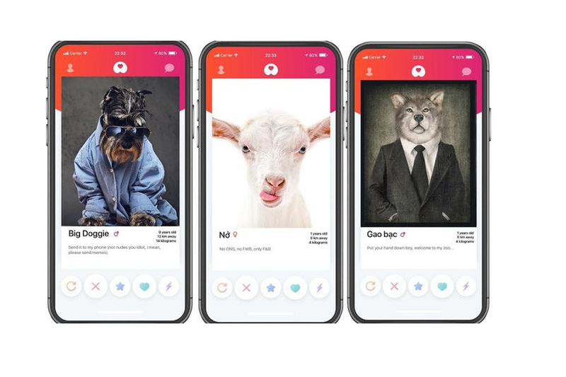

Figure - Get bone (app)

|  |  |
| --- | --- |
| **Advantages** | **Disadvantages** |
| * Provide news and more information about pets. * Interface is easy to use and be like Tinder * Support finding mates. | * Only news, no communication between users |

* **Website Datemypet.com**

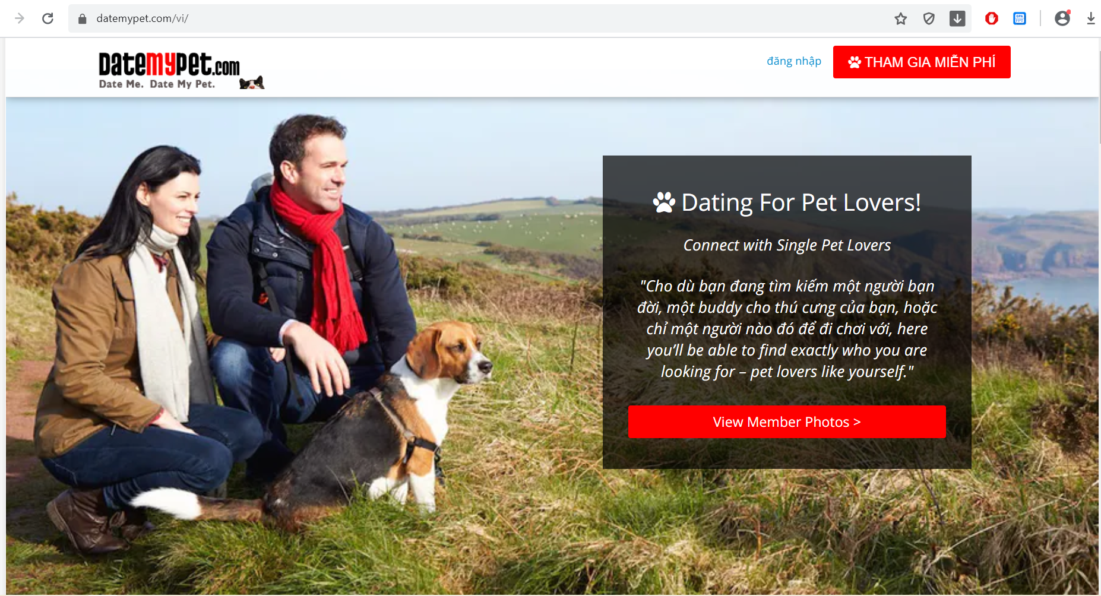

Figure 2 - Datemypet.com

|  |  |
| --- | --- |
| **Advantages** | **Disadvantages** |
| * Provide news and more information about pets. | * Not support finding mates. * Only news, no communication between users |

## Proposal

### The idea

We want to build a mobile application where everyone can find the half of their pets, or simply want to know about other pets. Major of application is finding the mates for their pets based on automation mode or manual mode. In the app, people maybe complete the user’s profile; pet’s profile; upload images; match what pets they want. In addition, everyone can connect and chat about pets. It helps making pets dating becomes easy, safe and enhance the community. Our idea has two part: mobile application for user and website for manager.

### The Proposal

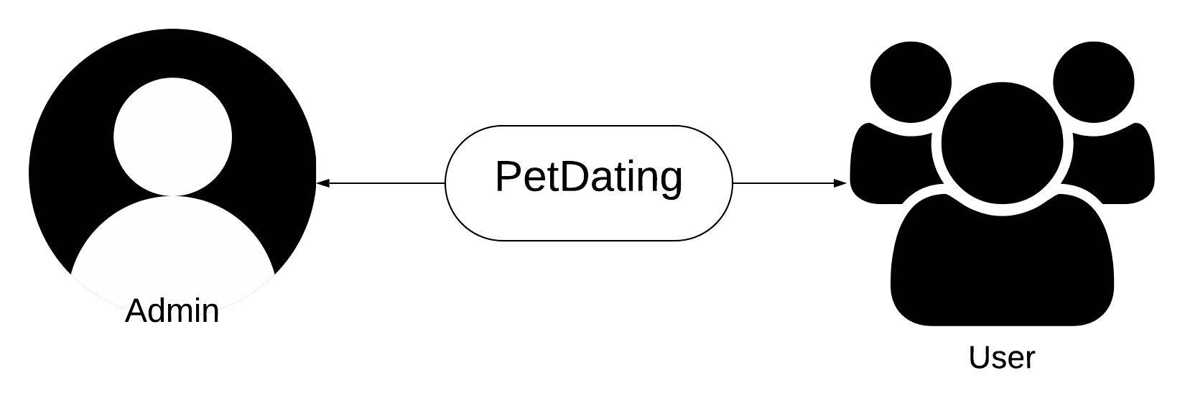

Figure - Roles in PD system

### 1.3.3. Business flow

* **Review report process**

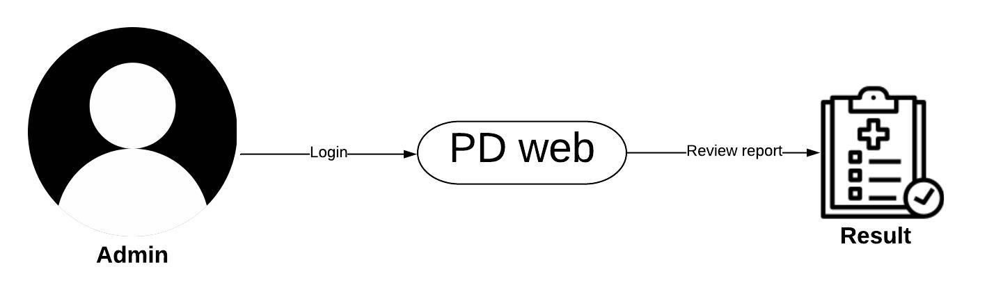

Figure 4 - Process of review report on PD

* **Ban and unban user**

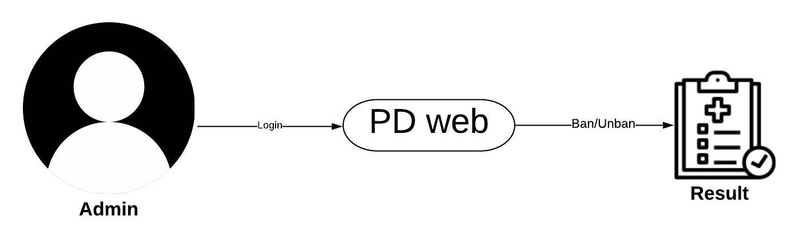

Figure 5 - Process of ban/unban on PD

* **Dating process**

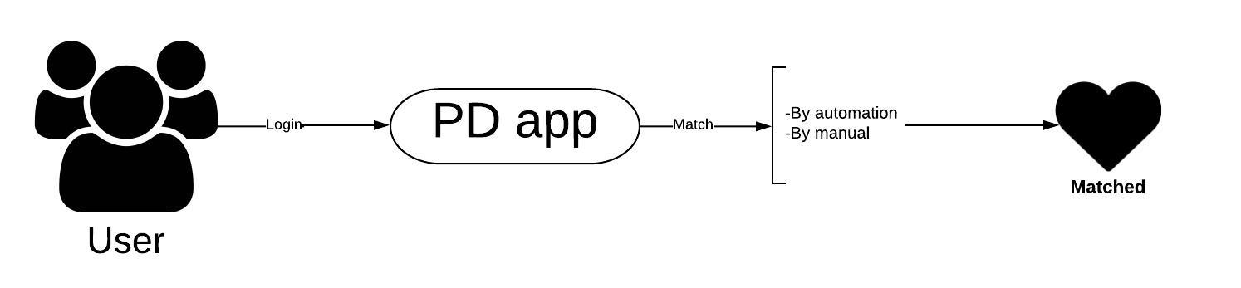

Figure 6 - Process of Dating on PD

* **User management process**

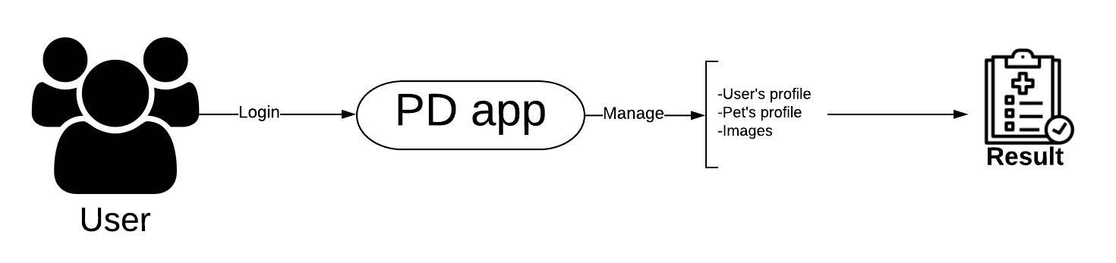

Figure 7 – Process of user management

# CHAPTER 2: SOFTWRE PROJECT MANAGEMENT PLAN (SPMP)

## 2.1. Purpose

Project plan describes the software process model, team organization and management plan of the project. All team members must follow this section as a guideline to complete assigned tasks and deadline.

## 2.2. Software Process Model

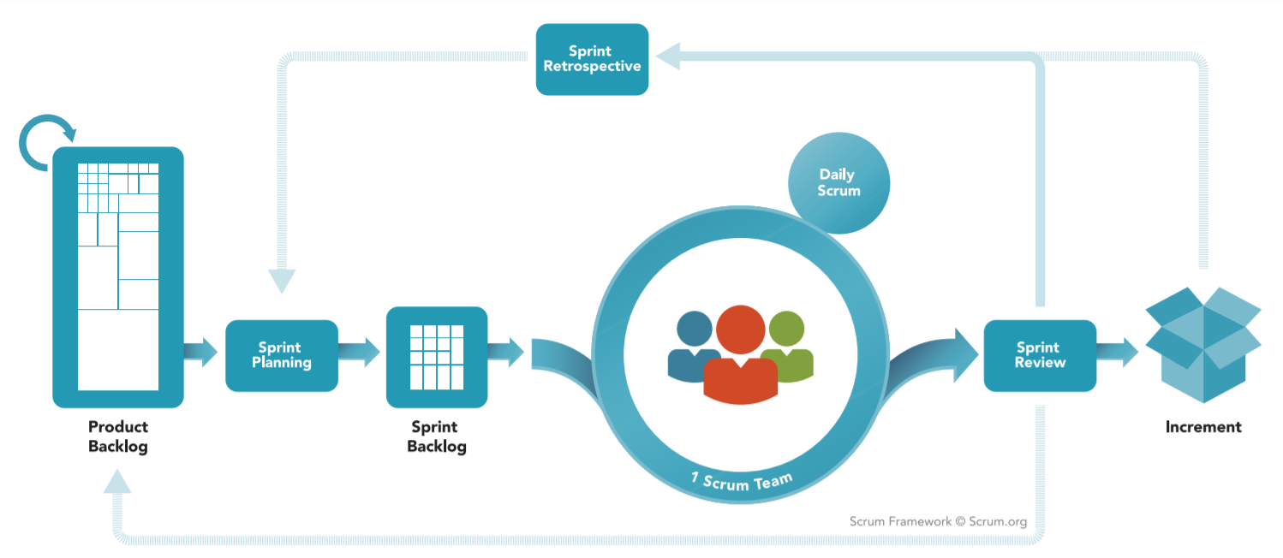

Figure 8 - Agile Model – SCRUM

### 2.2.1. About the SCRUM

SCRUM is Agile software development life cycle (SDLC) models. Scrum is a framework within which people can address complex adaptive problems, while productively and creatively delivering products of the highest possible value. And it is a simple framework for effective team collaboration on complex products.

* **Product Backlog**: is an ordered list of everything that is known to be needed in the product. It is the single source of requirements for any changes to be made to the product.
* **Sprint Planning**: The work to be performed in the Sprint is planned at the Sprint Planning. This plan is created by the collaborative work of the entire Scrum Team.
* **Sprint Backlog**: is the set of Product Backlog items selected for the Sprint, plus a plan for delivering the product Increment and realizing the Sprint Goal. The Sprint Backlog is a forecast by the Development Team about what functionality will be in the next Increment and the work needed to deliver that functionality into a “Done” Increment.
* **Sprint**: The heart of Scrum is a Sprint, a time-box of one month or less during which a “Done”, useable, and potentially releasable product Increment is created. Sprints have consistent durations throughout a development effort. A new Sprint starts immediately after the conclusion of the previous Sprint.

*Reference: “The Scrum Guide - The Definitive Guide to Scrum: The Rules of the Game” – Developed and sustained by Scrum creator: Ken Schwaber and Jeff Sutherland – November 2017.*

### 2.2.2. Advantages and disadvantages of SCRUM

|  |  |
| --- | --- |
| **Advantages** | **Disadvantages** |
| * Works well for fast-moving development projects. * The team gets clear visibility through scrum meetings. * Removing mistakes or rectifying them is considerably easy. * It is iterative in nature and needs continuous feedback from the user for the betterment of the process. | * Scrum often leads to scope creep, due to the lack of a definite end-date. * The chances of project failure are high if individuals aren't very committed or cooperative. * If any team member leaves in the middle of a project, it can have a huge negative impact on the project. * Daily meetings sometimes frustrate team members |

## 2.3. Project Organization

### 2.3.1. Organization structure

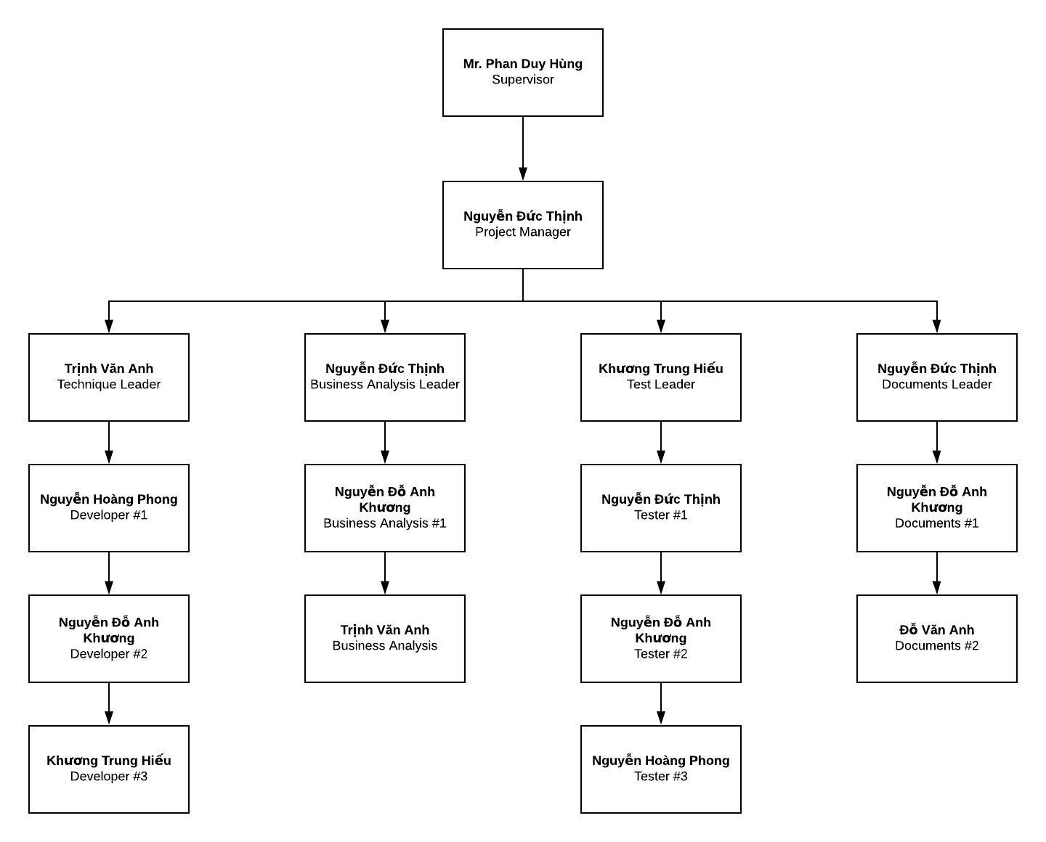

Figure - Organization structure

### 2.3.2. Roles and responsibilities

|  |  |  |
| --- | --- | --- |
| **Role** | **Responsibilities** | **Full Name** |
| **Project Manager** | | |
| Project Manager | * Guide team toward the goal of successfully passing the final capstone project. * Develop schedule and assigning task with responsibilities for each member. * Communicate with all teams to keep them focusing on the final goal. * Propose ideas or issues of the team to supervisor, university. | Nguyễn Đức Thịnh |
| **Business analyst team** | | |
| BA leader | * Elicit and analyze requirement. * Define scope and create SRS template. | Nguyễn Đức Thịnh |
| BA #1 | * Design entity relationship diagram. * Define business process flow and object state. | Nguyễn Đỗ Anh Khương |
| BA #2 | * Capture and specific describe use case. | Trịnh Văn Anh |
| **Developer** | | |
| Technical leader | * Define high level architecture base on SRS. * Implement configuration and server. * Design and code dating function. * Develop client functions in console system. * Design and review database. * Design mockup for application. | Trinh Văn Anh |
| Dev #1 | * Lead chatting function. * Design a part of database. * Design and code chatting function. * Code others screen. * Design mockup for application. | Nguyễn Hoàng Phong |
| Dev #2 | * Design and code dating function. * Code others screen. * Design mockup for application. | Nguyễn Đỗ Anh Khương |
| Dev #3 | * Design and code chatting function. * Code others screen. * Design mockup for application. | Khương Trung Hiếu |
| **Tester** | | |
| Test leader | * Create template testing documents. * Define test strategy, create test plan and defect log temple. | Khương Trung Hiếu |
| Test #1 | * Implement test case and log defect. | Nguyễn Đức Thịnh |
| Test #2 | * Implement test case and log defect. | Nguyễn Đỗ Anh Khương |
| Test #3 | * Implement test case and log defect. | Nguyễn Hoàng Phong |
| **Documentation** | | |
| Docs leader | * Prepare all the documentation relating to the project. * Give format in documentation. | Nguyễn Đức Thịnh |
| Docs #1 | * Check spelling errors and grammar errors. | Nguyễn Đỗ Anh Khương |
| Docs #2 | * Check spelling errors and grammar errors. | Đỗ Văn Anh |

## 2.4. Tools and Techniques

|  |  |  |
| --- | --- | --- |
| **Tool and techniques** | **Version** | **Description** |
| Visual Studio Code | Lastest | Text editor for coding, testing |
| Github | Lastest | Git GUI for controlling source code and version easily |
| NodeJS | 10.16.3 LTS | Environment for application |
| React-native-cli | 2.0.1 | Environment for developing React Native app |
| Google Drive | Online | Documents, resources storage |
| Lucidchart | Online | Diagram, UML, chart creation tool |
| Draw.io | Online | Diagram, UML, chart creation tool |
| Microsoft Project | 2019 | Plan management and schedule |
| Microsoft Office | 2019 | Documentation tool includes: Words, Excel, PP, … |
| Trello | Online | Control task, backlog |
| Facebook | Online | Communication tool |
| Skype | Lastest | Communication tool |
| Google Meet | Online | Video conferencing, presentation |
| Heroku Host | Online | Online hosting service |
| Heroku Storage | Online | Cloud storage for Firebase |
| Google Firebase Realtime Database | Online | Database for performing realtime function |

## 2.5. Project Management Plan

### 2.5.1. Project schedule

The tasks list detail is described in file: **“Plan.mpp”**

### 2.5.2. Meeting minutes

|  |  |  |  |  |
| --- | --- | --- | --- | --- |
| **Project Name/Code** | PetDating | **Date of meeting** | |  |
| **Conductor** | Nguyễn Đức Thịnh | **Location** | |  |
| **Topic of meeting** |  | | | |
|  |  | | | |
| **Attendees:** | | | | |
| **Name** | **Role** | | **Attendance** | |
| Phan Duy Hùng | Supervisor | | Present | |
| Nguyễn Đức Thịnh | PM | | Present | |
| Nguyễn Hoàng Phong | Team member | | Present | |
| Nguyễn Đỗ Anh Khương | Team member | | Present | |
| Trinh Văn Anh | Team member | | Present | |
|  | | | | |
| **Meeting objective:** | | | | |
|  | | | | |

### 2.5.3. Risk management plan

**\*Risk identification**

|  |  |  |  |  |
| --- | --- | --- | --- | --- |
| **No** | **Risk description** | **Contingency/Mitigation plan** | **Probability** | **Impact** |
| 1 | Scope of project was defined poorly that cause ambiguous for team members | Meeting with BA expert | Medium | High |
| 2 | Requirements changes during project time | Meeting and redefine objective with each team member. | Medium | High |
| 3 | Failure in estimating sprint time, inadequate change | Doing overnight work to keep process continuing | High | Medium |
| 4 | Confliction among team members | - Transfer problems to whole team to resolve it.  - Create happy and friendly environment among team members. | Low | Medium |
| 5 | Library or third-party features used in project is no longer supported | Choose alternative library or coding from scratch | Low | High |
| 6 | Illness or absence of team members | Ensure that the absence of a member will not affect the plan and schedule. Always have plans to deal with this problem | Low | Low |

**\*Probability – Impact matrix**

|  |  |  |  |  |
| --- | --- | --- | --- | --- |
| Probability | High |  | R3 |  |
| Medium |  |  | R1, R2 |
| Low | R6 | R4 | R5 |
|  |  | Low | Medium | High |
|  |  | Impact | | |

### 2.5.4. Communication plan

Project report and meeting:

|  |  |  |  |  |
| --- | --- | --- | --- | --- |
| **No** | **Activity** | **Stakeholder** | **Time** | **Description** |
| 1 | Weekly report | * Team member * Supervisor | Monday | * Report in meeting minutes * Review status based on weekly report * Plan for the next week |
| 2 | Daily report | Project manager | Daily | * Report issue and planning * Support to solve issues |
| 3 | Ad-hoc report | Team members | Event-based | * Report and talking face to face |

Project communication:

|  |  |  |
| --- | --- | --- |
| **No** | **Style** | **Description** |
| 1 | Weekly meeting schedule | Spend one day in a week for meeting to review and update solution for problems. |
| 2 | Unscheduled meeting | If any member has problems that he wants to solved immediately, we will have a chat box. |
| 3 | Communication channel | Our main communication is physical meeting, chat box, Facebook messenger. |

### 2.5.5. Coding convention

The following coding conventions are used to code the project to help improve readabilities, maintenance abilities, and code more easily.

|  |  |  |
| --- | --- | --- |
| **#** | **Style** | **Implementation component** |
| 1 | NodeJS coding convention | Service API |
| 2 | React coding convention | React native convention |
| 3 | RESTful API | REST convention |

# CHAPTER 3: SOFTWARE REQUIREMENT SPECIFICATION

## 3.1. Purpose

This chapter outlines functional and non-functional requirements of our system. It also provides some format constraints in common requirements and project success criteria. The content of this chapter is used as the basis for the work in the subsequent chapters.

## 3.2. Functional Requirement

### 3.2.1. Use case diagram

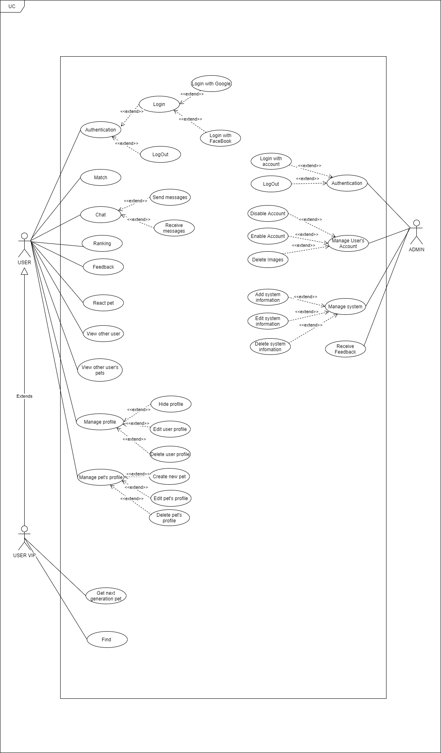

Figure 10 – Use case diagram

### .2.2. Business rules

|  |  |
| --- | --- |
| **ID** | **Description** |
| 1 | Google+ account or Facebook account must be validated. |
| 2 | Admin’s password must not be stored as plain text. Instead it must be hashed using a secure hash algorithm. |
| 3 | The field must be filled by characters consist of alphabet and numbers. |
| 4 | The field must be filled by characters consist of alphabet. |
| 5 | The field must be not empty. |
| 6 | The characters of field are greater than 10. |
| 7 | The characters of field are greater than 3. |
| 8 | The characters of field are greater than 5. |
| 9 | The maximum characters of field are 30. |
| 10 | The maximum characters of field are 20. |
| 11 | Image file type must be image type. |

### 3.2.3. Use case list

|  |  |
| --- | --- |
| **Actors** | **Description** |
| User | Everyone who has an account on the PetDating system and used it. |
| Admin | People who has responsibilities about system |

|  |  |  |
| --- | --- | --- |
| **ID** | **Actor** | **Name** |
| AD-UC-1.0 | Admin | Login with account |
| AD-UC-2.0 | Logout |
| AD-UC-3.0 | Disable Account |
| AD-UC-4.0 | Enable Account |
| AD-UC-5.0 | Delete Images |
| AD-UC-6.0 | Manage system |
| AD-UC-7.0 | Receive Feedback |
| US-UC-1.0 | User | Login with Goole/Facebook/(Phone number) |
| US-UC-2.0 | Logout |
| US-UC-3.0 | Match |
| US-UC-4.0 | Send messages |
| US-UC-5.0 | Receive message |
| US-UC-6.0 | Ranking |
| US-UC-7.0 | Feedback |
| US-UC-8.0 | React pet |
| US-UC-9.0 | View other user |
| US-UC-10.0 | View other user’s pets |
| US-UC-11.0 | Hide profile |
| US-UC-12.0 | Edit user’s profile |
| US-UC-13.0 | Delete user’s profile |
| US-UC-14.0 | Create new pet |
| US-UC-15.0 | Edit pet’s profile |
| US-UC-16.0 | Delete pet’s profile |
| US-UC-17.0 | Find |
| US-UC-18.0 | Get next generation pet |

### 3.2.4. Use case specification

#### 3.2.4.1. Admin

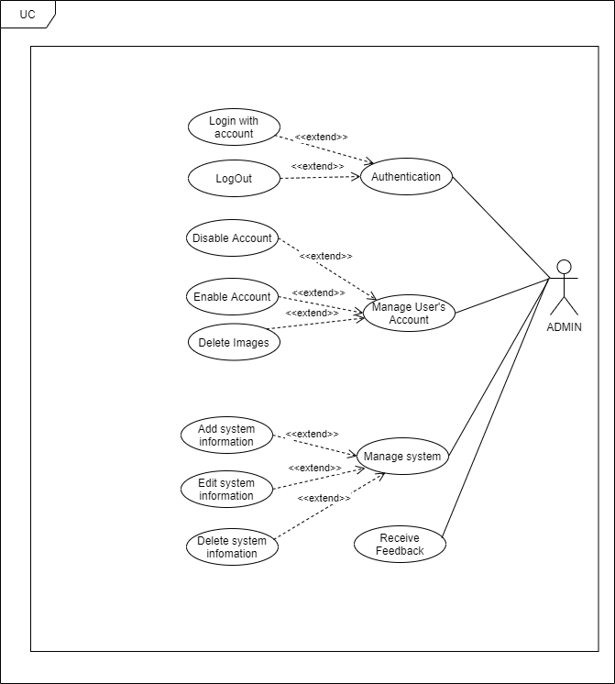

Figure 11 - Use case diagram of Admin actor

##### 3.2.4.1.1. Authentication

**\*Login with account**

|  |  |  |  |
| --- | --- | --- | --- |
| **USECASE AD-UC-1.0** **SPECIFICATION** | | | |
| **Use case ID** | AD-UC-1.0 | **Use case version** | V1.0 |
| **Use case name** | Login with account | | |
| **Author** | Nguyen Do Anh Khuong | | |
| **Date** | 09/07/2020 | **Priority** | High |
| **Primary actor** | Admin | **Secondary actor** | N/A |
| **Description** | Allows admin login to PD system in website. | | |
| **Pre-condition** | Admin has an account and the account is still working. | | |
| **Post-condition** | When the normal flow completes successfully, the login status is set to true, and the access token is saved on the website. | | |
| **Trigger** |  | | |
| **Main flow:**   |  |  |  | | --- | --- | --- | | **No.** | **Actor events** | **System respond** | | **1.** | Admin goes to login page |  | | **2.** |  | Website displays the login form | | **3.** | Admin fills account and password then clicks “Login” button. |  | | **4.** |  | System generates cookies and save them. | | **5.** |  | Website navigates to homepage. |   **Alternative Flows: Admin logged and not yet log out.**   |  |  |  | | --- | --- | --- | | **No.** | **Actor events** | **System respond** | | **1.** | Admin goes to homepage |  | | **2.** |  | Website checks cookies then navigates to login page if not exist cookies. |   **Extension Flows: N/A**  **Exception:**  **AD1.0-E1 – Cannot connect with Account API**  System displays error message.  **AD1.0-E2 – Wrong account or password**  System displays error message and requests login again.    **Business Rules: B3, B4** | | | |
|  | | | |

\***Logout**

|  |  |  |  |
| --- | --- | --- | --- |
| **USECASE AD-UC-2.0** **SPECIFICATION** | | | |
| **Use case ID** | AD-UC-2.0 | **Use case version** | V1.0 |
| **Use case name** | LogOut | | |
| **Author** | Nguyen Do Anh Khuong | | |
| **Date** | 09/07/2020 | **Priority** | High |
| **Primary actor** | Admin | **Secondary actor** | N/A |
| **Description** | Log out the PD System. | | |
| **Pre-condition** | Has logged into PD system. | | |
| **Post-condition** | When the normal flow completes successfully, the login status is set to false, and the access token is cleared. | | |
| **Trigger** |  | | |
| **Main flow:**   |  |  |  | | --- | --- | --- | | **No.** | **Actor events** | **System respond** | | **1.** | Clicks icon “Account” on top right of website. |  | | **2.** |  | Website displays “Account Management” pop-up | | **3.** | Admin/Mod clicks “Logout” on top right of website. |  | | **4.** |  | Website navigates to Login page. |   **Alternative Flows: N/A**  **Extension Flows:**  **Exception: N/A**  **Business Rules: N/A** | | | |
|  | | | |

\***Disable Account**

|  |  |  |  |
| --- | --- | --- | --- |
| **USECASE AD-UC-3.0** **SPECIFICATION** | | | |
| **Use case ID** | AD-UC-3.0 | **Use case version** | V1.0 |
| **Use case name** | Disable Account | | |
| **Author** | Nguyen Do Anh Khuong | | |
| **Date** | 16/07/2020 | **Priority** | High |
| **Primary actor** | Admin | **Secondary actor** | N/A |
| **Description** | Allows admin to disable account of user (ban) | | |
| **Pre-condition** | Admin logged in to system. | | |
| **Post-condition** | User’s Account was banned | | |
| **Trigger** |  | | |
| **Main flow:**   |  |  |  | | --- | --- | --- | | **No.** | **Actor events** | **System respond** | | **1.** | Clicks icon “Manage Profile” on top of website. |  | | **2.** |  | Website displays “Manage Profile ” screen | | **3.** | Choose account wanna ban and click on disable button |  | | **4.** |  | Website show confirm dialog on screen | | **5.** | Fills all require field and presses the “Confirm” button |  | | **6.** |  | Shows sucess message |   **Alternative Flows: N/A**  **Extension Flows: N/A**  **Exception: N/A**  **Business Rules: N/A** | | | |
|  | | | |

\***Enable Account**

|  |  |  |  |
| --- | --- | --- | --- |
| **USECASE AD-UC-4.0** **SPECIFICATION** | | | |
| **Use case ID** | AD-UC-4.0 | **Use case version** | V1.0 |
| **Use case name** | Enable Account | | |
| **Author** | Nguyen Do Anh Khuong | | |
| **Date** | 16/07/2020 | **Priority** | Medium |
| **Primary actor** | Admin | **Secondary actor** | N/A |
| **Description** | Administrator Enable user’s Account. | | |
| **Pre-condition** | Admin has logged into system by admin account.  Account have been banned | | |
| **Post-condition** | User’s Account was Enable ( unbanned) | | |
| **Trigger** |  | | |
| **Main flow:**   |  |  |  | | --- | --- | --- | | **No.** | **Actor events** | **System respond** | | **1.** | Admin clicks “Manage Profile” on left-menu |  | | **2.** |  | Website navigates to “Manage Profile” page | | **3.** | Choose account wanna Enable and click on “disable/enable” button |  | | **4.** |  | Website show “confirm” dialog on screen | | **5.** | Fills all require field and presses the “Confirm” button |  | | **6.** |  | Shows sucess message |   **Alternative Flows: N/A**  **Extension Flows: N/A**  **Exception:**  **AD6.0-E1 – Cannot communicate with API server**  System displays error message.  **Business Rules: N/A** | | | |
|  | | | |

\***Delete Image**

|  |  |  |  |
| --- | --- | --- | --- |
| **USECASE AD-UC-5.0** **SPECIFICATION** | | | |
| **Use case ID** | AD-UC-5.0 | **Use case version** | V1.0 |
| **Use case name** | Delete Image | | |
| **Author** | Nguyen Do Anh Khuong | | |
| **Date** | 16/07/2020 | **Priority** | High |
| **Primary actor** | Admin | **Secondary actor** | N/A |
| **Description** | Administrator can View and detele image of User’s Account. | | |
| **Pre-condition** | Admin has logged into system by admin account. | | |
| **Post-condition** | Image have been deleted | | |
| **Trigger** |  | | |
| **Main flow:**   |  |  |  | | --- | --- | --- | | **No.** | **Actor events** | **System respond** | | **1.** | Admin clicks “Account Manager” on left-menu |  | | **2.** |  | Website navigates to “Account manager” page | | **3.** | Admin can view , and search account was feedbacked |  | | **4.** |  | Website show information of user | | **5.** | Admin change information and  Admin clicks “detele” beside image |  | | **6.** |  | Website reloaded and show new information |   **Alternative Flows: N/A**  **Extension Flows: N/A**  **Exception:**  **AD6.0-E1 – Cannot communicate with API server**  System displays error message.  **Business Rules: N/A** | | | |
|  | | | |

\***Manage system**

|  |  |  |  |
| --- | --- | --- | --- |
| **USECASE AD-UC-6.0** **SPECIFICATION** | | | |
| **Use case ID** | AD-UC-6.0 | **Use case version** | V1.0 |
| **Use case name** | Manager system | | |
| **Author** | Nguyen Do Anh Khuong | | |
| **Date** | 16/07/2020 | **Priority** | High |
| **Primary actor** | Admin | **Secondary actor** | N/A |
| **Description** | Administrator can manage information of system | | |
| **Pre-condition** | Admin has logged into system by admin account. | | |
| **Post-condition** |  | | |
| **Trigger** |  | | |
| **Main flow:**   |  |  |  | | --- | --- | --- | | **No.** | **Actor events** | **System respond** | | **1.** | Admin clicks “Manager” on left-menu |  | | **2.** |  | Website navigates to “Manager” page | | **3.** | Admin choose “system manager” |  | | **4.** |  | Website shows “System Manager” screen | | **5.** | Admin can view , change information (add , edit ,delete ) |  | | **6.** |  | Website reloaded and show new information |   **Alternative Flows: N/A**  **Extension Flows: N/A**  **Exception:**  **AD6.0-E1 – Cannot communicate with API server**  System displays error message.  **Business Rules: N/A** | | | |
|  | | | |

\***Receive Feedback**

|  |  |  |  |
| --- | --- | --- | --- |
| **USECASE AD-UC-7.0** **SPECIFICATION** | | | |
| **Use case ID** | AD-UC-7.0 | **Use case version** | V1.0 |
| **Use case name** | Manager system | | |
| **Author** | Nguyen Do Anh Khuong | | |
| **Date** | 16/07/2020 | **Priority** | High |
| **Primary actor** | Admin | **Secondary actor** | N/A |
| **Description** | Administrator see all of feed back from user | | |
| **Pre-condition** | Admin has logged into system by admin account. | | |
| **Post-condition** |  | | |
| **Trigger** |  | | |
| **Main flow:**   |  |  |  | | --- | --- | --- | | **No.** | **Actor events** | **System respond** | | **1.** | Admin clicks “Feedback” on left-menu |  | | **2.** |  | Website navigates to “FeedBack” page | | **3.** |  | Website show list all of feedback |   **Alternative Flows: N/A**  **Extension Flows: N/A**  **Exception:**  **AD6.0-E1 – Cannot communicate with API server**  System displays error message.  **Business Rules: N/A** | | | |
|  | | | |

#### 3.2.4.2. User

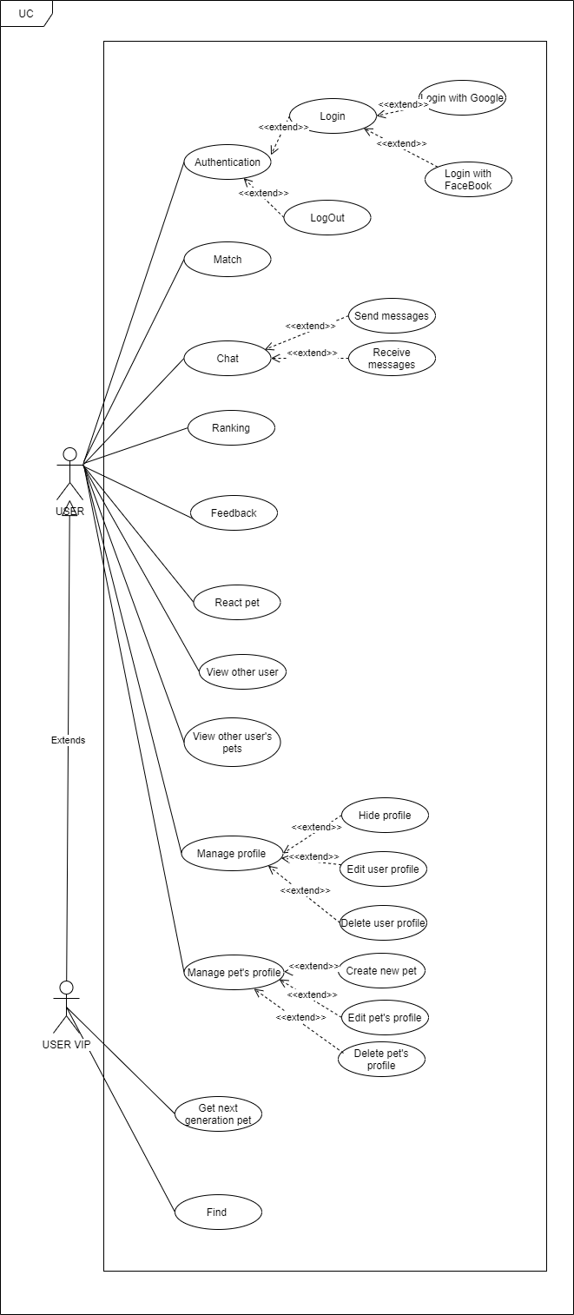

Figure 12 - Use case diagram of User actor

##### 3.2.4.2.1. Authentication

**\*Login with Google or Facebook**

|  |  |  |  |
| --- | --- | --- | --- |
| **USECASE US-UC-1.0** **SPECIFICATION** | | | |
| **Use case ID** | US-UC-1.0 | **Use case version** | V1.0 |
| **Use case name** | Login with Google+ or Facebook | | |
| **Author** | Nguyen Đỗ Anh Khuong | | |
| **Date** | 09/07/2020 | **Priority** | High |
| **Primary actor** | User | **Secondary actor** | N/A |
| **Description** | Allows User login to PD system in mobile application. | | |
| **Pre-condition** | People has a Google/Facebook account and the account is still working. | | |
| **Post-condition** | When the normal flow completes successfully, the login status is set to true, and the access token is saved on the application. | | |
| **Trigger** |  | | |
| **Main flow:**   |  |  |  | | --- | --- | --- | | **No.** | **Actor events** | **System respond** | | **1.** | User opens PD application |  | | **2.** |  | App displays title “Đăng nhập vào PET-DATING”, “Đăng nhập với Google+” button and “Đăng nhập với Facebook” button. | | **3.** | User clicks “Đăng nhập với Google+” or “Đăng nhập với Facebook”. |  | | **4.** |  | App shows a pop-up login. | | **5.** | User fills email and password or choose account (if signed in before) |  | | **6.** |  | System generates access token, user profile and save it on application. | | **7.** |  | App navigates to inside app. |   **Alternative Flows: User logged and not yet log out.**   |  |  |  | | --- | --- | --- | | **No.** | **Actor events** | **System respond** | | **1.** | User opens PD application |  | | **2.** |  | Application checks data then navigates to inside app. |   **Extension Flows: N/A**  **Exception:**  **US1.0-E1 – Cannot connect with Google API**  System displays error message.  **US1.0-E2 – Cannot connect with Facebook API**  System displays error message.    **Business Rules: B1** | | | |
|  | | | |

\***Logout**

|  |  |  |  |
| --- | --- | --- | --- |
| **USECASE US-UC-2.0** **SPECIFICATION** | | | |
| **Use case ID** | US-UC-2.0 | **Use case version** | V1.0 |
| **Use case name** | LogOut | | |
| **Author** | Nguyen Do Anh Khuong | | |
| **Date** | 09/07/2020 | **Priority** | High |
| **Primary actor** | User | **Secondary actor** | N/A |
| **Description** | Log out the app | | |
| **Pre-condition** | Has logged into on application | | |
| **Post-condition** | When the normal flow completes successfully, the login status is set to false, and the access token is cleared. | | |
| **Trigger** |  | | |
| **Main flow:**   |  |  |  | | --- | --- | --- | | **No.** | **Actor events** | **System respond** | | **1.** | Clicks icon “Account” on top right of app |  | | **2.** |  | Application displays “Account “ screen | | **3.** | User clicks “Logout” on tab |  | | **4.** |  | Website navigates to Login screen |   **Alternative Flows: N/A**  **Extension Flows:**  **Exception: N/A**  **Business Rules: N/A** | | | |
|  | | | |

##### 3.2.4.2.2. Match

|  |  |  |  |
| --- | --- | --- | --- |
| **USECASE US-UC-3.0** **SPECIFICATION** | | | |
| **Use case ID** | US-UC-3.0 | **Use case version** | V1.0 |
| **Use case name** | Match | | |
| **Author** | Nguyen Do Anh Khuong | | |
| **Date** | 09/07/2020 | **Priority** | High |
| **Primary actor** | User | **Secondary actor** | N/A |
| **Description** | User selects pet for dating. | | |
| **Pre-condition** | User has logged into application. | | |
| **Post-condition** |  | | |
| **Trigger** |  | | |
| **Main flow:**   |  |  |  | | --- | --- | --- | | **No.** | **Actor events** | **System respond** | | **1.** | User choose Matching screen. |  | | **2.** |  | Application displays matching Screen | | **3.** | User choose pet active on list pets |  | | **4.** |  | Screen display pet was choosed | | **5** | User choose “X” button. Or drag pet card left to skip |  | | **6.** | User choose “V” button. Or drag pet card right to match |  | | **7.** |  | Application next to other pet  display list of pets | | **8.** | User Vip can use “Rollback “ to back pet was passed |  | | **9.** |  | If user match with other pet , screen display message “Matched !“ |   **Alternative Flows: N/A**  **Extension Flows: N/A**  **Exception:**  **US10.0-E1 – Cannot communicate with API server**  System displays error message.  **Business Rules: N/A** | | | |
|  | | | |

##### 3.2.4.2.3. Chat

###### 3.2.4.2.3.1. Send message

|  |  |  |  |
| --- | --- | --- | --- |
| **USECASE US-UC-4.0** **SPECIFICATION** | | | |
| **Use case ID** | US-UC-4.0 | **Use case version** | V1.0 |
| **Use case name** | Send message | | |
| **Author** | Nguyen Do Anh Khuong | | |
| **Date** | 09/07/2020 | **Priority** | High |
| **Primary actor** | User | **Secondary actor** | N/A |
| **Description** | User sends messages to others user. | | |
| **Pre-condition** | User has logged into application. | | |
| **Post-condition** |  | | |
| **Trigger** |  | | |
| **Main flow:**   |  |  |  | | --- | --- | --- | | **No.** | **Actor events** | **System respond** | | **1.** | Do US-UC-2.0 then view receiver profile. |  | | **2.** |  | Application displays receiver profile. | | **3.** | User clicks “Chat” button in receiver profile. |  | | **4.** |  | Application displays “Chat” screen. | | **5.** | User enters message then clicks icon send. |  | |  |  | Application sends message to receiver. |   **Alternative Flows:**   |  |  |  | | --- | --- | --- | | **No.** | **Actor events** | **System respond** | | **1.** | User click message icon on top tab bar |  | | **2.** |  | Application displays “ConversationList” screen. | | **3.** | User clicks specific conversation |  | | **4.** |  | Application displays “Chat” screen. | | **5.** | User fills receiver name and enter message then clicks icon send. |  | |  |  | Application sends message to receiver. |   **Extension Flows: N/A**  **Exception:**  **US5.0-E1 – Cannot communicate with API server**  System displays error message.  **US5.0-E2 – User does not exist or empty**  System cannot send message.  **Business Rules:N/A** | | | |
|  | | | |

###### 3.2.4.2.3.2. Receive message

|  |  |  |  |
| --- | --- | --- | --- |
| **USECASE US-UC-5.0** **SPECIFICATION** | | | |
| **Use case ID** | US-UC-5.0 | **Use case version** | V1.0 |
| **Use case name** | Receive message | | |
| **Author** | Nguyen Do Anh Khuong | | |
| **Date** | 09/07/2020 | **Priority** | High |
| **Primary actor** | User | **Secondary actor** | N/A |
| **Description** | User receives messages from others user. | | |
| **Pre-condition** | User has logged into application. | | |
| **Post-condition** |  | | |
| **Trigger** |  | | |
| **Main flow:**   |  |  |  | | --- | --- | --- | | **No.** | **Actor events** | **System respond** | | **1.** |  | Application display notification | | **2.** | User click message icon on top tab bar |  | | **3.** |  | Application displays “ConversationList” screen. | | **4.** | User clicks sender name to read message. |  | | **5.** |  | Application displays chatting screen with sender. |   **Alternative Flows: N/A**  **Extension Flows: N/A**  **Exception:**  **US6.0-E1 – Cannot communicate with API server**  System displays error message.    **Business Rules: N/A** | | | |
|  | | | |

##### 3.2.4.2.4. Ranking

|  |  |  |  |
| --- | --- | --- | --- |
| **USECASE US-UC6.0** **SPECIFICATION** | | | |
| **Use case ID** | US-UC-6.0 | **Use case version** | V1.0 |
| **Use case name** | Ranking | | |
| **Author** | Nguyen Do Anh Khuong | | |
| **Date** | 09/07/2020 | **Priority** | High |
| **Primary actor** | User | **Secondary actor** | N/A |
| **Description** | User see top of 10 pet have most reaction | | |
| **Pre-condition** | User has logged into application. | | |
| **Post-condition** |  | | |
| **Trigger** |  | | |
| **Main flow:**   |  |  |  | | --- | --- | --- | | **No.** | **Actor events** | **System respond** | | **1.** | User choose sidebar |  | | **2.** |  | Application display sidebar with menu ( feedback , ranking, privacy ,..) | | **3.** | User choose ranking |  | | **4.** |  | Application display top of pet, that have most of like |   **Alternative Flows: N/A**  **Extension Flows: N/A**  **Exception:**  **US6.0-E1 – Cannot communicate with API server**  System displays error message.    **Business Rules: N/A** | | | |
|  | | | |

##### 3.2.4.2.5. Feedback

|  |  |  |  |
| --- | --- | --- | --- |
| **USECASE US-UC-7.0** **SPECIFICATION** | | | |
| **Use case ID** | US-UC-7.0 | **Use case version** | V1.0 |
| **Use case name** | Feedback | | |
| **Author** | Nguyen Do Anh Khuong | | |
| **Date** | 09/07/2020 | **Priority** | Medium |
| **Primary actor** | User | **Secondary actor** | N/A |
| **Description** | User can feed back about bug, issue … to admin | | |
| **Pre-condition** | User has logged into application. | | |
| **Post-condition** |  | | |
| **Trigger** |  | | |
| **Main flow:**   |  |  |  | | --- | --- | --- | | **No.** | **Actor events** | **System respond** | | **1.** | User choose sidebar |  | | **2.** |  | Application display sidebar with menu ( feedback , ranking, privacy ,..) | | **3.** | User choose “Feedback” |  | | **4.** |  | Application display Text area to feedback | | **5.** | User Enter his feedback on text area  And choose “submit” |  | | **6.** |  | Show message “ your feedback was send to admin, thank you for your feedback !” |   **Alternative Flows: N/A**  **Extension Flows: N/A**  **Exception:**  **US4.0-E1 – Cannot communicate with API server**  System displays error message.  **US4.0-E2 – User does not exist and not match**  System displays nothing.  **Business Rules: N/A** | | | |

##### 3.2.4.2.6. React pet

|  |  |  |  |
| --- | --- | --- | --- |
| **USECASE US-UC-8.0** **SPECIFICATION** | | | |
| **Use case ID** | US-UC-8.0 | **Use case version** | V1.0 |
| **Use case name** | React pet | | |
| **Author** | Nguyen Do Anh Khuong | | |
| **Date** | 10/07/2020 | **Priority** | High |
| **Primary actor** | User | **Secondary actor** | N/A |
| **Description** | User react a pet to rank pet on system | | |
| **Pre-condition** | User has logged into application. | | |
| **Post-condition** | Privacy of user is public | | |
| **Trigger** |  | | |
| **Main flow:**   |  |  |  | | --- | --- | --- | | **No.** | **Actor events** | **System respond** | | **1.** | User choose react on UC-3.0 |  | | **2.** |  | Application displays target pet’s profile. | | **3.** | User clicks react icon in target pet profile. |  | | **4.** |  | Application displays success message. |   **Alternative Flows: N/A**  **Extension Flows:**   |  |  |  | | --- | --- | --- | | **No.** | **Actor events** | **System respond** | | **1.** | Click on Pet profile |  | | **2.** |  | Application displays target profile. | | **3.** | User clicks like icon in target profile. |  | | **4.** |  | Application displays success message. |   **Exception:**  **US8.0-E1 – Cannot communicate with API server**  System displays error message.  **Business Rules: N/A** | | | |

##### 3.2.4.2.7. View other user

|  |  |  |  |
| --- | --- | --- | --- |
| **USECASE US-UC-9.0** **SPECIFICATION** | | | |
| **Use case ID** | US-UC-9.0 | **Use case version** | V1.0 |
| **Use case name** | View other user | | |
| **Author** | Nguyen Do Anh Khuong | | |
| **Date** | 10/07/2020 | **Priority** | Medium |
| **Primary actor** | User | **Secondary actor** | N/A |
| **Description** | User views others user’s profile. | | |
| **Pre-condition** | User has logged into application. | | |
| **Post-condition** |  | | |
| **Trigger** |  | | |
| **Main flow:**   |  |  |  | | --- | --- | --- | | **No.** | **Actor events** | **System respond** | | **1.** | User use “Match” screen and click “info” on top-right card and choose  “View owner” |  | | **2.** |  | Application displays profile screen, which includes all information of that user :  Name  Date of birth  Gender  Email  Phone  Description | | **3.** | User roll down to choose user’s profile, which user want to view |  |   **Alternative Flows: N/A**   |  |  |  | | --- | --- | --- | | **No.** | **Actor events** | **System respond** | | **1.** | User clicks top left icon on top tab bar |  | | **2.** |  | Application displays profile screen, which includes:  Name  Date of birth  Gender  Email  Phone  Description | | **3.** | User roll down to choose user’s profile, which user want to view |  |   **Extension Flows: N/A**  **Exception:**  **US7.0-E1 – Cannot communicate with API server**  System displays error message.    **Business Rules: N/A** | | | |
|  | | | |

##### 3.2.4.2.8. Hide profile

|  |  |  |  |
| --- | --- | --- | --- |
| **USECASE US-UC-11.0** **SPECIFICATION** | | | |
| **Use case ID** | US-UC-11.0 | **Use case version** | V1.0 |
| **Use case name** | Hide profile | | |
| **Author** | Nguyen Do Anh Khuong | | |
| **Date** | 10/07/2020 | **Priority** | Medium |
| **Primary actor** | User | **Secondary actor** | N/A |
| **Description** | User hide profile (other user can’t see his/her profile and all of her/his pets) | | |
| **Pre-condition** | User has logged into application. | | |
| **Post-condition** |  | | |
| **Trigger** |  | | |
| **Main flow:**   |  |  |  | | --- | --- | --- | | **No.** | **Actor events** | **System respond** | | **1.** | User choose sidebar |  | | **2.** |  | Application display sidebar with menu ( feedback , ranking, privacy ,..) | | **3.** | User choose “Hide profile” |  | | **4.** |  | Show confirm message “You are sure to hide your profile “ | | **5.** | User choose “Yes” |  | |  |  | Show message “your profile was hide !” |   **Alternative Flows: N/A**  **Extension Flows: N/A**  **Exception:**  **US7.0-E1 – Cannot communicate with API server**  System displays error message.    **Business Rules: N/A** | | | |
|  | | | |

##### 3.2.4.2.9. Manage profile

###### 3.2.4.2.9.1. Modify user’s profile

|  |  |  |  |
| --- | --- | --- | --- |
| **USECASE US-UC-12.0** **SPECIFICATION** | | | |
| **Use case ID** | US-UC-12.0 | **Use case version** | V1.0 |
| **Use case name** | Modify user’s profile | | |
| **Author** | Nguyen Do Anh Khuong | | |
| **Date** | 10/07/2020 | **Priority** | High |
| **Primary actor** | User | **Secondary actor** | N/A |
| **Description** | User modify own profile. | | |
| **Pre-condition** | User has logged into application. | | |
| **Post-condition** |  | | |
| **Trigger** |  | | |
| **Main flow:**   |  |  |  | | --- | --- | --- | | **No.** | **Actor events** | **System respond** | | **1.** | User clicks “Account” icon on top tab bar |  | | **2.** |  | Application displays “Account Management” screen | | **3.** |  | Application navigates to “Own Profile” screen, which include:  avata  profile  list image | | **4.** | User clicks “Modify profile”. |  | | **5.** |  | Application navigates to “Modify Profile” screen. | | **6.** | User fills and select all required information then clicks “Edit” button. |  | |  |  | Application displays success message. |   **Alternative Flows: N/A**  **Extension Flows: N/A**  **Exception:**  **US13.0-E1 – Cannot communicate with API server**  System displays error message.  **Business Rules: B5, B8, B9** | | | |
|  | | | |

###### 3.2.4.2.9.2. Delete user profile

|  |  |  |  |
| --- | --- | --- | --- |
| **USECASE US-UC-13.0** **SPECIFICATION** | | | |
| **Use case ID** | US-UC-13.0 | **Use case version** | V1.0 |
| **Use case name** | Delete user’s profile | | |
| **Author** | Nguyen Do Anh Khuong | | |
| **Date** | 10/07/2020 | **Priority** | High |
| **Primary actor** | User | **Secondary actor** | N/A |
| **Description** | User delete his/her profile | | |
| **Pre-condition** | User has logged into application. | | |
| **Post-condition** |  | | |
| **Trigger** |  | | |
| **Main flow:**   |  |  |  | | --- | --- | --- | | **No.** | **Actor events** | **System respond** | | **1.** | User clicks “Account” icon on side tab bar |  | | **2.** |  | Application displays “Account Management” screen | | **3.** | Choose “Edit profile” |  | | **4.** |  | Application navigates to “Profile” screen, which include:  avata  profile  list image | | **5.** | User clicks “Delete profile”. |  | | **6.** |  | Show confirm message “ Do you want to delete your profile . Warn : your profile will loss all of information | | **7.** | User choose “yes”. |  | | **8.** |  | Application displays success message. |   **Alternative Flows: N/A**  **Extension Flows: N/A**  **Exception:**  **US13.0-E1 – Cannot communicate with API server**  System displays error message.  **Business Rules: N/A** | | | |

##### 3.2.4.2.10. Find user

|  |  |  |  |
| --- | --- | --- | --- |
| **USECASE US-UC-17.0** **SPECIFICATION** | | | |
| **Use case ID** | US-UC-17.0 | **Use case version** | V1.0 |
| **Use case name** | Find | | |
| **Author** | Nguyen Do Anh Khuong | | |
| **Date** | 10/07/2020 | **Priority** | High |
| **Primary actor** | User | **Secondary actor** | N/A |
| **Description** | User Find other user/pets around | | |
| **Pre-condition** | User has logged into application. | | |
| **Post-condition** |  | | |
| **Trigger** |  | | |
| **Main flow:**   |  |  |  | | --- | --- | --- | | **No.** | **Actor events** | **System respond** | | **1.** | Choose “Find” icon on sidebar |  | | **2.** |  | Application navigates to “Find” screen | | **3.** | User setting distance and gender of pet/user . |  | | **4.** |  | Show list pet/user appropriate with condition | | **5.** | Choose pet/user you want to see more information |  | | **6.** |  | Show detail information of that pet/user |   **Alternative Flows: N/A**  **Extension Flows: N/A**  **Exception:**  **US17.0-E1 – Cannot communicate with API server**  System displays error message.  **Business Rules: N/A** | | | |
|  | | | |

##### 3.2.4.2.11. React Pet

|  |  |  |  |
| --- | --- | --- | --- |
| **USECASE US-UC-8.0** **SPECIFICATION** | | | |
| **Use case ID** | US-UC-8.0 | **Use case version** | V1.0 |
| **Use case name** | React pet | | |
| **Author** | Nguyen Do Anh Khuong | | |
| **Date** | 10/07/2020 | **Priority** | High |
| **Primary actor** | User | **Secondary actor** | N/A |
| **Description** | User react a pet to rank pet on system | | |
| **Pre-condition** | User has logged into application. | | |
| **Post-condition** | Privacy of user is public | | |
| **Trigger** |  | | |
| **Main flow:**   |  |  |  | | --- | --- | --- | | **No.** | **Actor events** | **System respond** | | **1.** | User choose react on UC-3.0 |  | | **2.** |  | Application displays target pet’s profile. | | **3.** | User clicks react icon in target pet profile. |  | | **4.** |  | Application displays success message. |   **Alternative Flows: N/A**  **Extension Flows:**   |  |  |  | | --- | --- | --- | | **No.** | **Actor events** | **System respond** | | **1.** | Click on post |  | | **2.** |  | Application displays target profile. | | **3.** | User clicks follow icon in target profile. |  | | **4.** |  | Application displays success message. |   **Exception:**  **US8.0-E1 – Cannot communicate with API server**  System displays error message.  **Business Rules: N/A** | | | |

##### 3.2.4.2.12. View another user

|  |  |  |  |
| --- | --- | --- | --- |
| **USECASE US-UC-9.0** **SPECIFICATION** | | | |
| **Use case ID** | US-UC-9.0 | **Use case version** | V1.0 |
| **Use case name** | View other user | | |
| **Author** | Nguyen Do Anh Khuong | | |
| **Date** | 10/07/2020 | **Priority** | Medium |
| **Primary actor** | User | **Secondary actor** | N/A |
| **Description** | User views others user’s profile. | | |
| **Pre-condition** | User has logged into application. | | |
| **Post-condition** |  | | |
| **Trigger** |  | | |
| **Main flow:**   |  |  |  | | --- | --- | --- | | **No.** | **Actor events** | **System respond** | | **1.** | User clicks top left icon on top tab bar |  | | **2.** |  | Application displays profile screen, which includes:  List user | | **3.** | User roll down to choose user’s profile, which user want to view |  |   **Alternative Flows: N/A**  **Extension Flows: N/A**  **Exception:**  **US7.0-E1 – Cannot communicate with API server**  System displays error message.    **Business Rules: N/A** | | | |
|  | | | |

##### 3.2.4.2.13. View other user’s pets

|  |  |  |  |
| --- | --- | --- | --- |
| **USECASE US-UC-10.0** **SPECIFICATION** | | | |
| **Use case ID** | US-UC-10.0 | **Use case version** | V1.0 |
| **Use case name** | View other user | | |
| **Author** | Nguyen Do Anh Khuong | | |
| **Date** | 10/07/2020 | **Priority** | Medium |
| **Primary actor** | User | **Secondary actor** | N/A |
| **Description** | User views others user’s profile. | | |
| **Pre-condition** | User has logged into application. | | |
| **Post-condition** |  | | |
| **Trigger** |  | | |
| **Main flow:**   |  |  |  | | --- | --- | --- | | **No.** | **Actor events** | **System respond** | | **1.** | When user view other user’s profile (US-UC-9.0 ) him can choose view pet’s profile |  | | **2.** |  | Application displays profile screen, which includes:  List pet | | **3.** | User roll down to choose pet’s profile, which user want to view |  |   **Alternative Flows: N/A**  **Extension Flows: N/A**  **Exception:**  **US7.0-E1 – Cannot communicate with API server**  System displays error message.    **Business Rules: N/A** | | | |
|  | | | |

##### 3.2.4.2.14. Manage profile

|  |  |  |  |
| --- | --- | --- | --- |
| **USECASE US-UC-11.0** **SPECIFICATION** | | | |
| **Use case ID** | US-UC-11.0 | **Use case version** | V1.0 |
| **Use case name** | Modify user’s profile | | |
| **Author** | Nguyen Do Anh Khuong | | |
| **Date** | 10/07/2020 | **Priority** | High |
| **Primary actor** | User | **Secondary actor** | N/A |
| **Description** | User modify own profile. | | |
| **Pre-condition** | User has logged into application. | | |
| **Post-condition** |  | | |
| **Trigger** |  | | |
| **Main flow:**   |  |  |  | | --- | --- | --- | | **No.** | **Actor events** | **System respond** | | **1.** | User clicks “Account” icon on top tab bar |  | | **2.** |  | Application displays “Account Management” screen | | **3.** |  | Application navigates to “Own Profile” screen, which include:  avatar  profile  list image | | **4.** | User clicks “Modify profile”. |  | | **5.** |  | Application navigates to “Modify Profile” screen. | | **6.** | User fills and select all required information then clicks “Edit” button. |  | |  |  | Application displays success message. |   **Alternative Flows: N/A**  **Extension Flows: N/A**  **Exception:**  **US13.0-E1 – Cannot communicate with API server**  System displays error message.  **Business Rules: B5, B6, B8, B9** | | | |

##### 3.2.4.2.15. Manage pet’s profile

###### 3.2.4.2.15.1. Create pet’s profile

|  |  |  |  |
| --- | --- | --- | --- |
| **USECASE US-UC-14.0** **SPECIFICATION** | | | |
| **Use case ID** | US-UC-14.0 | **Use case version** | V1.0 |
| **Use case name** | Create pet’s profile | | |
| **Author** | Nguyen Do Anh Khuong | | |
| **Date** | 10/07/2020 | **Priority** | High |
| **Primary actor** | User | **Secondary actor** | N/A |
| **Description** | User adds own pet’s profile. | | |
| **Pre-condition** | User has logged into application. | | |
| **Post-condition** |  | | |
| **Trigger** |  | | |
| **Main flow:**   |  |  |  | | --- | --- | --- | | **No.** | **Actor events** | **System respond** | | **1.** | User clicks pet icon on top tab bar |  | | **2.** |  | Application displays “Pet Management” screen | | **3.** | User click new icon. |  | | **4.** |  | Application navigates to “Create Pet” screen. | | **5.** | User fills and select all required information then clicks “Add” button. |  | | **6.** |  | Application displays success message. |   **Alternative Flows: N/A**  **Extension Flows: N/A**  **Exception:**  **US15.0-E1 – Cannot communicate with API server**  System displays error message.  **Business Rules: B5, B10** | | | |

###### 3.2.4.2.15.2. View pet’s profile

|  |  |  |  |
| --- | --- | --- | --- |
| **USECASE US-UC-10.0** **SPECIFICATION** | | | |
| **Use case ID** | US-UC-10.0 | **Use case version** | V1.0 |
| **Use case name** | View pet’s profile | | |
| **Author** | Nguyen Do Anh Khuong | | |
| **Date** | 10/07/2020 | **Priority** | High |
| **Primary actor** | User | **Secondary actor** | N/A |
| **Description** | User views other user’s pet profile. | | |
| **Pre-condition** | User has logged into application. | | |
| **Post-condition** |  | | |
| **Trigger** |  | | |
| **Main flow:**   |  |  |  | | --- | --- | --- | | **No.** | **Actor events** | **System respond** | | **1.** | User use “Match” screen and click “info” on top-right card |  | | **2.** |  | Application displays profile screen, which includes all information of that pet :  Name  Date of birth  Gender  Weight  Breed  Description | | **3.** | User roll down to choose pet profile, which user want to view |  |   **Alternative Flows: N/A**   |  |  |  | | --- | --- | --- | | **No.** | **Actor events** | **System respond** | | **1.** | User clicks pet’s icon on “user profile “ screen |  | | **2.** |  | Application displays profile screen, which includes all information of that pet :  Name  Date of birth  Gender  Weight  Breed | | **3.** | User roll down to choose pet profile, which user want to view |  |   **Extension Flows: N/A**  **Exception:**  **US7.0-E1 – Cannot communicate with API server**  System displays error message.    **Business Rules: N/A** | | | |
|  | | | |

###### 3.2.4.2.15.3. Edit pet’s profile

|  |  |  |  |
| --- | --- | --- | --- |
| **USECASE US-UC-15.0** **SPECIFICATION** | | | |
| **Use case ID** | US-UC-15.0 | **Use case version** | V1.0 |
| **Use case name** | Edit pet’s profile | | |
| **Author** | Nguyen Do Anh Khuong | | |
| **Date** | 10/07/2020 | **Priority** | High |
| **Primary actor** | User | **Secondary actor** | N/A |
| **Description** | User edit own pet’s profile. | | |
| **Pre-condition** | User has logged into application. | | |
| **Post-condition** |  | | |
| **Trigger** |  | | |
| **Main flow:**   |  |  |  | | --- | --- | --- | | **No.** | **Actor events** | **System respond** | | **1.** | Do US-UC-16.0 then click “Edit profile” |  | | **2.** |  | Application navigates to “Edit Pet Profile” screen | | **3.** | User fills and select all required information then clicks “Edit” button. |  | |  |  | Application displays success message. |   **Alternative Flows: N/A**  **Extension Flows: N/A**  **Exception:**  **US17.0-E1 – Cannot communicate with API server**  System displays error message.  **Business Rules: B7, B8,B9** | | | |
|  | | | |

###### 3.2.4.2.15.4. Delete pet’s profile

|  |  |  |  |
| --- | --- | --- | --- |
| **USECASE US-UC-16.0** **SPECIFICATION** | | | |
| **Use case ID** | US-UC-16.0 | **Use case version** | V1.0 |
| **Use case name** | Delete pet’s profile | | |
| **Author** | Nguyen Do Anh Khuong | | |
| **Date** | 10/07/2020 | **Priority** | High |
| **Primary actor** | User | **Secondary actor** | N/A |
| **Description** | User delete own pet’s profile. | | |
| **Pre-condition** | User has logged into application. | | |
| **Post-condition** |  | | |
| **Trigger** |  | | |
| **Main flow:**   |  |  |  | | --- | --- | --- | | **No.** | **Actor events** | **System respond** | | **1.** | User open “ pet profile “ screen |  | | **2.** |  | Show “ Pet profile “ screen | | **3.** | Scroll down and choose “Delete Pet” |  | | **4.** |  | Application navigates to “delete Pet Profile” popup confirm | | **5.** | User see information then clicks “yes” button. |  | | **6.** |  | Application displays success message. |   **Alternative Flows: N/A**  **Extension Flows: N/A**  **Exception:**  **US17.0-E1 – Cannot communicate with API server**  System displays error message.  **Business Rules: N/A** | | | |
|  | | | |

##### 3.2.4.2.16. Get next generation

|  |  |  |  |
| --- | --- | --- | --- |
| **USECASE US-UC-18.0** **SPECIFICATION** | | | |
| **Use case ID** | US-UC-18.0 | **Use case version** | V1.0 |
| **Use case name** | Get next generation | | |
| **Author** | Nguyen Do Anh Khuong | | |
| **Date** | 10/07/2020 | **Priority** | High |
| **Primary actor** | User | **Secondary actor** | N/A |
| **Description** | User get predict for next generation | | |
| **Pre-condition** | User has logged into application. | | |
| **Post-condition** |  | | |
| **Trigger** |  | | |
| **Main flow:**   |  |  |  | | --- | --- | --- | | **No.** | **Actor events** | **System respond** | | **1.** | Open “Match “ screen and click icon “next generation” on slide card |  | | **2.** |  | Application navigates to “view next generation” screen | | **3.** | User see information then clicks “confirm” button. |  |   **Alternative Flows: N/A**  **Extension Flows: N/A**  **Exception:**  **US17.0-E1 – Cannot communicate with API server**  System displays error message.  **Business Rules: N/A** | | | |
|  | | | |

## 3.3. Non-functional Requirement

### 3.3.1. Security

* User must use Google authentication (login with Google) or Facebook authentication (login with Facebook) in order to join the system. So, this is an absolute guarantee of account information security.
* Admin does not access to database of user.
* Your information can hide in private mode.

### 3.3.2. Availability

* The system active 24/24.

### 3.3.3. Usability

* User interface should be friendly and easy to use.
* Application supports Android.
* The guideline is clearly and easy to use.
* The system is easy to deploy.

# CHAPTER 4: SPOFTWARE DESIGN

## 4.1. Purpose

This chapter is to give the developer team an overview of what the system’s architecture  
is, and how they should be implemented. This chapter consists of:

* Overview of system architecture
* Database Design
* Detailed Design

## 4.2. Overview of System Architecture

### 4.2.1. Diagram

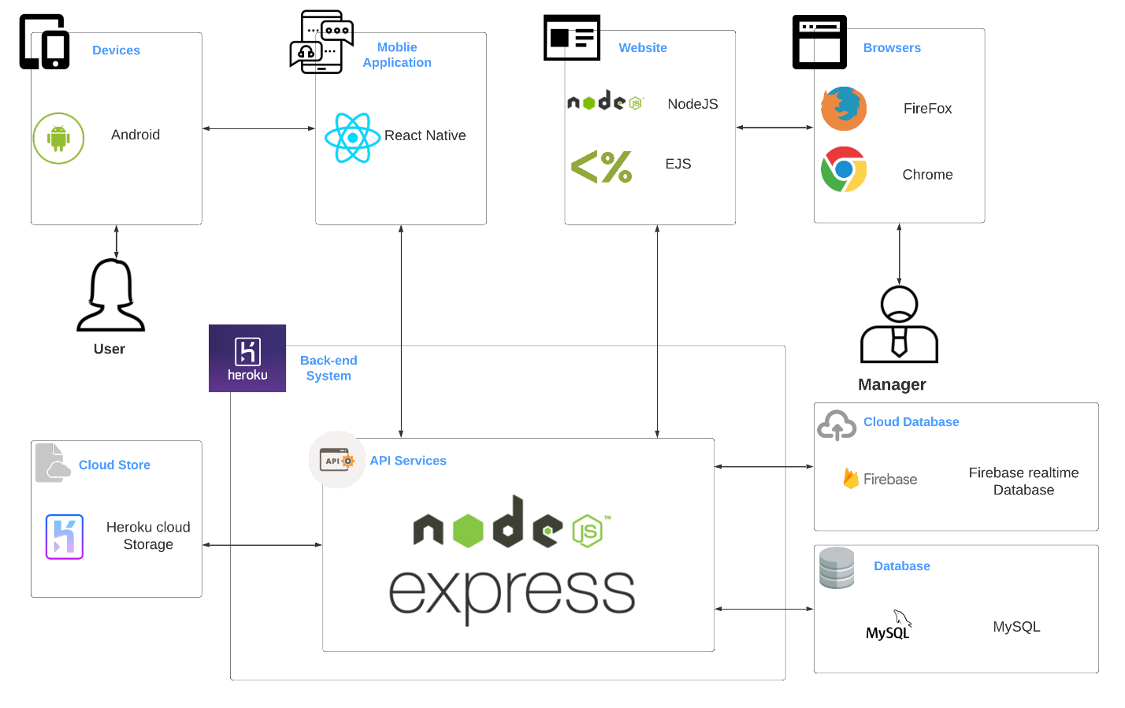

Figure 13 - PetDating system architecture

### 4.2.2. Component Explanation

This section will explain the function and mechanism of each unit in the system architecture design.

#### 4.2.2.1. Deploy and Hosting

##### 4.2.2.1.1. Heroku



Heroku is a service provider like as hosting, VPS, Cloud, … We use Heroku to deploy API services, hosting for website.

##### 4.2.2.1.2. Heroku Cloud Storage

**Heroku Cloud Storage** is an online file storage web service for storing and accessing data. The service combines the performance and scalability of Google's cloud with advanced security and sharing capabilities. **We use Heroku Cloud Storage for storing images that uploaded from users.**

#### 4.2.2.2. Mobile Application components



**React Native** combines the best parts of native development with React, a best-in-class JavaScript library for building user interfaces. Many platforms, one React. Create platform-specific versions of components so a single codebase can share code across platforms**.**

#### 4.2.2.3. Website components

##### 4.2.2.3.1. NodeJS



Node.js is an open-source, cross-platform JavaScript runtime environment that executes  
JavaScript code server-side. It uses an event-driven, non-blocking I/O model that makes it  
lightweight and efficient. **We use NodeJS for font-end website.**

##### 4.2.2.3.2. EJS

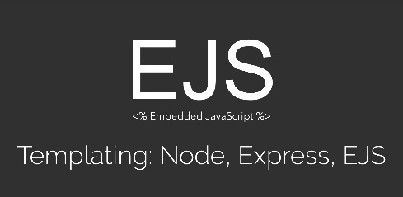

**EJS** is a simple templating language that lets you generate HTML markup with JavaScript. No Religiousness about how to organize things. No reinvention of iteration and control-flow. **We use EJS for operate across devices, operating systems and web browsers.**

#### 4.2.2.4. API Services components

##### 4.2.2.4.1. NodeJS



Node.js is an open-source, cross-platform JavaScript runtime environment that executes  
JavaScript code server-side. It uses an event-driven, non-blocking I/O model that makes it  
lightweight and efficient. **We use NodeJS to develop API services.**

##### 4.2.2.4.2. ExpressJS



**ExpressJS** is a NodeJS framework. It’s fast, unopinionated, minimalist framework for NodeJS. **We use ExpressJS and many of its modules to construct our API services.**

#### 4.2.2.5. Database components

##### 4.2.2.5.1. Firebase Realtime Database



The **Firebase Realtime Database** is a cloud-hosted database. Data is stored as JSON and synchronized in real-time to every connected client. **We use it to work with chatting function.**

##### 4.2.2.5.2. MySQL



**MySQL** is a fast, easy-to-use RDBMS being used for many small and big businesses. **We use MongoDB to manage PD data.**

## 4.3. Application Custom MVC Design

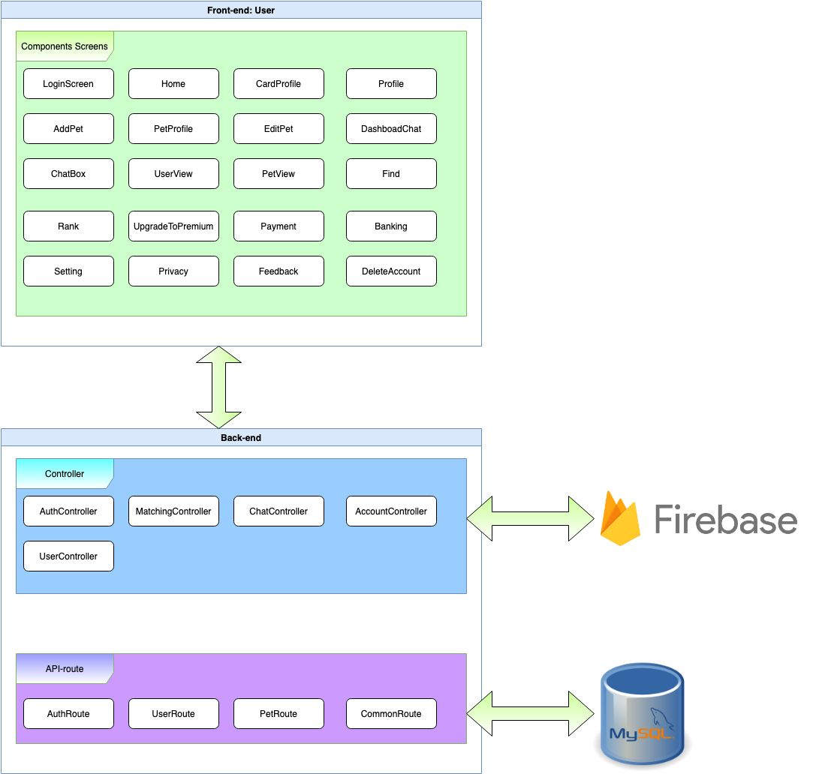

Figure 14 – MVC design

## 4.4. Database Design

### 4.4.1. Entity relationship diagram

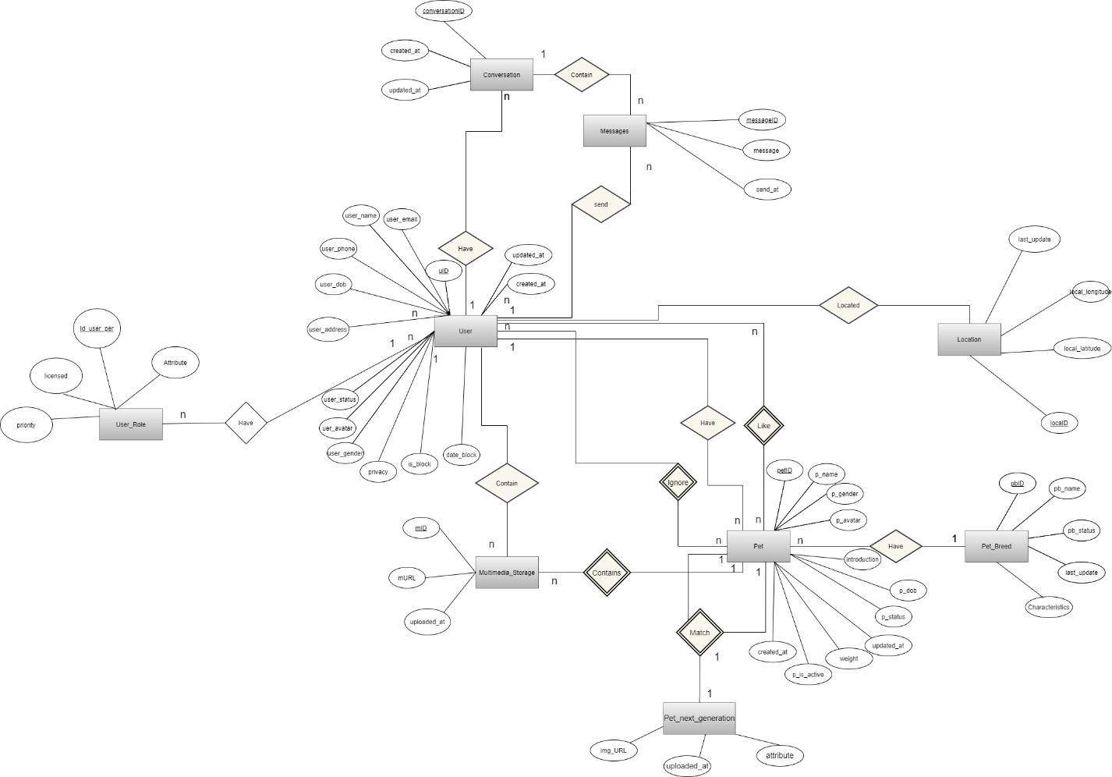

Figure 15 - Entity relationship diagram

|  |  |  |
| --- | --- | --- |
| **Entity** | **Attributes** | **Description** |
| User | **uID** | id of user |
| user_email | email of user |
| user_name | name of user |
| user_avatar | avatar of user |
| user_gender | gender of user |
| user_phone | phone of user |
| user_dob | birthdate of user |
| user_address | address of user |
| user_status | status of user |
| privacy | privacy of user |
| is_block | user is blocked or not |
| date_block | date expire blocked |
| local | Real-time location |
| created_at | datetime that the user was created |
| updated_at | datetime that the user was updated |
| Pet | **petID** | id of pet |
| p_name | name of pet |
| p_dob | birthdate of pet |
| p_gender | gender of pet |
| p_avatar | link to the avatar of pet |
| p_status | status of pet |
| introduction | introduction of the pet |
| p_is_active | this pet is choosen |
| weight | weight of pet |
| created_at | datetime that the pet was created |
| updated_at | datetime that the pet was updated |
| Location | **loca_id** | id of pet location |
| local_latitude | latitude of location |
| loca_longitude | longitude of location |
| updated_at | datetime that the specie was updated |
| Multimedia_Storage | **mID** | id of multimedia |
| mURL | link to multimedia |
| uploaded_at | datetime that the multimedia was uploaded |
| Conversation | **conversationID** | id of conversation |
| user_one | user on conversation |
| user_two | user on conversation |
| created_at | datetime that the conversation was created |
| updated_at | datetime that the last message in conversation was updated |
| User_Role | **Id_user_per** | id of role |
| licensed | licensed of user role |
| priority | priority of user role |
| attribute | attribute of user role |
| Pet_Next_Generation | **img_URL** | url of the image |
| atribute | attribute of pet next generation |
| uploaded_at | datetime that the image was uploaded |
| Message | messageID | id of message |
| message | content of message |
| send_at | time message be send |

### 4.4.2. Database diagram

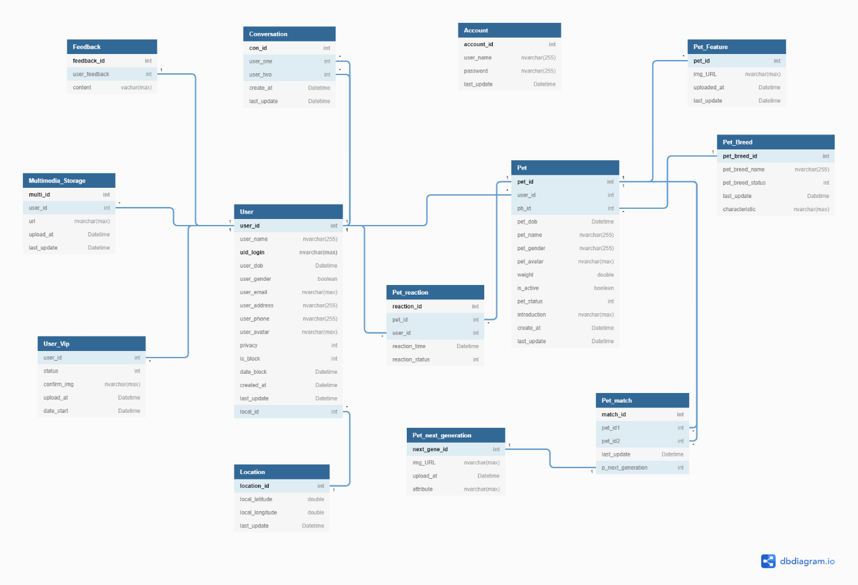

Figure 16 - Database diagram

**Database Explanation:**

**\*User:**

|  |  |  |  |  |
| --- | --- | --- | --- | --- |
| **No** | **Field Name** | **Type** | **Allow Null** | **Desceription** |
| 1 | **uID** | int | no | id of user  **PRIMARY KEY** |
| 2 | user_email | varchar(255) | No | email of user  **UNIQUE** |
|  | uid_login | varchar(max) | No | Id login by google or facebook  **PRIMARY KEY** |
| 3 | user_name | varchar(255) | No | name of user |
| 4 | user_avatar | varchar(max) | No | avatar of user |
| 5 | user_gender | boolean | No | gender of user (true : male , false :female) |
| 6 | user_phone | varchar(20) | Yes | phone of user |
| 7 | user_dob | date | No | birthdate of user |
| 8 | user_address | varchar(max) | Yes | address of user |
| 9 | user_status | boolean | No | status of user  1: Activated - Default  0: inActivated |
| 10 | privacy | boolean | No | privacy of user  true: unhide  false : hide |
| 11 | is_block | int | No | User is blocked or not  1 : block  0 : unblock |
|  | date_block | date | No | Expire block date |
| 12 | created_at | timestamp | No | datetime that the user was created  Default: CURRENT_TIMESTAMP |
| 13 | updated_at | timestamp | No | datetime that the pet was updated  Default: CURRENT_TIMESTAMP  ON UPDATE CURRENT_TIMESTAMP |

**\*Pet:**

|  |  |  |  |  |
| --- | --- | --- | --- | --- |
| **No** | **Field Name** | **Type** | **Allow Null** | **Desceription** |
| 1 | **petID** | int | No | id of pet  **Primary key** |
| 2 | *user_id* | int | No | id of user who have pets  Foreign key references to uID in “User” table |
| 3 | *pb_id* | int | No | breed of pet  Foreign key references to pbID in “PetBreed” table |
| 5 | p_name | varchar(255) | No | name of pet |
| 6 | p_dob | date | No | birthdate of pet |
| 7 | p_gender | varchar(255) | No | gender of pet (Đực; Cái) |
| 8 | p_avatar | varchar(max) | No | avatar of pet |
| 9 | weight | double | Yes | weight of pet |
| 10 | is_active | boolean | No | pet is choosen  1: Activated  0: inActivated |
| 11 | p_status | int | No | status of pet |
| 12 | introduction | text | Yes | introduction about pet |
| 13 | created_at | timestamp | No | datetime that the pet was created  Default: CURRENT_TIMESTAMP |
| 14 | updated_id | timestamp | No | datetime that the pet was updated  Default: CURRENT_TIMESTAMP  ON UPDATE CURRENT_TIMESTAMP |

**\*Pet_Breed:**

|  |  |  |  |  |
| --- | --- | --- | --- | --- |
| **No** | **Field Name** | **Type** | **Allow Null** | **Desceription** |
| 1 | **pbID** | int | No | id of pet’s breed  **Primary key** |
| 2 | *ps_id* | int | No | id of pet’s species  Foreign key references to psID in “PetSpecies” table |
| 3 | pb_name | varchar (30) | No | name of breed |
| 4 | pb_status | boolean | No | status of breed  1: Activated - Default  0: inActivated |
| 5 | updated_at | timestamp | No | datetime that the breed was updated.  Default: CURRENT_TIMESTAMP  ON UPDATE CURRENT_TIMESTAMP |

**\*Location:**

|  |  |  |  |  |
| --- | --- | --- | --- | --- |
| **No** | **Field Name** | **Type** | **Allow Null** | **Desceription** |
| 1 | **locaID** | int | No | id of location  **Primary key** |
| 2 | local_latitude | double | No | local_latitude of location |
| 3 | local_longitude | double | No | local_longitude of location |
| 4 | updated_at | timestamp | No | time that the location was updated. |

**\*Conversation:**

|  |  |  |  |  |
| --- | --- | --- | --- | --- |
| **No** | **Field Name** | **Type** | **Allow Null** | **Desceription** |
| 1 | **conID** | int | No | id of conversation  **Primary key** |
| 2 | *userOne* | int | No | id of user one who join in a conversation  Foreign key references to uID in “User” table |
| 3 | *userTwo* | int | No | id of user two who join in a conversation  Foreign key references to uID in “User” table |
| 4 | created_at | timestamp | No | datetime that the conversation was created  Default: CURRENT_TIMESTAMP |
| 5 | updated_at | timestamp | No | datetime that the last message in conversation was updated  Default: CURRENT_TIMESTAMP  ON UPDATE CURRENT_TIMESTAMP |

**\*Mutimedia_Storage:**

|  |  |  |  |  |
| --- | --- | --- | --- | --- |
| **No** | **Field Name** | **Type** | **Allow Null** | **Desceription** |
| 1 | **mID** | int | No | id of multimedia  **Primary key** |
| 2 | *user_id* | int | No | user_id of user who has multimedia  Foreign key refernces to uID in “User” table |
| 3 | url | varchar(max) | No | url contain content |
| 4 | uploaded_at | timestamp | No | datetime that the multimedia was uploaded  Default: CURRENT_TIMESTAMP |

**\*Account**

|  |  |  |  |  |
| --- | --- | --- | --- | --- |
| **No** | **Field Name** | **Type** | **Allow Null** | **Desceription** |
| 1 | **account_id** | int | No | id of account |
| 2 | user_name | varchar(255) | No | username of account user |
| 3 | password | varchar(255) | No | password of account user |
| 4 | last_update | timestamp | No | Default: CURRENT_TIMESTAMP  ON UPDATE CURRENT_TIMESTAMP |

**\*User_Vip:**

|  |  |  |  |  |
| --- | --- | --- | --- | --- |
| **No** | **Field Name** | **Type** | **Allow Null** | **Desceription** |
| 1 | **user_id** | int | No | id of user have vip |
| 2 | status | int | No | status of user vip  1: is Vip  0: non-Vip |
| 3 | confirm_img | varchar(max) | No | image user screen shot transfer money to accounts of admin |
| 4 | upload_at | timestamp | No | Default: CURRENT_TIMESTAMP |
| 5 | date_start | Datetime | No | date admin set user is Vip |

**\*Feedback:**

|  |  |  |  |  |
| --- | --- | --- | --- | --- |
| **No** | **Field Name** | **Type** | **Allow Null** | **Desceription** |
| 1 | **feedback_id** | int | No | id of feedback |
| 2 | user*_*feedback | int | No | id of user feedback reference to User table |
| 3 | content | vachar(max) | No | content of feedback |

**\*Pet_Feature:**

|  |  |  |  |  |
| --- | --- | --- | --- | --- |
| **No** | **Field Name** | **Type** | **Allow Null** | **Desceription** |
| 1 | **pet_id** | int | No | id of pet reference to PetId in Pet table |
| 2 | img_URL | varchar(max) | No | img url content |
| 3 | uploaded_at | timestamp | No | Default: CURRENT_TIMESTAMP |
| 4 | last_update | timestamp | No | Default: CURRENT_TIMESTAMP  ON UPDATE CURRENT_TIMESTAMP |

**\*Pet_Match:**

|  |  |  |  |  |
| --- | --- | --- | --- | --- |
| **No** | **Field Name** | **Type** | **Allow Null** | **Desceription** |
| 1 | **match_id** | int | No | id of match between two pets |
| 2 | *pet_id1* | int | No | id of pet match  reference to PetId in Pet table |
| 3 | *pet_id2* | int | No | id of pet is matched  reference to PetId in Pet table |
| 4 | last_update | timestamp | No | Default: CURRENT_TIMESTAMP  ON UPDATE CURRENT_TIMESTAMP |
| 5 | p_next_generation | int | No | id of pet next generation  reference to next_gene_id of Pet_Next_Generation table |

**\*Pet_Reaction:**

|  |  |  |  |  |
| --- | --- | --- | --- | --- |
| **No** | **Field Name** | **Type** | **Allow Null** | **Desceription** |
| 1 | **reaction_id** | int | No | id of reaction |
| 2 | *pet_id* | int | No | id of pet , that is reacted  reference to PetId of Pet table |
| 3 | *user_id* | int | No | id of user reacted,  reference to UserId of User table |
| 4 | reaction_time | timestamp | No | Default: CURRENT_TIMESTAMP |
| 5 | reaction_status | int | No | type of react:  1: like  2: dislike |

**\*Pet_Next_Generation:**

|  |  |  |  |  |
| --- | --- | --- | --- | --- |
| **No** | **Field Name** | **Type** | **Allow Null** | **Desceription** |
| 1 | **next_gene_id** | int | No | Id of next generation |
| 2 | *img_URL* | varchar(max) | No | url of image, which is content |
| 3 | upload_at | timestamp | No | Default: CURRENT_TIMESTAMP |
| 4 | attribute | nvarchar(max) | No | attribute of next generation |

## 4.5. Detailed Design

### 4.5.1. Login

**\*Login class diagram**

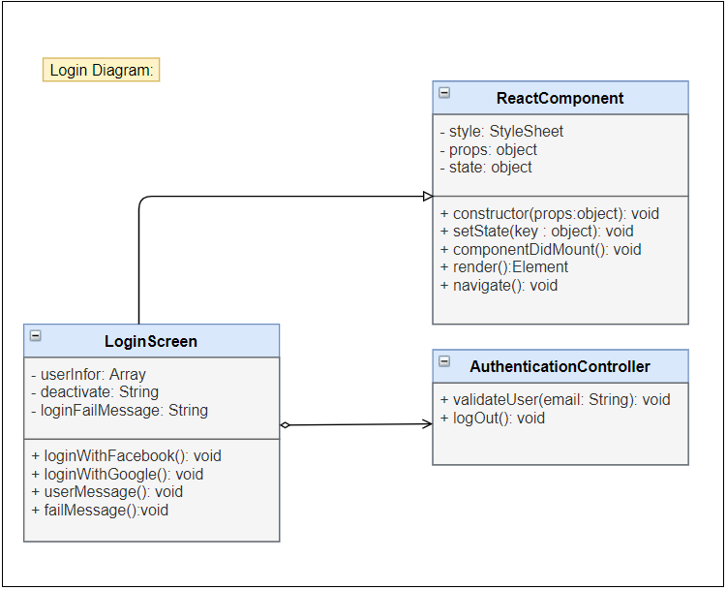

Figure 17 - Login class diagram

|  |  |  |  |  |  |
| --- | --- | --- | --- | --- | --- |
| **Name** | AuthController | | | **Type** | Class |
| **Description** | Controller class to control authentication. | | | | |
| **Attributes** | | | | | |
| **Name** | **Type** | **Visibility** | **Description** | | |
|  |  |  |  | | |
| **Operations** | | | | | |
| **Name** | **Type** | **Visibility** | **Description** | | |
| validateUser(email) | void | public | Validate the email in database. | | |
|  |  |  |  | | |
|  |  |  |  | | |

|  |  |  |  |  |  |
| --- | --- | --- | --- | --- | --- |
| **Name** | LoginScreen | | | **Type** | Class |
| **Description** | A class that displays login screen. | | | | |
| **Attributes** | | | | | |
| **Name** | **Type** | **Visibility** | **Description** | | |
| loading | boolean | private | state of loading modal | | |
|  |  |  |  | | |
|  |  |  |  | | |
| **Operations** | | | | | |
| **Name** | **Type** | **Visibility** | **Description** | | |
| loginWithGoogle() | void | public | Handle login with google | | |
| loginWithFacebook() | void | public | Handle login with facebook | | |
| saveUserInfo() | void | public | Save user information in AsyncStorage | | |
| userMessage() | void | public | Display deactivated message | | |
| createNewUser() | void | public | Navigate to CreateUser Screen | | |
|  |  |  |  | | |

**\*Login with Google sequence diagram**

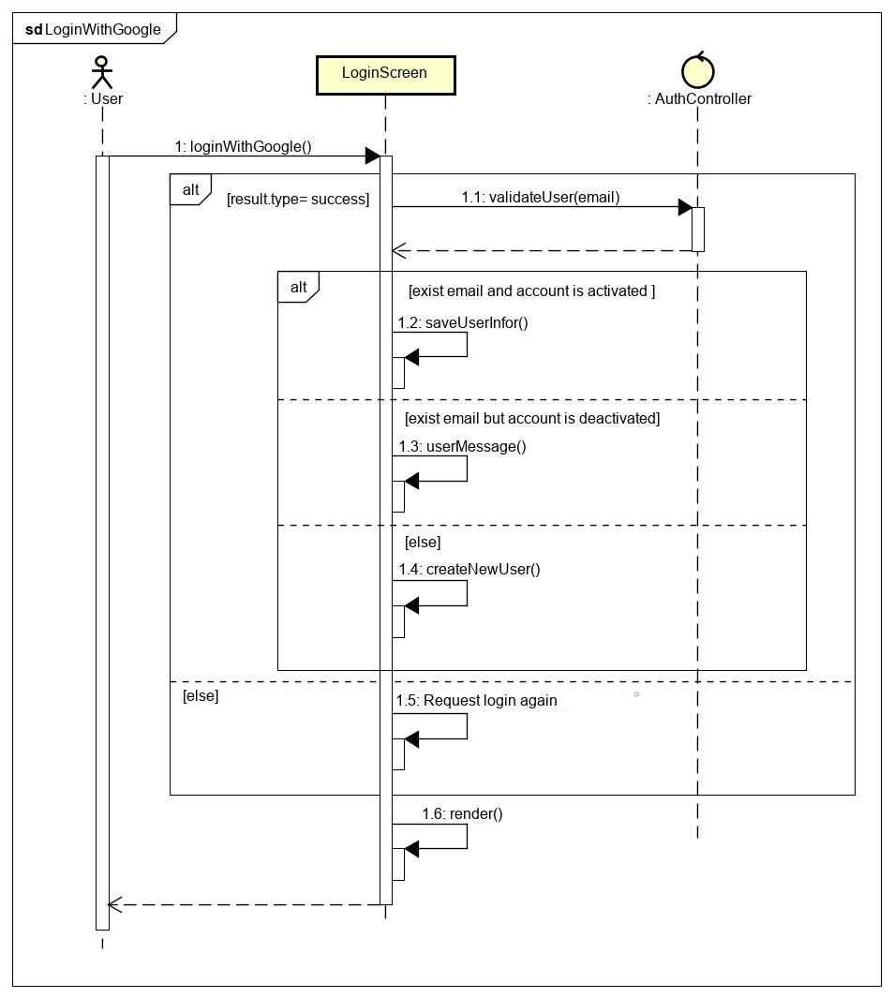

Figure 18 - Login with Google sequence diagram

**\*Login with Facebook sequence diagram**

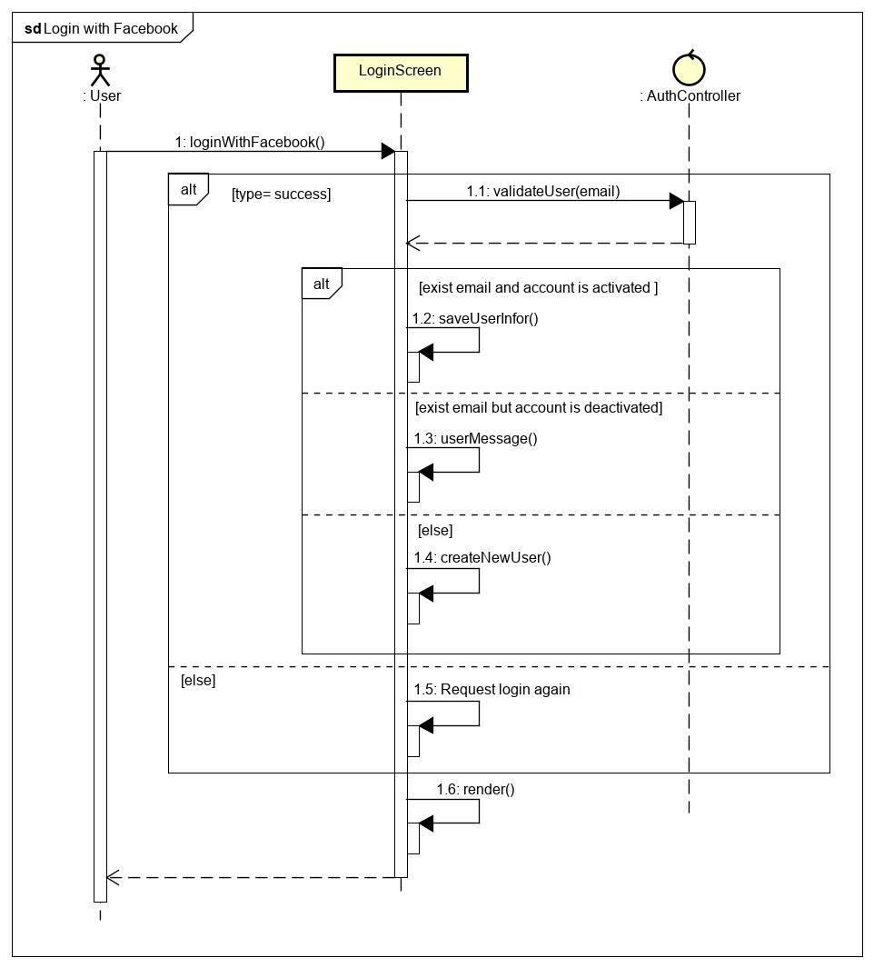

Figure 19 - Login with Facebook class diagram

### s4.5.2. Logout

**\*Logout class diagram**

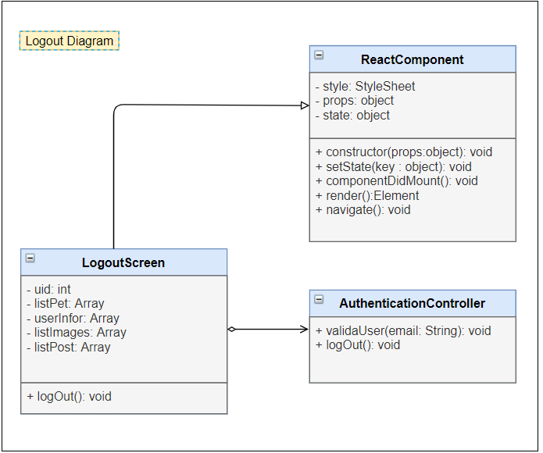

Figure 20 - Logout class diagram

|  |  |  |  |  |  |
| --- | --- | --- | --- | --- | --- |
| **Name** | AuthController | | | **Type** | Class |
| **Description** | Controller class to control authentication. | | | | |
| **Attributes** | | | | | |
| **Name** | **Type** | **Visibility** | **Description** | | |
|  |  |  |  | | |
| **Operations** | | | | | |
| **Name** | **Type** | **Visibility** | **Description** | | |
| logOutSystem() | void | public | Clear AnsyncStorage and logout user from application. | | |
|  |  |  |  | | |

|  |  |  |  |  |  |
| --- | --- | --- | --- | --- | --- |
| **Name** | NavScreen | | | **Type** | Class |
| **Description** | A class that displays navigator screen. | | | | |
| **Attributes** | | | | | |
| **Name** | **Type** | **Visibility** | **Description** | | |
|  |  |  |  | | |
| **Operations** | | | | | |
| **Name** | **Type** | **Visibility** | **Description** | | |
| logOut() | void | public | Handle logout from application. | | |
|  |  |  |  | | |

**\*Logout sequence diagram**

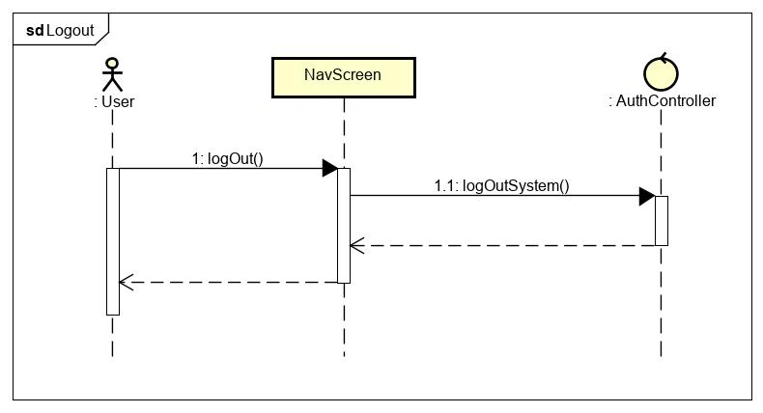

Figure 21 - Logout sequence diagram

### 4.5.3. Matching

**\* Matching Class Diagram**

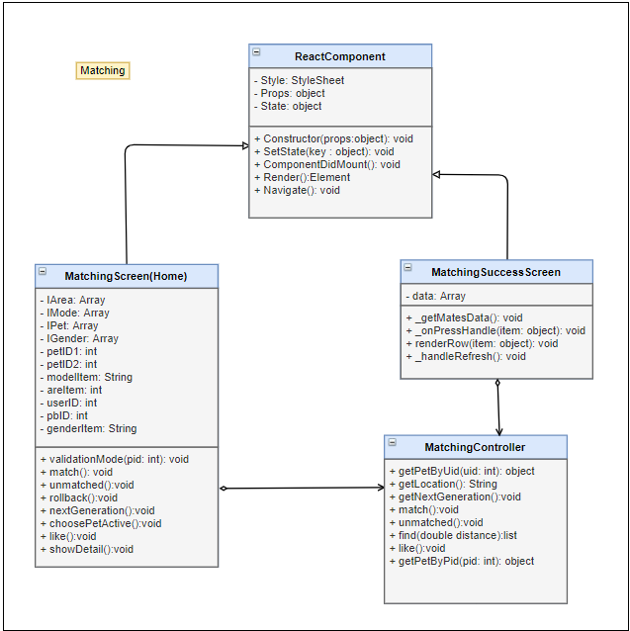

Figure 22 - Matching class diagram

|  |  |  |  |  |  |
| --- | --- | --- | --- | --- | --- |
| **Name** | MatchingController | | | **Type** | Class |
| **Description** | Controller class to control User and some functions relative. | | | | |
| **Attributes** | | | | | |
| **Name** | **Type** | **Visibility** | **Description** | | |
|  |  |  |  | | |
| **Operations** | | | | | |
| **Name** | **Type** | **Visibility** | **Description** | | |
| getPetByUid (id) | object | public | Get Information of list pet with UserId in database | | |
| getLocation () | void | public | Get real location of user | | |
| getNextGeneration() | void | public | Get new baby pet for 2 parent pets | | |
| match() | void | public | Match random for active pet  Or unmatch them | | |
| unmatched() | void | public | Unmatch 2 pets ( they are matched) | | |
| like() | void | public | Reaction a pet to rankking or show | | |

|  |  |  |  |  |  |
| --- | --- | --- | --- | --- | --- |
| **Name** | Matching screen | | | **Type** | Class |
| **Description** | Main (Home ) Screen  Screen allow user match, like , get nextgeneration , choose pet active | | | | |
| **Attributes** | | | | | |
| **Name** | **Type** | **Visibility** | **Description** | | |
| IArea | Array | private | List location of pets | | |
| IMode | Array | private | List Mode view of pets | | |
| IPet | Array | private | List pet show | | |
| IGender | Array | private | List gender of pets | | |
| petID1 | int | private | Id of pet actived | | |
| petID2 | int | private | Id of pet matched | | |
| modelItem | String | private | Mode of view pets | | |
| areItem | int | private | Pet was showed or not | | |
| userID | int | private | userId of user , who own pet be matched | | |
| pbID | int | private | Pet_breed of pet active | | |
| genderItem | String | private | Gender of pet is showing | | |
|  |  |  |  | | |
| **Operations** | | | | | |
| **Name** | **Type** | **Visibility** | **Description** | | |
| validationMode (pid: int) | void | public | Decision pet is showed or not | | |
| match | void | public | Add match record between 2 pets to database or delete both of 2 records | | |
| unmatched | void | public | Unmatch 2 pet ( they are matched) | | |
| rollback | void | public | Rollback pet card user passed | | |
| nextGeneration | void | public | Get image of Next generation between 2 pets (parent)s | | |
| choosePetActive | void | public | Choose pet to match | | |
| like | void | public | Reaction pet on screen | | |
| showDetail | void | public | Show all information of that pet | | |

|  |  |  |  |  |  |
| --- | --- | --- | --- | --- | --- |
| **Name** | MatchingSuccess screen | | | **Type** | Class |
| **Description** | Screen Matching Success Result | | | | |
| **Attributes** | | | | | |
| **Name** | **Type** | **Visibility** | **Description** | | |
| data | Array | private | Data tranfer of matching screen | | |
|  |  |  |  | | |
| **Operations** | | | | | |
| **Name** | **Type** | **Visibility** | **Description** | | |
| _onPressHandle | void | public | Handle event press matching button | | |
| _getMatesData | void | public | Get list information of 2 pets are matched | | |
| renderRow | void | public | Show list pets are matched | | |
| _handleRefresh | void | public | Handle event refresh screen | | |

**\*Matching Sequence Diagram**

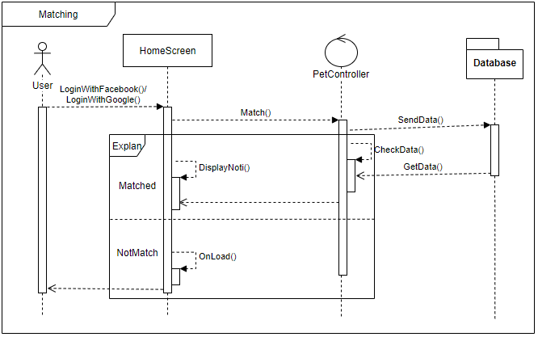

Figure 23 - Matching Sequencediagram

### 4.5.4. Chat

**\* View ConversationList Class Diagram**

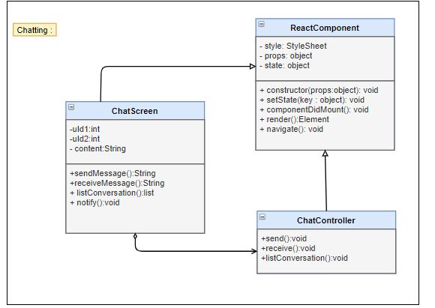

Figure 24 - View ConversationList Class Diagram

|  |  |  |  |  |  |
| --- | --- | --- | --- | --- | --- |
| **Name** | ChatController | | | **Type** | Class |
| **Description** | Controller control chat messages and conversations | | | | |
| **Attributes** | | | | | |
| **Name** | **Type** | **Visibility** | **Description** | | |
|  |  |  |  | | |
| **Operations** | | | | | |
| **Name** | **Type** | **Visibility** | **Description** | | |
| send() | void | public | Send message ( real time) | | |
| receive() | void | public | Recive messages (real time) | | |
| listConversation | list | public | Show list all of conversation | | |

|  |  |  |  |  |  |
| --- | --- | --- | --- | --- | --- |
| **Name** | Chatting Screen | | | **Type** | Class |
| **Description** | Client Screen show list conversation and chat messages | | | | |
| **Attributes** | | | | | |
| **Name** | **Type** | **Visibility** | **Description** | | |
| conversationList | Array | private | List all of conversation | | |
|  |  |  |  | | |
| **Operations** | | | | | |
| **Name** | **Type** | **Visibility** | **Description** | | |
| chatNote | void | public | Load List all of conversation new message | | |
| notify | void | public | Notify when receive messages | | |
| send | void | public | Send message | | |
| receive | void | public | Receive message | | |

|  |  |  |  |  |  |
| --- | --- | --- | --- | --- | --- |
| **Name** | ChatController | | | **Type** | Class |
| **Description** | The screen controls chatting action | | |  |  |
| **Attributes** | | | | | |
| **Name** | **Type** | **Visibility** | **Description** | | |
|  |  |  |  | | |
| **Operations** | | | | | |
| **Name** | **Type** | **Visibility** | **Description** | | |
| getCVList(uid) | Promise | public | Get list of conversations in database | | |

|  |  |  |  |  |  |
| --- | --- | --- | --- | --- | --- |
| **Name** | ConversationList | | | **Type** | Class |
| **Description** | The screen displays content of conver | | | sation |  |
| **Attributes** | | | | | |
| **Name** | **Type** | **Visibility** | **Description** | | |
| loggedUserID | int | private | Id of user | | |
| dataSource | Array | private | List of conversations | | |
| isLoading | boolean | private | Status of loading | | |
| **Operations** | | | | | |
| **Name** | **Type** | **Visibility** | **Description** | | |
| _getConversationList() | void | public | Handle get list of conversations | | |

**\*View ConversationList Sequence Diagram**

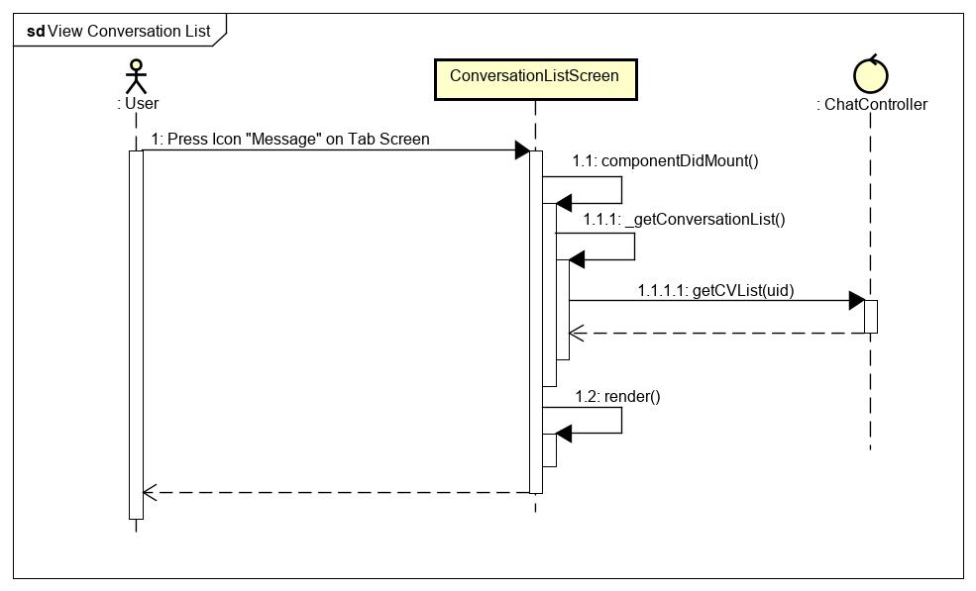

Figure 25 - Conversation list sequence diagram

**\*Send Messages class diagram**

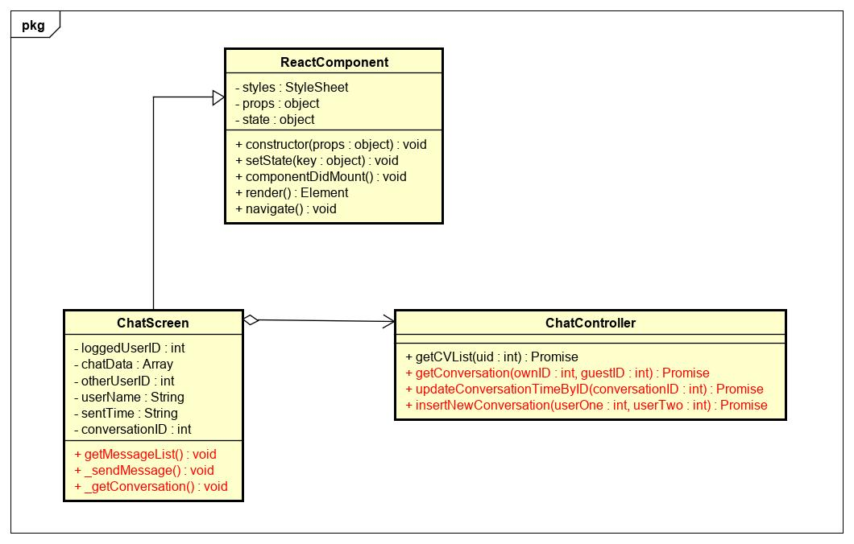

Figure 26 - Send message class diagram

|  |  |  |  |  |  |
| --- | --- | --- | --- | --- | --- |
| **Name** | ChatController | | | **Type** | Class |
| **Description** | The screen controls chatting action | | |  |  |
| **Attributes** | | | | | |
| **Name** | **Type** | **Visibility** | **Description** | | |
|  |  |  |  | | |
| **Operations** | | | | | |
| **Name** | **Type** | **Visibility** | **Description** | | |
| getConversation() | Promise | public | Get detail of the conversations in database | | |
| updateConversationTimeByID() | Promise | public | Update conversation time | | |
| insertNewConversation() | Promise | public | Insert new conversation to database | | |

|  |  |  |  |  |  |
| --- | --- | --- | --- | --- | --- |
| **Name** | ChatScreen | | | **Type** | Class |
| **Description** | The screen displays content of chat | | |  |  |
| **Attributes** | | | | | |
| **Name** | **Type** | **Visibility** | **Description** | | |
| loggedUserID | int | private | Id of own user | | |
| chatData | Array | private | List messages | | |
| otherUserID | int | private | Status of loading | | |
| userName | String | private | Name of user | | |
| sentTime | String | private | Current time to send message | | |
| conversationID | int | private | Id of this conversation | | |
| **Operations** | | | | | |
| **Name** | **Type** | **Visibility** | **Description** | | |
| _getConversation() | void | public | Handle get detail of conversations | | |
| _sendMessage() | void | public | Handle send message | | |
| getMessageList() | void | public | Get list of messages | | |

**\*Send Messages sequence diagram**

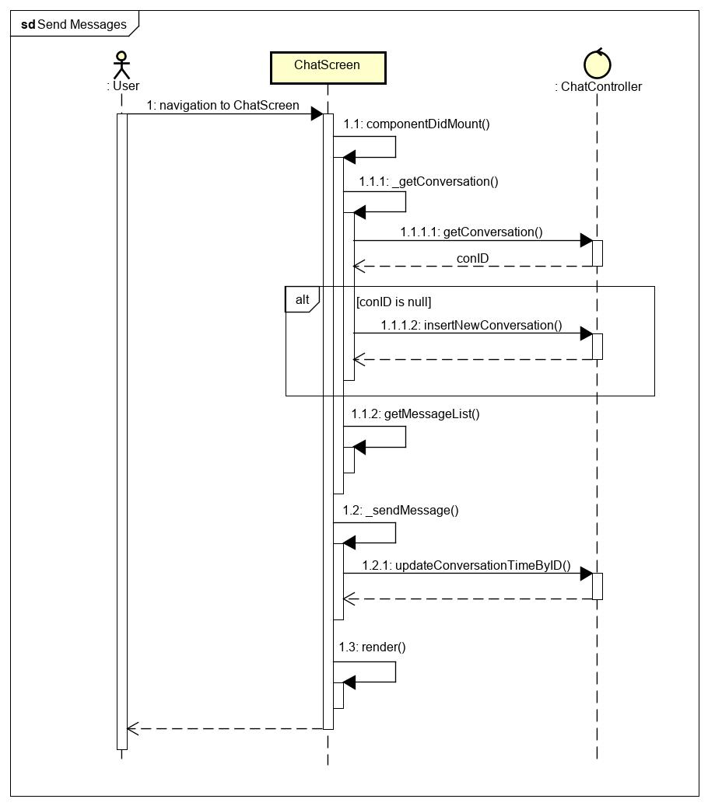

Figure 27 - Send message sequence diagram

**\*Receive Messages class diagram**

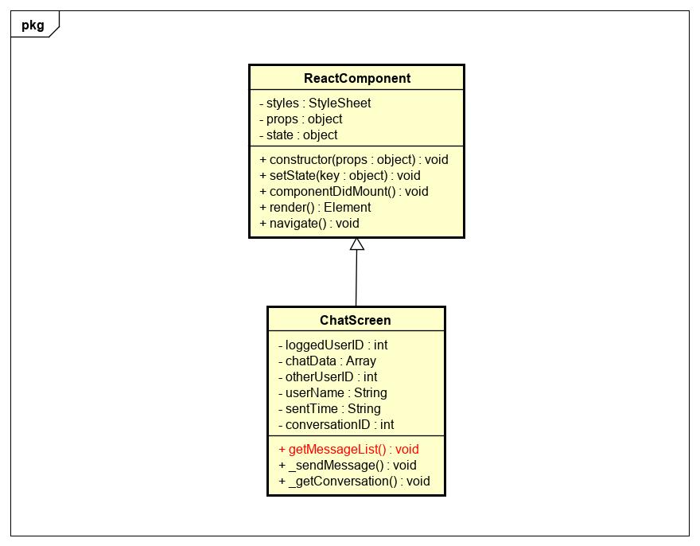  
Figure 28 - Receive message class diagram

|  |  |  |  |  |  |
| --- | --- | --- | --- | --- | --- |
| **Name** | ChatScreen | | | **Type** | Class |
| **Description** | The screen displays content of chat | | |  |  |
| **Attributes** | | | | | |
| **Name** | **Type** | **Visibility** | **Description** | | |
| loggedUserID | int | private | Id of own user | | |
| chatData | Array | private | List messages | | |
| otherUserID | int | private | Status of loading | | |
| userName | String | private | Name of user | | |
| sentTime | String | private | Current time to send message | | |
| conversationID | int | private | Id of this conversation | | |
| **Operations** | | | | | |
| **Name** | **Type** | **Visibility** | **Description** | | |
| getMessageList() | void | public | Get list of messages | | |

**\* Receive Messages sequence diagram**

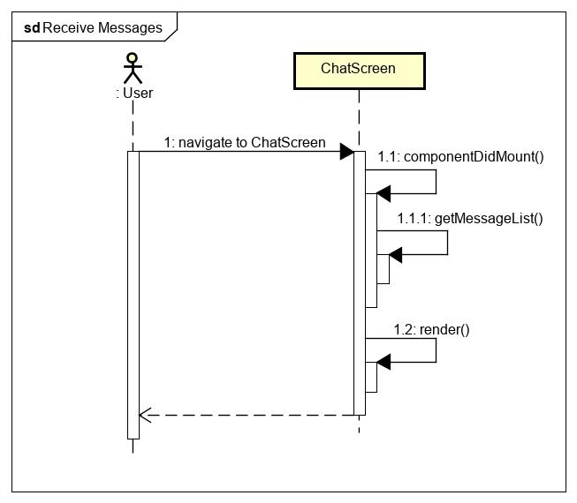

Figure 29 - Receive message sequence diagram

### 4.5.5. Ranking

**\* Ranking class diagram**

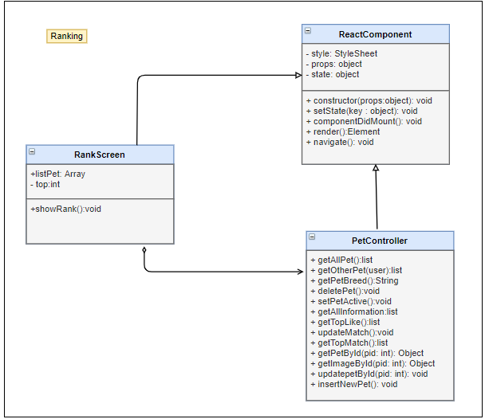

Figure 30 – Ranking class diagram

|  |  |  |  |  |  |
| --- | --- | --- | --- | --- | --- |
| **Name** | PetController | | | **Type** | Class |
| **Description** | Controller class to control Pet and some functions relative. | | | | |
| **Attributes** | | | | | |
| **Name** | **Type** | **Visibility** | **Description** | | |
|  |  |  |  | | |
| **Operations** | | | | | |
| **Name** | **Type** | **Visibility** | **Description** | | |
| getAllPet | list | public | Get list all of pet belong to this user | | |
| deletePet | void | public | Delete a pet in list pets | | |
| setPetActive | void | public | Set a pet is active to match | | |
| getAllInformation | list | public | Get all information of pet on list pet | | |
| getTopLike | list | public | Get top pet have most liked | | |
| updateMatch | void | public | Update match record in database | | |
| getTopMatch | list | public | Get top pets are most matched | | |
| getPetById(pid: int) | Object | public | Get Pet by PetID | | |
| getImageById(pid: int) | Object | public | Get all image by petID | | |

|  |  |  |  |  |  |
| --- | --- | --- | --- | --- | --- |
| **Name** | RankingScreen | | | **Type** | Class |
| **Description** | Screen show top of pet with most liked , match | | | | |
| **Attributes** | | | | | |
| **Name** | **Type** | **Visibility** | **Description** | | |
| listPet | Array | private | List pet have most match , like | | |
| top | Int | private | Amount pet in rank | | |
|  |  |  |  | | |
| **Operations** | | | | | |
| **Name** | **Type** | **Visibility** | **Description** | | |
| showRank | void | public | Show list pet with most matched , like | | |
|  |  |  |  | | |

**\* Ranking sequence diagram**

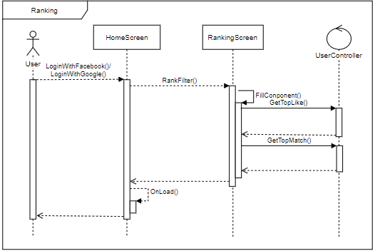

Figure 31 – Ranking sequence diagram

### 4.5.6. Feedback

**\* Feedback class diagram**

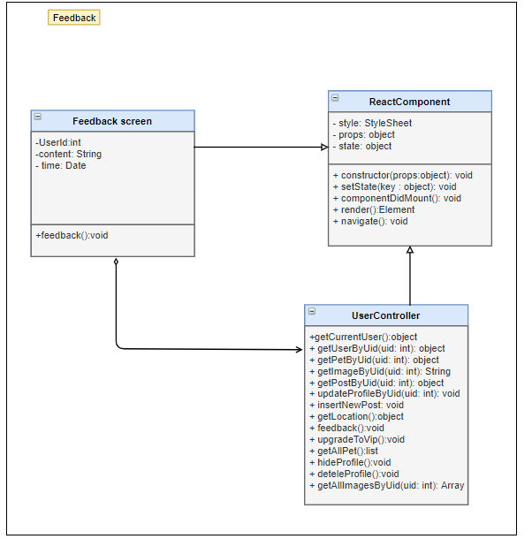

Figure 32 – Feedback class diagram

|  |  |  |  |  |  |
| --- | --- | --- | --- | --- | --- |
| **Name** | UserController | | | **Type** | Class |
| **Description** | Controller class to control Matching and some functions relative. | | | | |
| **Attributes** | | | | | |
| **Name** | **Type** | **Visibility** | **Description** | | |
|  |  |  |  | | |
| **Operations** | | | | | |
| **Name** | **Type** | **Visibility** | **Description** | | |
| getCurrentUser() | object | public | Get all information of user, which did login | | |
| getUserByUid(uID) | object | public | Get all information of user with Uid | | |
| getImageByUid(()) | String | public | Select image form database by Uid | | |
| getLocation() | object | public | Get location( latitude and longitude) of user | | |
| Feedback() | void | public | Send feedback to admin | | |
| getAllImagesByUid() | Array | public | Get list of image User has | | |

|  |  |  |  |  |  |
| --- | --- | --- | --- | --- | --- |
| **Name** | FeedbackScreen | | | **Type** | Class |
| **Description** | Screen to send feedback | | | | |
| **Attributes** | | | | | |
| **Name** | **Type** | **Visibility** | **Description** | | |
| UserId | int | private | Id of currence user have logined | | |
| content | String | private | Content of message feedback | | |
| time | Date | private | Time feedback | | |
|  |  |  |  | | |
| **Operations** | | | | | |
| **Name** | **Type** | **Visibility** | **Description** | | |
| feedback | void | public | Send feedback to server | | |
|  |  |  |  | | |

**\* Feedback sequence diagram**

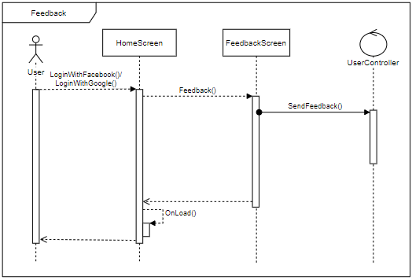

Figure 33 – Feedback sequence diagram

### 4.5.7. React pet

**\* React pet class diagram**

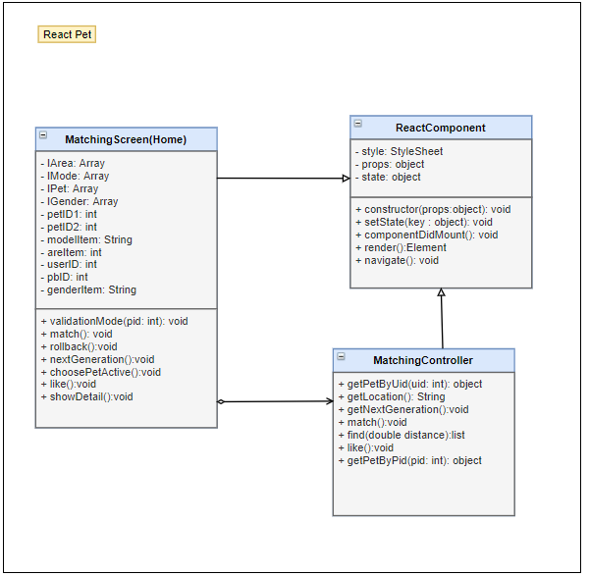

Figure 34 – React pet class diagram

|  |  |  |  |  |  |
| --- | --- | --- | --- | --- | --- |
| **Name** | PetController | | | **Type** | Class |
| **Description** | Controller class to control Pet and some functions relative. | | | | |
| **Attributes** | | | | | |
| **Name** | **Type** | **Visibility** | **Description** | | |
|  |  |  |  | | |
| **Operations** | | | | | |
| **Name** | **Type** | **Visibility** | **Description** | | |
| getAllPet | list | public | Get list all of pet belong to this user | | |
| getOtherPet(user) | list | public | Get list all of Pet by userID | | |
| getPetBreed | String | public | Get pet breed for pet | | |
| setPetActive | void | public | Set a pet is active to match | | |
| getAllInformation | list | public | Get all information of pet on list pet | | |
| getTopLike | list | public | Get top pet have most liked | | |
| updateMatch | void | public | Update match record in database | | |
| getTopMatch | list | public | Get top pets are most matched | | |
| getPetById(pid: int) | Object | public | Get Pet by PetID | | |
| getImageById(pid: int) | Object | public | Get all image by petID | | |

|  |  |  |  |  |  |
| --- | --- | --- | --- | --- | --- |
| **Name** | MatchingScreen | | | **Type** | Class |
| **Description** | Reaction pet | | | | |
| **Attributes** | | | | | |
| **Name** | **Type** | **Visibility** | **Description** | | |
| IArea | Array | private | List location of pets | | |
| IMode | Array | private | List Mode view of pets | | |
| IPet | Array | private | List pet show | | |
| IGender | Array | private | List gender of pets | | |
| petID1 | int | private | Id of pet actived | | |
| petID2 | int | private | Id of pet matched | | |
| modelItem | String | private | Mode of view pets | | |
| areItem | int | private | Pet was showed or not | | |
| userID | int | private | userId of user , who own pet be matched | | |
| pbID | int | private | Pet_breed of pet active | | |
| genderItem | String | private | Gender of pet is showing | | |
|  |  |  |  | | |
| **Operations** | | | | | |
| **Name** | **Type** | **Visibility** | **Description** | | |
| validationMode (pid: int) | void | public | Decision pet is showed or not | | |
| match | void | public | Add match record between 2 pets to database | | |
| rollback | void | public | Rollback pet card user passed | | |
| nextGeneration | void | public | Get image of Next generation between 2 pets (parent)s | | |
| choosePetActive | void | public | Choose pet to match | | |
| like | void | public | Reaction pet on screen | | |
| showDetail | void | public | Show all information of that pet | | |
|  |  |  |  | | |

**\* React pet sequence diagram**

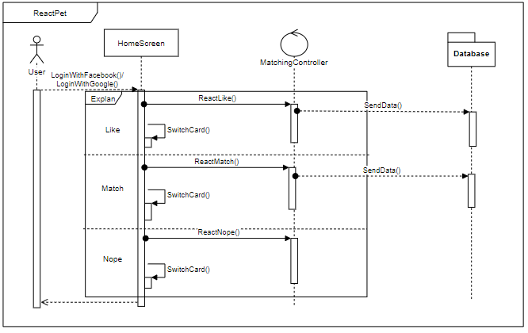

Figure 35 – React pet sequence diagram

### 4.5.8. View other user

**\* View other user class diagram**

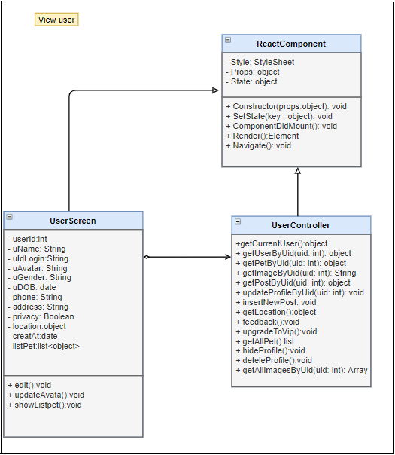

Figure 36 – View other user class diagram

|  |  |  |  |  |  |
| --- | --- | --- | --- | --- | --- |
| **Name** | UserController | | | **Type** | Class |
| **Description** | Controller class to control Matching and some functions relative. | | | | |
| **Attributes** | | | | | |
| **Name** | **Type** | **Visibility** | **Description** | | |
|  |  |  |  | | |
| **Operations** | | | | | |
| **Name** | **Type** | **Visibility** | **Description** | | |
| getCurrentUser() | object | public | Get all information of user, which did login | | |
| getUserByUid(uID) | object | public | Get all information of user with Uid | | |
| getPetByPid(pID) | object | public | Get information of Pet with  PetID | | |
| getImageByUid(()) | String | public | Select image form database by Uid | | |
| updateProfileByUid() | void | public | Update detail of user profile | | |
| getLocation() | object | public | Get location( latitude and longitude) of user | | |
| getAllPet() | list | public | Get all information of list pet Pet  For this user | | |
| getAllImagesByUid() | Array | public | Get list of image User has | | |

|  |  |  |  |  |  |
| --- | --- | --- | --- | --- | --- |
| **Name** | UserScreen | | | **Type** | Class |
| **Description** | Screen show all information of user | | | | |
| **Attributes** | | | | | |
| **Name** | **Type** | **Visibility** | **Description** | | |
| userId | int | private | UserID of user , who you want to view | | |
| uName | String | private | User name | | |
| uIdLogin | String | private | User id login ( facebook , Google) | | |
| uAvatar | String | private | User’s Avatar | | |
| uGender | String | private | User’s gender | | |
| uDOB | date | private | User’s date of birth | | |
| phone | String | private | User’s phone numbers | | |
| address | String | private | User’s address | | |
| privacy | Boolean | private | User’s privacy | | |
| location | object | private | Local of user ( latitude , longitude) | | |
| creatAt | date | private | Time user was created | | |
| listPet | list | private | List pet of that user | | |
|  |  |  |  | | |
| **Operations** | | | | | |
| **Name** | **Type** | **Visibility** | **Description** | | |
| showListPet() | void | public | Refresh and show list pets | | |
|  |  |  |  | | |

**\* View other user sequence diagram**

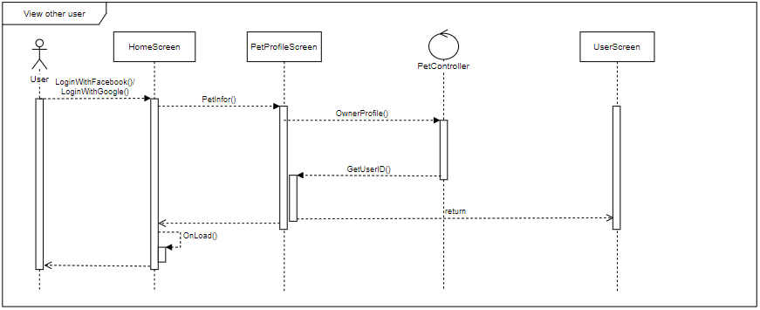

Figure 37 – View other user sequence diagram

### 4.5.9. View other user’s pet

**\* View other user’s pet class diagram**

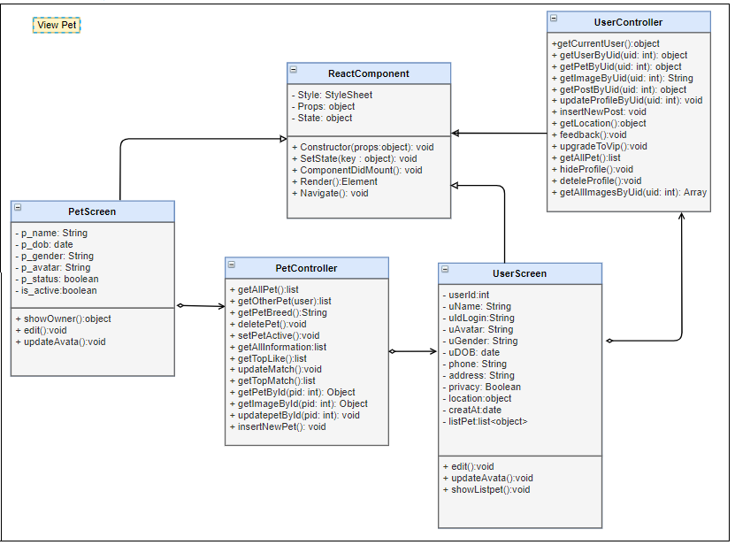

Figure 38 – View other user’s pet class diagram

|  |  |  |  |  |  |
| --- | --- | --- | --- | --- | --- |
| **Name** | UserController | | | **Type** | Class |
| **Description** | Controller class to control Matching and some functions relative. | | | | |
| **Attributes** | | | | | |
| **Name** | **Type** | **Visibility** | **Description** | | |
|  |  |  |  | | |
| **Operations** | | | | | |
| **Name** | **Type** | **Visibility** | **Description** | | |
| getCurrentUser() | object | public | Get all information of user, which did login | | |
| getUserByUid(uID) | object | public | Get all information of user with Uid | | |
| getPetByPid(pID) | object | public | Get information of Pet with  PetID | | |
| getImageByUid(()) | String | public | Select image form database by Uid | | |
| updateProfileByUid() | void | public | Update detail of user profile | | |
| getLocation() | object | public | Get location( latitude and longitude) of user | | |
| getAllImagesByUid() | Array | public | Get list of image User has | | |

|  |  |  |  |  |  |
| --- | --- | --- | --- | --- | --- |
| **Name** | PetController | | | **Type** | Class |
| **Description** | Controller class to control Pet and some functions relative. | | | | |
| **Attributes** | | | | | |
| **Name** | **Type** | **Visibility** | **Description** | | |
|  |  |  |  | | |
| **Operations** | | | | | |
| **Name** | **Type** | **Visibility** | **Description** | | |
| getAllPet | list | public | Get list all of pet belong to this user | | |
| getOtherPet(user) | list | public | Get list all of Pet by userID | | |
| getPetBreed | String | public | Get pet breed for pet | | |
| getAllInformation | list | public | Get all information of pet on list pet | | |
| getTopLike | list | public | Get top pet have most liked | | |
| getTopMatch | list | public | Get top pets are most matched | | |
| getPetById(pid: int) | Object | public | Get Pet by PetID | | |
| getImageById(pid: int) | Object | public | Get all image by petID | | |
| insertNewPet() | void | public | Create a new pet | | |

|  |  |  |  |  |  |
| --- | --- | --- | --- | --- | --- |
| **Name** | UserScreen | | | **Type** | Class |
| **Description** | Screen show all information of user | | | | |
| **Attributes** | | | | | |
| **Name** | **Type** | **Visibility** | **Description** | | |
| userId | int | private | UserID of user , who you want to view | | |
| uName | String | private | User name | | |
| uIdLogin | String | private | User id login ( facebook , Google) | | |
| uAvatar | String | private | User’s Avatar | | |
| uGender | String | private | User’s gender | | |
| uDOB | date | private | User’s date of birth | | |
| phone | String | private | User’s phone numbers | | |
| address | String | private | User’s address | | |
| privacy | Boolean | private | User’s privacy | | |
| location | object | private | Local of user ( latitude , longitude) | | |
| creatAt | date | private | Time user was created | | |
| listPet | list | private | List pet of that user | | |
|  |  |  |  | | |
| **Operations** | | | | | |
| **Name** | **Type** | **Visibility** | **Description** | | |
| showListPet() | void | public | Refresh and show list pets | | |
|  |  |  |  | | |

|  |  |  |  |  |  |
| --- | --- | --- | --- | --- | --- |
| **Name** | PetScreen | | | **Type** | Class |
| **Description** | Screen show detail information of pet | | | | |
| **Attributes** | | | | | |
| **Name** | **Type** | **Visibility** | **Description** | | |
| p_name | String | private | Name of pet | | |
| p_dob | date | private | Pet’s date of birth | | |
| p_gender | String | private | Pet’s gender | | |
| p_avatar | String | private | Pet’s avata | | |
| p_status | boolean | private | Pet’s status | | |
| is_active | boolean | private | Pet’s is active | | |
|  |  |  |  | | |
|  |  |  |  | | |
| **Operations** | | | | | |
| **Name** | **Type** | **Visibility** | **Description** | | |
| showOwner | object | public | Show information of user , who own pet | | |
|  |  |  |  | | |

**\* View other user’s pet sequence diagram**

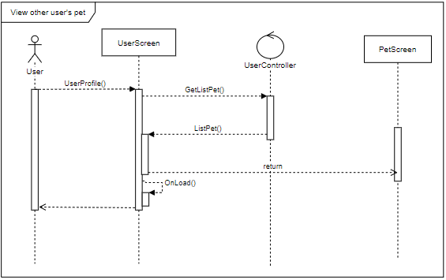

Figure 39 – View other user’s pet sequence diagram

### 4.5.10. Hide profile

**\* Hide profile class diagram**

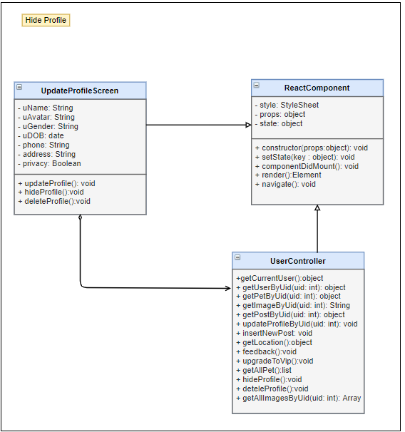

Figure 40 – Hide profile class diagram

|  |  |  |  |  |  |
| --- | --- | --- | --- | --- | --- |
| **Name** | UserController | | | **Type** | Class |
| **Description** | Controller class to control Matching and some functions relative. | | | | |
| **Attributes** | | | | | |
| **Name** | **Type** | **Visibility** | **Description** | | |
|  |  |  |  | | |
| **Operations** | | | | | |
| **Name** | **Type** | **Visibility** | **Description** | | |
| getCurrentUser() | object | public | Get all information of user, which did login | | |
| getUserByUid(uID) | object | public | Get all information of user with Uid | | |
| getImageByUid(()) | String | public | Select image form database by Uid | | |
| updateProfileByUid() | void | public | Update detail of user profile | | |
| getLocation() | object | public | Get location( latitude and longitude) of user | | |
| hideProfile() | void | public | Hide of unhide user profile | | |
| getAllImagesByUid() | Array | public | Get list of image User has | | |

|  |  |  |  |  |  |
| --- | --- | --- | --- | --- | --- |
| **Name** | Update profile Screen | | | **Type** | Class |
| **Description** | Screen update information of user profile | | | | |
| **Attributes** | | | | | |
| **Name** | **Type** | **Visibility** | **Description** | | |
| uName | String | Private | User name | | |
| uAvatar | String | Private | User’s Avatar | | |
| uGender | String | Private | User’s gender | | |
| uDOB | date | Private | User’s date of birth | | |
| phone | String | Private | User’s phone numbers | | |
| address | String | Private | User’s address | | |
| privacy | Boolean | Private | User’s privacy | | |
|  |  |  |  | | |
| **Operations** | | | | | |
| **Name** | **Type** | **Visibility** | **Description** | | |
| hideProfile() | void | Public | Hide user profile | | |
|  |  |  |  | | |

**\* Hide profile sequence diagram**

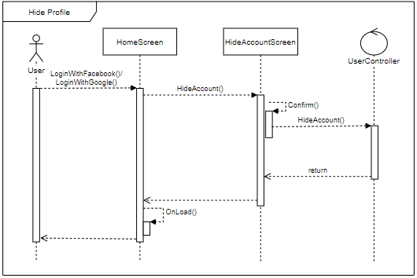

Figure 41 – Hide profile sequence diagram

### 4.5.11. Edit user’s profile

**\* Edit pet’s profile class diagram**

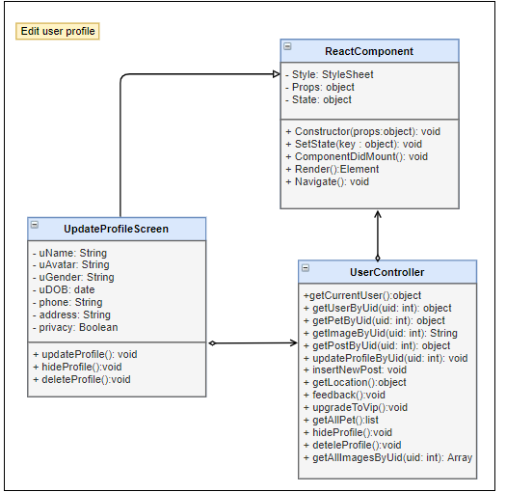

Figure 42 – Edit user’s pet class diagram

|  |  |  |  |  |  |
| --- | --- | --- | --- | --- | --- |
| **Name** | UserController | | | **Type** | Class |
| **Description** | Controller class to control Matching and some functions relative. | | | | |
| **Attributes** | | | | | |
| **Name** | **Type** | **Visibility** | **Description** | | |
|  |  |  |  | | |
| **Operations** | | | | | |
| **Name** | **Type** | **Visibility** | **Description** | | |
| getCurrentUser() | object | public | Get all information of user, which did login | | |
| getPetByPid(pID) | object | public | Get information of Pet with  PetID | | |
| getImageByUid(()) | String | public | Select image form database by Uid | | |
| updateProfileByUid() | void | public | Update detail of user profile | | |
| getLocation() | object | public | Get location( latitude and longitude) of user | | |
| upgradeToVip() | void | public | Update user role to Vip user | | |
| getAllPet() | list | public | Get all information of list pet Pet  For this user | | |
| deteleProfile() | void | public | Delete physical all of information for this user profile | | |
| getAllImagesByUid() | Array | public | Get list of image User has | | |

|  |  |  |  |  |  |
| --- | --- | --- | --- | --- | --- |
| **Name** | Update profile Screen | | | **Type** | Class |
| **Description** | Screen update information of user profile | | | | |
| **Attributes** | | | | | |
| **Name** | **Type** | **Visibility** | **Description** | | |
| uName | String | private | User name | | |
| uAvatar | String | private | User’s Avatar | | |
| uGender | String | private | User’s gender | | |
| uDOB | date | private | User’s date of birth | | |
| phone | String | private | User’s phone numbers | | |
| address | String | private | User’s address | | |
| privacy | Boolean | private | User’s privacy | | |
|  |  |  |  | | |
| **Operations** | | | | | |
| **Name** | **Type** | **Visibility** | **Description** | | |
| updateProfile | void | Public | Update user profile | | |
|  |  |  |  | | |

**\* Edit user’s profile sequence diagram**

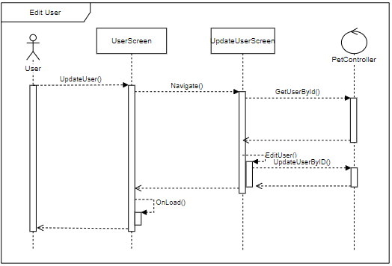

Figure 43 – Edit user’s profile sequence diagram

### 4.5.12. Delete user’s profile

**\* Delete user’s profile class diagram**

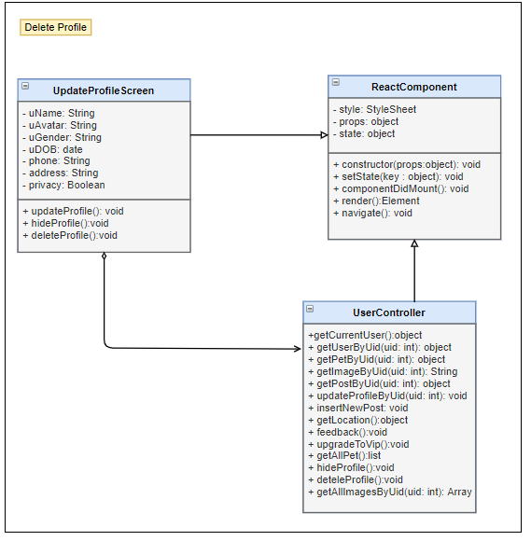

Figure 44 – Delete user’s profile class diagram

|  |  |  |  |  |  |
| --- | --- | --- | --- | --- | --- |
| **Name** | UserController | | | **Type** | Class |
| **Description** | Controller class to control Matching and some functions relative. | | | | |
| **Attributes** | | | | | |
| **Name** | **Type** | **Visibility** | **Description** | | |
|  |  |  |  | | |
| **Operations** | | | | | |
| **Name** | **Type** | **Visibility** | **Description** | | |
| getCurrentUser() | object | public | Get all information of user, which did login | | |
| getImageByUid(()) | String | public | Select image form database by Uid | | |
| updateProfileByUid() | void | public | Update detail of user profile | | |
| getLocation() | object | public | Get location( latitude and longitude) of user | | |
| deteleProfile() | void | public | Delete physical all of information for this user profile | | |
| getAllImagesByUid() | Array | public | Get list of image User has | | |

|  |  |  |  |  |  |
| --- | --- | --- | --- | --- | --- |
| **Name** | Update profile Screen | | | **Type** | Class |
| **Description** | Screen update information of user profile | | | | |
| **Attributes** | | | | | |
| **Name** | **Type** | **Visibility** | **Description** | | |
| uName | String | private | User name | | |
| uAvatar | String | private | User’s Avatar | | |
| uGender | String | private | User’s gender | | |
| uDOB | date | private | User’s date of birth | | |
| phone | String | private | User’s phone numbers | | |
| address | String | private | User’s address | | |
| privacy | Boolean | private | User’s privacy | | |
|  |  |  |  | | |
| **Operations** | | | | | |
| **Name** | **Type** | **Visibility** | **Description** | | |
| deleteProfile() | void | Public | Delete user profile | | |
|  |  |  |  | | |

**\* Delete user’s profile sequence diagram**

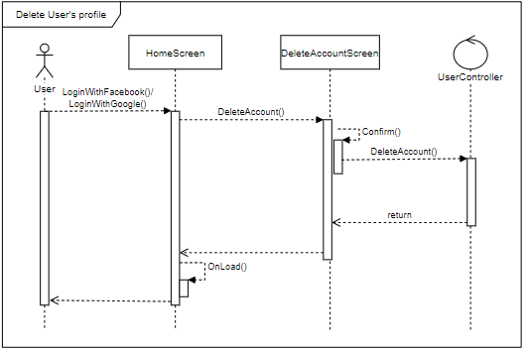

Figure 45 – Delete user’s profile sequence diagram

### 4.5.13. Create new pet

**\* Create new pet class diagram**

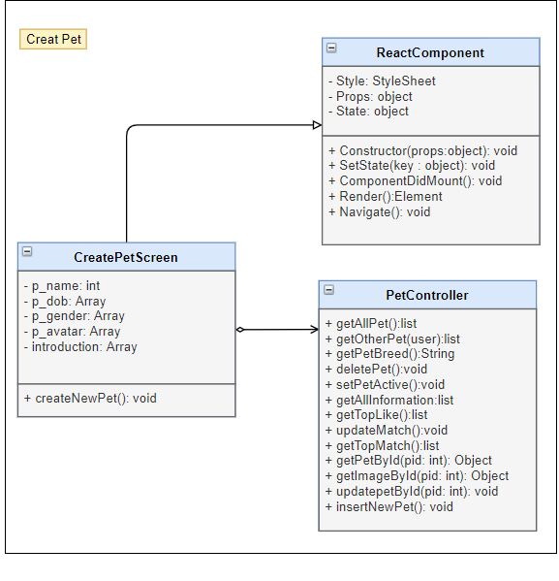

Figure 46 – Create new pet class diagram

|  |  |  |  |  |  |
| --- | --- | --- | --- | --- | --- |
| **Name** | PetController | | | **Type** | Class |
| **Description** | Controller class to control Pet and some functions relative. | | | | |
| **Attributes** | | | | | |
| **Name** | **Type** | **Visibility** | **Description** | | |
|  |  |  |  | | |
| **Operations** | | | | | |
| **Name** | **Type** | **Visibility** | **Description** | | |
| getAllPet | list | Public | Get list all of pet belong to this user | | |
| getPetBreed | String | Public | Get pet breed for pet | | |
| setPetActive | void | Public | Set a pet is active to match | | |
| getAllInformation | list | Public | Get all information of pet on list pet | | |
| getPetById(pid: int) | Object | Public | Get Pet by PetID | | |
| getImageById(pid: int) | Object | Public | Get all image by petID | | |
| insertNewPet() | void | Public | Create a new pet | | |

|  |  |  |  |  |  |
| --- | --- | --- | --- | --- | --- |
| **Name** | CreatePetScreen | | | **Type** | Class |
| **Description** | Screen create pet | | | | |
| **Attributes** | | | | | |
| **Name** | **Type** | **Visibility** | **Description** | | |
| p_name | String | private | Name of pet | | |
| p_dob | date | private | Pet’s date of birth | | |
| p_gender | String | private | Pet’s gender | | |
| p_avatar | String | private | Pet’s avatar | | |
| Introduction | String | Private | Pet’s introduction | | |
|  |  |  |  | | |
| **Operations** | | | | | |
| **Name** | **Type** | **Visibility** | **Description** | | |
| createNewPet() | void | public | Create new pet of user login | | |
|  |  |  |  | | |

**\* Create new pet sequence diagram**

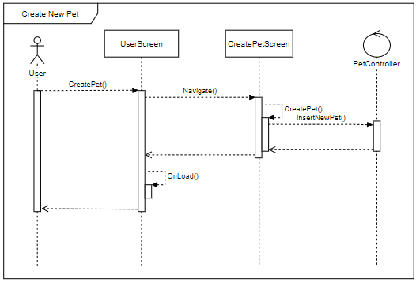

Figure 47 – Create new pet sequence diagram

### 4.5.14. Edit pet’s profile

**\* Edit pet’s profile class diagram**

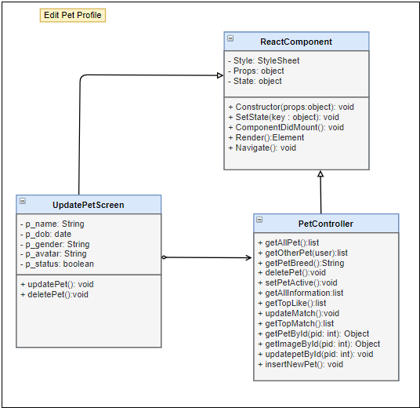

Figure 48 – Edit pet’s profile class diagram

|  |  |  |  |  |  |
| --- | --- | --- | --- | --- | --- |
| **Name** | PetController | | | **Type** | Class |
| **Description** | Controller class to control Pet and some functions relative. | | | | |
| **Attributes** | | | | | |
| **Name** | **Type** | **Visibility** | **Description** | | |
|  |  |  |  | | |
| **Operations** | | | | | |
| **Name** | **Type** | **Visibility** | **Description** | | |
| getAllPet | list | public | Get list all of pet belong to this user | | |
| getOtherPet(user) | list | public | Get list all of Pet by userID | | |
| getPetBreed | String | public | Get pet breed for pet | | |
| setPetActive | void | public | Set a pet is active to match | | |
| getAllInformation | list | public | Get all information of pet on list pet | | |
| getPetById(pid: int) | Object | public | Get Pet by PetID | | |
| getImageById(pid: int) | Object | public | Get all image by petID | | |
| updatepetById(pid: int) | void | public | Update Pet by petID | | |

|  |  |  |  |  |  |
| --- | --- | --- | --- | --- | --- |
| **Name** | UpdatePetScreen | | | **Type** | Class |
| **Description** | Screen update pet’s information | | | | |
| **Attributes** | | | | | |
| **Name** | **Type** | **Visibility** | **Description** | | |
| p_name | String | private | Name of pet | | |
| p_dob | date | private | Pet’s date of birth | | |
| p_gender | String | private | Pet’s gender | | |
| p_avatar | String | private | Pet’s avata | | |
| p_status | boolean | private | Pet’s status | | |
|  |  |  |  | | |
| **Operations** | | | | | |
| **Name** | **Type** | **Visibility** | **Description** | | |
| updatePet() | void | public | Update pet function | | |
|  |  |  |  | | |

**\* Edit pet’s profile sequence diagram**

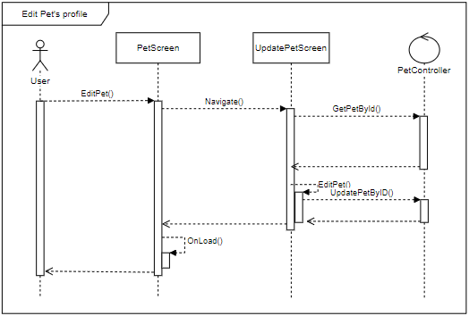

Figure 49 – Edit pet’s profile sequence diagram

### 4.5.15. Delete pet’s profile

**\* Delete pet’s profile class diagram**

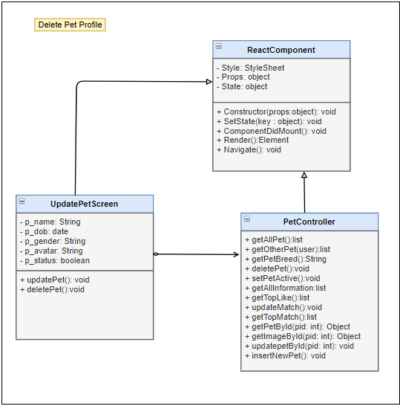

Figure 50 – Delete pet’s class diagram

|  |  |  |  |  |  |
| --- | --- | --- | --- | --- | --- |
| **Name** | PetController | | | **Type** | Class |
| **Description** | Controller class to control Pet and some functions relative. | | | | |
| **Attributes** | | | | | |
| **Name** | **Type** | **Visibility** | **Description** | | |
|  |  |  |  | | |
| **Operations** | | | | | |
| **Name** | **Type** | **Visibility** | **Description** | | |
| getAllPet | list | public | Get list all of pet belong to this user | | |
| getOtherPet(user) | list | public | Get list all of Pet by userID | | |
| getPetBreed | String | public | Get pet breed for pet | | |
| deletePet | void | public | Delete a pet in list pets | | |
| setPetActive | void | public | Set a pet is active to match | | |
| getAllInformation | list | public | Get all information of pet on list pet | | |
| getPetById(pid: int) | Object | public | Get Pet by PetID | | |
| getImageById(pid: int) | Object | public | Get all image by petID | | |

|  |  |  |  |  |  |
| --- | --- | --- | --- | --- | --- |
| **Name** | UpdatePetScreen | | | **Type** | Class |
| **Description** | Screen update pet’s information | | | | |
| **Attributes** | | | | | |
| **Name** | **Type** | **Visibility** | **Description** | | |
| p_name | String | private | Name of pet | | |
| p_dob | date | private | Pet’s date of birth | | |
| p_gender | String | private | Pet’s gender | | |
| p_avatar | String | private | Pet’s avata | | |
| p_status | boolean | private | Pet’s status | | |
|  |  |  |  | | |
| **Operations** | | | | | |
| **Name** | **Type** | **Visibility** | **Description** | | |
| deletePet() | void | public | Delete pet function | | |
|  |  |  |  | | |

**\* Delete pet’s profile sequence diagram**

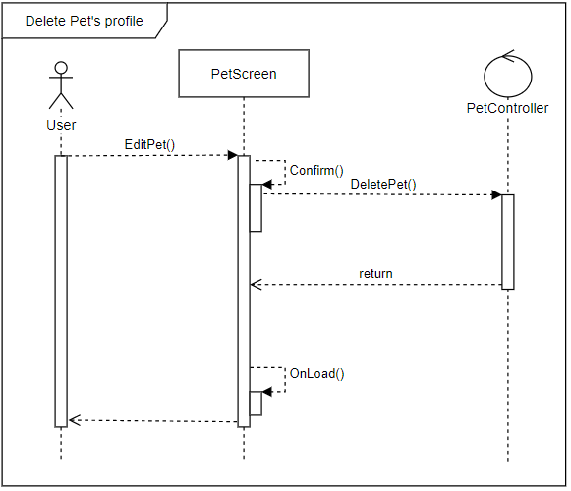

Figure 51 – Delete pet’s profile sequence diagram

### 4.5.16. Find

**\* Find class diagram**

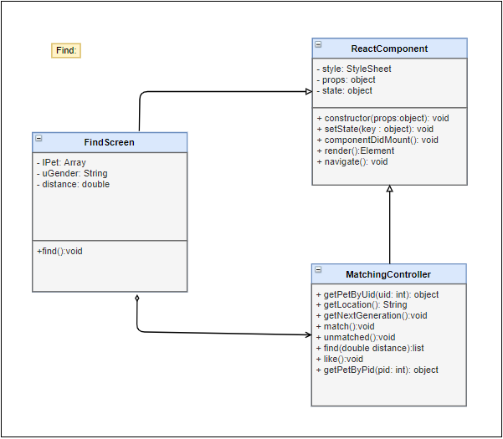

Figure 52 – Find class diagram

|  |  |  |  |  |  |
| --- | --- | --- | --- | --- | --- |
| **Name** | MatchingController | | | **Type** | Class |
| **Description** | Controller class to control User and some functions relative. | | | | |
| **Attributes** | | | | | |
| **Name** | **Type** | **Visibility** | **Description** | | |
|  |  |  |  | | |
| **Operations** | | | | | |
| **Name** | **Type** | **Visibility** | **Description** | | |
| getPetByUid (id) | object | public | Get Information of list pet with UserId in database | | |
| getLocation () | void | public | Get real location of user | | |
| find(double distance) | list | public | find user around with distance | | |
| like() | void | public | Reaction a pet to rankking or show | | |
| getPetByPid(pid: int) | object | public | Get Information of pet with PetId in database | | |

|  |  |  |  |  |  |
| --- | --- | --- | --- | --- | --- |
| **Name** | FindScreen | | | **Type** | Class |
| **Description** | Screen provide Find pet/user feature | | | | |
| **Attributes** | | | | | |
| **Name** | **Type** | **Visibility** | **Description** | | |
| lPet | Array | private | List of pet result | | |
| uGender | String | private | User gender | | |
| distance | double | private | Distance device to other users | | |
|  |  |  |  | | |
| **Operations** | | | | | |
| **Name** | **Type** | **Visibility** | **Description** | | |
| find() | void | public | Find user/pet around device | | |
|  |  |  |  | | |

**\* Find sequence diagram**

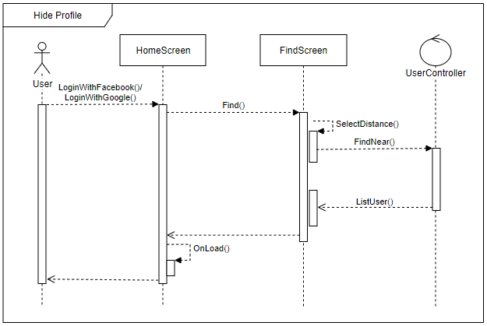

Figure 53 – Find sequence diagram

### 4.5.17. Get next generation pet

**\* Get new generation class diagram**

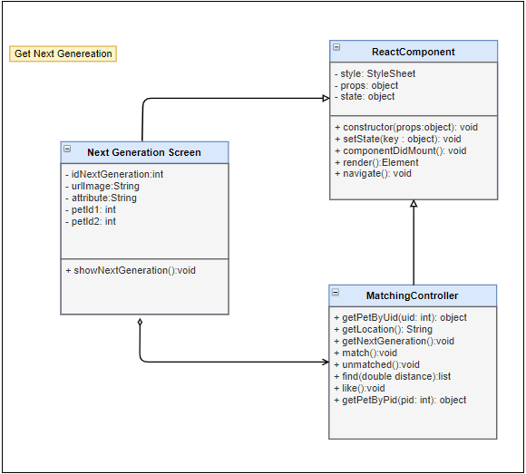

Figure 54 – Get next generation pet class diagram

|  |  |  |  |  |  |
| --- | --- | --- | --- | --- | --- |
| **Name** | MatchingController | | | **Type** | Class |
| **Description** | Controller class to control User and some functions relative. | | | | |
| **Attributes** | | | | | |
| **Name** | **Type** | **Visibility** | **Description** | | |
|  |  |  |  | | |
| **Operations** | | | | | |
| **Name** | **Type** | **Visibility** | **Description** | | |
| getPetByUid (id) | object | public | Get Information of list pet with UserId in database | | |
| getLocation () | void | public | Get real location of user | | |
| getNextGeneration() | void | public | Get new baby pet for 2 parent pets | | |
| find(double distance) | list | public | find user around with distance | | |
| getPetByPid(pid: int) | object | public | Get Information of pet with PetId in database | | |

|  |  |  |  |  |  |
| --- | --- | --- | --- | --- | --- |
| **Name** |  | | | **Type** | Class |
| **Description** |  | | | | |
| **Attributes** | | | | | |
| **Name** | **Type** | **Visibility** | **Description** | | |
| idNextGeneration | int | private | Id of pet is next generation | | |
| urlImage | String | private | url Image of pet is next generation | | |
| attribute | String | private | Attribute of next generation | | |
| petId1 | int | private | Id of parent | | |
| petId2 | int | private | Id of parent | | |
|  |  |  |  | | |
| **Operations** | | | | | |
| **Name** | **Type** | **Visibility** | **Description** | | |
| showNextGeneration() | void | public | Show image pet is next generation | | |
|  |  |  |  | | |

**\* Get new generation sequence diagram**

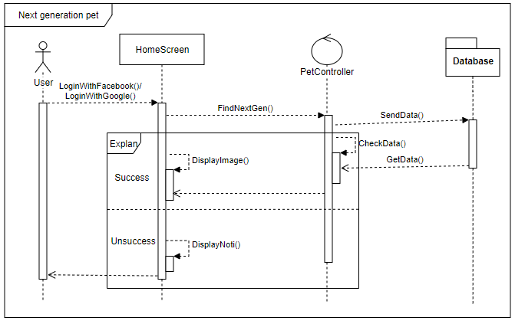

Figure 55 – Get new generation pet sequence diagram

### 4.5.18. Login/Logout for Admin

**\* Login/Logout for Admin** **class diagram**

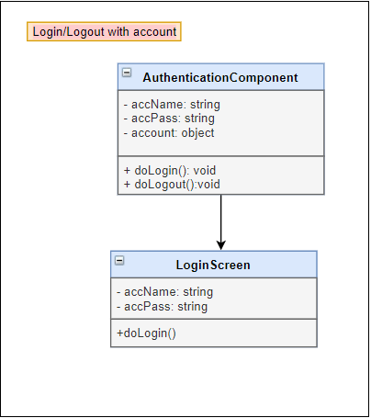

Figure 56 – Login/Logout with account

|  |  |  |  |  |  |
| --- | --- | --- | --- | --- | --- |
| **Name** | AuthenticationComponent | | | **Type** | Class |
| **Description** | Authentication controller for admin | | | | |
| **Attributes** | | | | | |
| **Name** | **Type** | **Visibility** | **Description** | | |
| accName | String | private | User name | | |
| accPass | String | private | Password | | |
| account | object | private | Account and all of it’s information | | |
|  |  |  |  | | |
| **Operations** | | | | | |
| **Name** | **Type** | **Visibility** | **Description** | | |
| doLogin() | void | public | Login function | | |
| doLoout() | void | public | Logout function | | |

|  |  |  |  |  |  |
| --- | --- | --- | --- | --- | --- |
| **Name** | LoginScreen | | | **Type** | Class |
| **Description** | Screen login for admin | | | | |
| **Attributes** | | | | | |
| **Name** | **Type** | **Visibility** | **Description** | | |
| accName | String | private | User name | | |
| accPass | String | private | Password | | |
|  |  |  |  | | |
| **Operations** | | | | | |
| **Name** | **Type** | **Visibility** | **Description** | | |
| doLogin | void | public | Login function | | |
|  |  |  |  | | |

**\* Login/Logout for Admin** **sequence diagram**

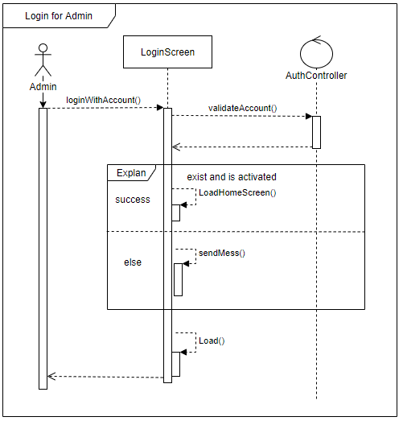

Figure 57 – Login for Admin sequence diagram

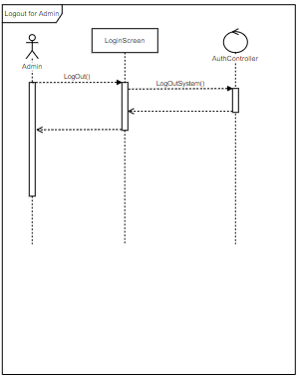

Figure 58 – Logout for Admin sequence diagram

### 4.5.20. Enable/Disable Account for Admin

**\* Enable/Disable account class diagram**

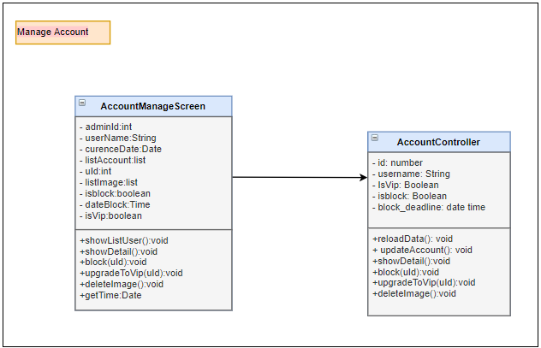

Figure 59 – Enable/Disable Account for Admin class diagram

|  |  |  |  |  |  |
| --- | --- | --- | --- | --- | --- |
| **Name** | AccountController | | | **Type** | Class |
| **Description** | Controller control user account | | | | |
| **Attributes** | | | | | |
| **Name** | **Type** | **Visibility** | **Description** | | |
| Id | Int | private | Id of user account | | |
| userName | String | private | User name of user | | |
| isVip | Boolean | private | Vip attribute of user | | |
| isBlock | Boolean | private | User blocked or not | | |
| block_deadline | date | private | Time block | | |
|  |  |  |  | | |
| **Operations** | | | | | |
| **Name** | **Type** | **Visibility** | **Description** | | |
| reloadData() | void | public | Reload data on screen | | |
| updateAccount() | void | public | Update information of account | | |
| showDetail() | void | public | Show detail information | | |
| Block(uID) | void | public | Block user | | |
| upgradeToVip(uID) | void | public | Upgrade user to Vip | | |
| deleteImage() | void | public | Delete image | | |
|  |  |  |  | | |

|  |  |  |  |  |  |
| --- | --- | --- | --- | --- | --- |
| **Name** | AccountManageScreen | | | **Type** | Class |
| **Description** | Screen manage account | | | | |
| **Attributes** | | | | | |
| **Name** | **Type** | **Visibility** | **Description** | | |
| admintId | int | private | Admin id | | |
| userName | String | private | Username of user account | | |
| curenceDate | Date | private | Currence date | | |
| listAccount | list | private | List account of users | | |
| uId | int | private | User id | | |
| listImage | list | private | List image | | |
| isblock | boolean | private | User is blocked | | |
| dateBlock | Time | private | Time block | | |
| isVip | boolean | private | User is vip | | |
|  |  |  |  | | |
| **Operations** | | | | | |
| **Name** | **Type** | **Visibility** | **Description** | | |
| showListUser() | void | public | Show list account of users | | |
| showDetail() | void | public | Show detail informaiton of account | | |
| block(uId) | void | public | Block user | | |
| upgradeToVip(uId) | void | public | Upgrade user to vip | | |
| deleteImage() | void | public | Delete image | | |
| getTime() | Date | public | Get currence time | | |

**\* Enable/Disable account sequence diagram**

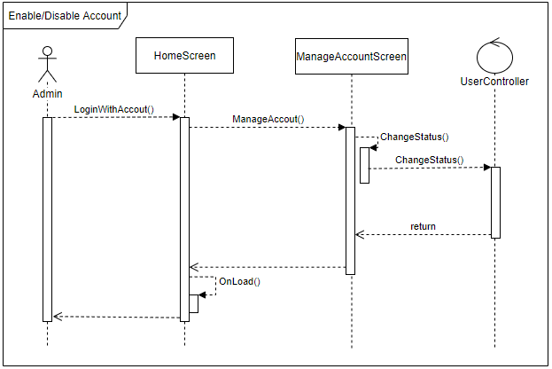

Figure 60 – Enable/Disable Account for Admin sequence diagram

### 4.5.22. Delete Images for Admin

**\* Delete Image class diagram**



Figure 61 – Delete Images for Admin class diagram

|  |  |  |  |  |  |
| --- | --- | --- | --- | --- | --- |
| **Name** | AccountController | | | **Type** | Class |
| **Description** | Controller control user account | | | | |
| **Attributes** | | | | | |
| **Name** | **Type** | **Visibility** | **Description** | | |
| Id | Int | private | Id of user account | | |
| userName | String | private | User name of user | | |
| isVip | Boolean | private | Vip attribute of user | | |
| isBlock | Boolean | private | User blocked or not | | |
| block_deadline | date | private | Time block | | |
|  |  |  |  | | |
| **Operations** | | | | | |
| **Name** | **Type** | **Visibility** | **Description** | | |
| deleteImage() | void | public | Delete image | | |
|  |  |  |  | | |

|  |  |  |  |  |  |
| --- | --- | --- | --- | --- | --- |
| **Name** | AccountManageScreen | | | **Type** | Class |
| **Description** | Screen manage account | | | | |
| **Attributes** | | | | | |
| **Name** | **Type** | **Visibility** | **Description** | | |
| admintId | int | private | Admin id | | |
| userName | String | private | Username of user account | | |
| curenceDate | Date | private | Currence date | | |
| listAccount | list | private | List account of users | | |
| uId | int | private | User id | | |
| listImage | list | private | List image | | |
| isblock | boolean | private | User is blocked | | |
| dateBlock | Time | private | Time block | | |
| isVip | boolean | private | User is vip | | |
|  |  |  |  | | |
| **Operations** | | | | | |
| **Name** | **Type** | **Visibility** | **Description** | | |
| deleteImage() | void | public | Delete image | | |
| getTime() | Date | public | Get currence time | | |
|  |  |  |  | | |

**\* Delete Image sequence diagram**

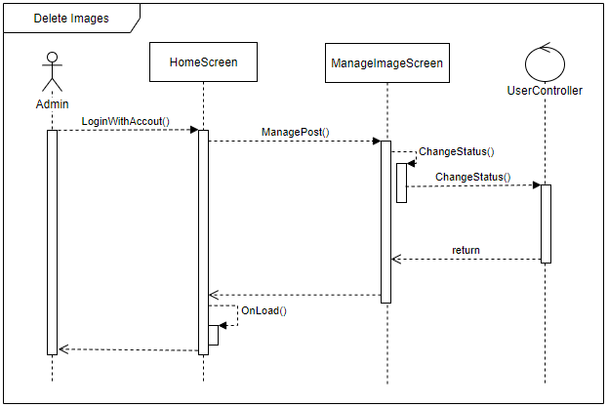

Figure 62 – Delete Images for Admin sequence diagram

### 4.5.23. Manage system for Admin

**\* Manage system class diagram**

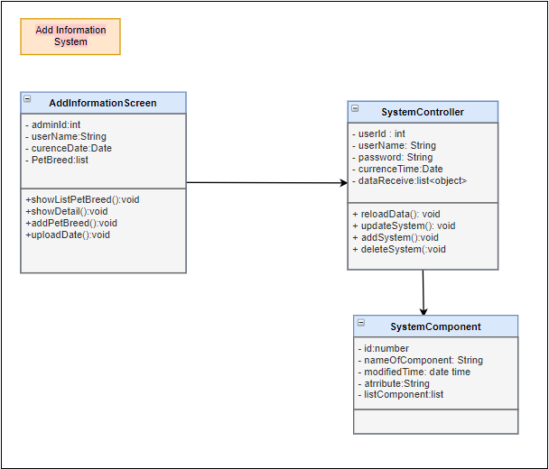

Figure 61 – Manage system for Admin class diagram

|  |  |  |  |  |  |
| --- | --- | --- | --- | --- | --- |
| **Name** | SystemController | | | **Type** | Class |
| **Description** | Controller control system information | | | | |
| **Attributes** | | | | | |
| **Name** | **Type** | **Visibility** | **Description** | | |
| userId | int | private | admin id | | |
| userName | String | private | Admin username | | |
| password | String | private | Admin password | | |
| currenceTime | Date | private | Currence time | | |
| dataReceive:list | list | private | Data receive | | |
|  |  |  |  | | |
| **Operations** | | | | | |
| **Name** | **Type** | **Visibility** | **Description** | | |
| reloadData | void | public | Reload data | | |
| updateSystem | void | public | Update information | | |
| addSystem | void | public | Add information | | |
| deleteSystem | void | public | Delete information | | |
|  |  |  |  | | |

|  |  |  |  |  |  |
| --- | --- | --- | --- | --- | --- |
| **Name** | SystemComponent | | | **Type** | Class |
| **Description** | Entity of system | | | | |
| **Attributes** | | | | | |
| **Name** | **Type** | **Visibility** | **Description** | | |
| id | int | private | Id of component | | |
| nameOfComponent | String | private | Name of component | | |
| modifiedTime | date | private | currence time | | |
| atrribute:String | String | private | Attribute of component | | |
| listComponent | list | private | List component | | |
|  |  |  |  | | |
| **Operations** | | | | | |
| **Name** | **Type** | **Visibility** | **Description** | | |
|  |  |  |  | | |
|  |  |  |  | | |

|  |  |  |  |  |  |
| --- | --- | --- | --- | --- | --- |
| **Name** | AddInformationScreen | | | **Type** | Class |
| **Description** | Add Information Screen | | | | |
| **Attributes** | | | | | |
| **Name** | **Type** | **Visibility** | **Description** | | |
| adminId | int | private | Admin id | | |
| userName | String | private | Username of admin account | | |
| curenceDate | Date | private | Curence date | | |
| PetBreed | list | private | List Pet breed | | |
|  |  |  |  | | |
| **Operations** | | | | | |
| **Name** | **Type** | **Visibility** | **Description** | | |
| showListPetBreed | void | public | Show list pet breed | | |
| showDetail | void | public | Show detail of pet breed | | |
| addPetBreed | void | public | Add pet breed | | |
| uploadDate | void | public | Upload date | | |
|  |  |  |  | | |

**\* Manage system sequence diagram**

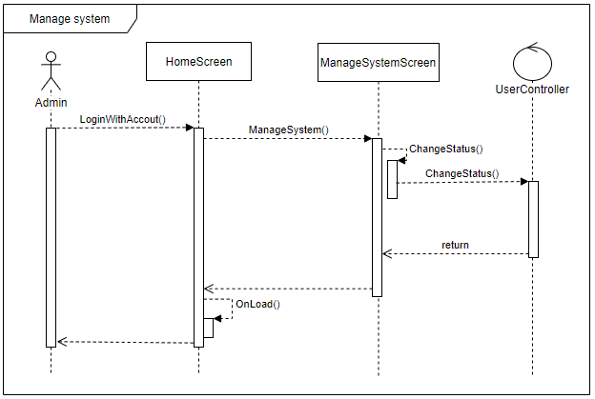

Figure 62 – Manage system for Admin sequence diagram

### 4.5.24. Receive Feedback for Admin

**\* Receive Feedback class diagram**

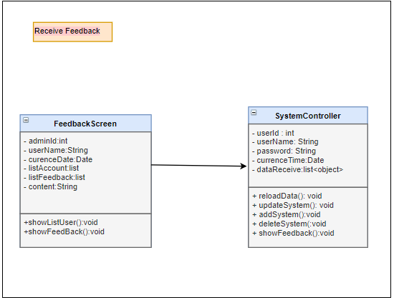

Figure 63 – Receive Feedback class diagram

|  |  |  |  |  |  |
| --- | --- | --- | --- | --- | --- |
| **Name** | SystemController | | | **Type** | Class |
| **Description** | Controller control system information | | | | |
| **Attributes** | | | | | |
| **Name** | **Type** | **Visibility** | **Description** | | |
| userId | int | private | admin id | | |
| userName | String | private | Admin username | | |
| password | String | private | Admin password | | |
| currenceTime | Date | private | Currence time | | |
| dataReceive:list | list | private | Data receive | | |
|  |  |  |  | | |
| **Operations** | | | | | |
| **Name** | **Type** | **Visibility** | **Description** | | |
| reloadData | void | public | Reload data | | |
| updateSystem | void | public | Update information | | |
| addSystem | void | public | Add information | | |
| deleteSystem | void | public | Delete information | | |
|  |  |  |  | | |

|  |  |  |  |  |  |
| --- | --- | --- | --- | --- | --- |
| **Name** | FeedbackScreen | | | **Type** | Class |
| **Description** | Show all of feedback from user | | | | |
| **Attributes** | | | | | |
| **Name** | **Type** | **Visibility** | **Description** | | |
| adminId | int | private | Id of admin | | |
| userName | String | private | User name of admin account | | |
| curenceDate | Date | private | Currence date | | |
| listAccount | List | private | List all of account write feedback | | |
| listFeedback | List | private | List all of feedback | | |
| content | String | private | Content of each feedback | | |
|  |  |  |  | | |
| **Operations** | | | | | |
| **Name** | **Type** | **Visibility** | **Description** | | |
| showListUser() | Void | Public | Show list user feedback | | |
| showFeedback() | void | public | Show list feedback | | |
|  |  |  |  | | |

**\* Receive Feedback sequence diagram**

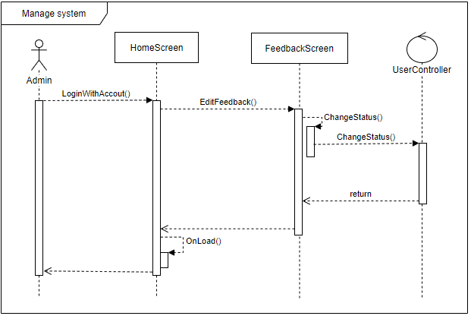

Figure 64 – Receive Feedback for Admin sequence diagram

# CHAPTER 5: Software Testing Document

## 5.1. Introduction

### 5.1.1. Purpose

The primary purpose of this chapter is the process to check whether the software is defect-free or not. It is the process of verification and validation of software service or application by checking whether it is meeting the user requirements and what all is implemented as per the characteristics. Software testing plays a vital role in the process of developing a high quality software. Testing is necessary because we all make mistakes. Some of those mistakes are unimportant but some of them are expensive and dangerous. It contains the following sections:

* Scope of Testing
* Testing Tool and Environment
* Resources and responsibilities
* Test strategy: Test approach, test stage
* Test schedule
* Feature to be tested
* Feature not to be tested
* Defect Log
* Test report

### 5.1.2. Scope of testing

* There are four main stages of testing that need to be completed before a program can be cleared for use: unit testing, integration testing, system testing, and acceptance testing.

|  |  |  |
| --- | --- | --- |
| ID | Test Stages | Description |
| 1 | Unit testing | During this first round of testing, the program is submitted to assessments that focus on specific units or components of the software to determine whether each one is fully functional. The main aim of this endeavor is to determine whether the application functions as designed. In this phase, a unit can refer to a function, individual program or even a procedure, and a White-box Testing method is usually used to get the job done. One of the biggest benefits of this testing phase is that it can be run every time a piece of code is changed, allowing issues to be resolved as quickly as possible. It’s quite common for software developers to perform unit tests before delivering software to testers for formal testing. |
| 2 | Integration testing | Integration testing allows individuals the opportunity to combine all of the units within a program and test them as a group. This testing level is designed to find interface defects between the modules/functions. This is particularly beneficial because it determines how efficiently the units are running together. Keep in mind that no matter how efficiently each unit is running, if they aren’t properly integrated, it will affect the functionality of the software program. In order to run these types of tests, individuals can make use of various testing methods, but the specific method that will be used to get the job done will depend greatly on the way in which the units are defined. |
| 3 | System testing | System testing is the first level in which the complete application is tested as a whole. The goal at this level is to evaluate whether the system has complied with all of the outlined requirements and to see that it meets Quality Standards. System testing is undertaken by independent testers who haven’t played a role in developing the program. This testing is performed in an environment that closely mirrors production. System Testing is very important because it verifies that the application meets the technical, functional, and business requirements that were set by the customer. |
| 4 | Acceptance testing | The final level, Acceptance testing (or User Acceptance Testing), is conducted to determine whether the system is ready for release. During the Software development life cycle, requirements changes can sometimes be misinterpreted in a fashion that does not meet the intended needs of the users. During this final phase, the user will test the system to find out whether the application meets their business’ needs. Once this process has been completed and the software has passed, the program will then be delivered to production. |

* Type of testing

The following type of testing is used in this project are:

* + GUI test
  + Function test
  + Regression test
  + Acceptance test include alpha test
  + Unit test

### 5.1.3. Range of testing

Team performs all functions defined in the SRS based on the approved version.

## 5.2. Test plan

### 5.2.1. Testing Tools and Environment

#### 5.2.1.1. Testing tools

* **Front-end and Project Testing**
  + Chrome Developer Tool: To view logs.
  + Trello: Manage bug.
  + Microsoft Excel, Git: Manage testcase
* **API testing**
  + PostMan: to manage the list of all APIs and manually test APIs’ result
* **Unit test**
  + Jest: Unit test for JavaScripts
* **UI testing**
  + React-Native-CLI client: View app when development

#### 5.2.1.2. Testing environment

* **Device 1: Laptop Dell** 
  + CPU: i7 7300hq
  + Ram: 8gb
  + Gpu: gtx1050ti
* **Device 2: Laptop HP**
  + CPU: i7 10510U
  + Ram: 8gb
  + Gpu: Geforce MX250
* **Device 3: Laptop Asus**
  + CPU: i7 9750H
  + Ram: 8gb
  + Gpu: GTX1650
* **Other device: Mobile phone**
  + OPPO F7
  + Samsung Galaxy A21s
  + Samsung Galaxy A80
  + OPPO A52

### 5.2.2. Resources and Responsibilities

|  |  |  |
| --- | --- | --- |
| ID | Resources | Responsibilities |
| 1 | Project Manager | - Responsible for project schedule and overall success of the project  - Review test-case and report |
| 2 | Tester | - Preforming the actual system testing  - Manage test resource and assign test tasks  - Create test plan  - Create test cases  - Create test report  - Execute test  - Test log report |
| 3 | Developer | - Create unit test and integration test scripts  - Fix bugs |

### 5.2.3. Test Strategy

#### 5.2.3.1. Test Model

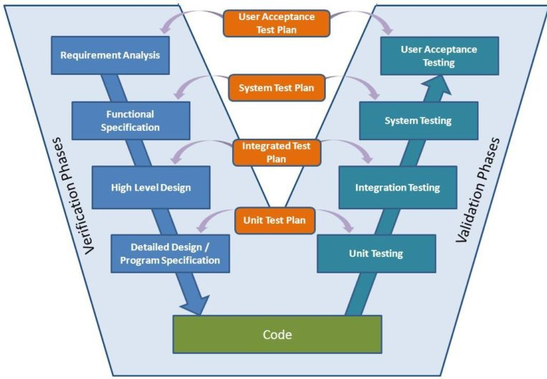

Figure 65 - V-model

Overall, we choose V-Model to implement testing process. With V-Model, software development is separated into two appropriate phase’s groups: development and testing. In this model, the verification and validation will be done side by side. It emphasizes the strict process flow to develop a quality product. The errors occurred in any phase will be corrected in that phase. Proactive defect tracking defects, which are found at early stages even, may be in the development phase before application being tested.

Pet Dating API has 2 levels of test:

* Unit testing: Automation tests that cover logic of Models and Libraries
* API testing: Automation tests that involve testing APIs directly (in isolation) to determine whether APIs return the correct response (in the expected format) for a broad range of feasible requests, react properly to edge cases such as failures and unexpected/extreme inputs.
* Pet Dating Front-end works mostly with GUI instead of logic and it depends on Pet Dating API, so that Pet Dating Front-end apply system testing which coverage of whole Pet Dating system.

#### 5.2.3.2. Test types

The following type of testing is used in this project are:

* + - Unit test:

**UNIT TESTING** is a level of software testing where individual units/ components of a software are tested. The purpose is to validate that each unit of the software performs as designed. A unit is the smallest testable part of any software. It usually has one or a few inputs and usually a single output. In procedural programming, a unit may be an individual program, function, procedure, etc. In object-oriented programming, the smallest unit is a method, which may belong to a base/ super class, abstract class or derived/ child class.

* Unit test also includes database testing to verify constraint, transaction, default value, data types, data format, and check null and junk characters which are mentioned in database design and software requirement.
* Test case will have to cover all logic branch that function or method could execute with difference data input. Another alternative logic branch should be covered if not, that logic branch should be detected at API testing level.
* Implemented function's error message and database error message will be included in this test.
  + - API test:

**API TESTING** is a software testing type that validates Application Programming Interfaces (APIs). The purpose of API Testing is to check the functionality, reliability, performance, and security of the programming interfaces. In API Testing, instead of using standard user inputs (keyboard) and outputs, you use software to send calls to the API, get output, and note down the system's response. API tests are very different from GUI Tests and won't concentrate on the look and feel of an application. It mainly concentrates on the business logic layer of the software architecture.

* Involves testing APIs directly to determine if they meet expectations for functionality, reliability, performance, and security. API testing will test all of individual implemented API of PetDating API.
* Test case will verify constraint of data which be mention in Business rule
* Basically, almost all API test cases are executed as automation test. After that all API with standard sample datasets will be saved and confirmation tests will be executed by using Postman with developer's local database.
  + - UI test:

**Graphical User Interface testing** is mainly about ensuring that the UI functions in the right, an app follows its written specifications and that defects are identified. Other than that, we check that the design elements are good. This involves checking the screens with the controls like menu bars, toolbars, color, fonts, sizes, icons, content, buttons, etc. How do they respond to user input? GUI test will be performed fully on all screens.

* This test targets to cover the verification of the overall look and feel of the OCFU system including initial position, font, text size, color, focus, initial button, tab order, label, screen sizes and sentences width.
* Check all the GUI elements for size, position, width, length and acceptance of characters or numbers. For instance, it must be able to provide inputs to the input fields.
* Check if Error Messages are displayed correctly.
* Check if Font used in application is readable.
* Check if the alignment of the text is proper.
* Check if the Color of the font and warning messages is aesthetically pleasing.
* Check if images have good clarity.
* Check if images are properly aligned.
* Check the positioning of GUI elements for different screen resolution.
  + - Regression testing

**Regression Testing** is a type of testing that is done to verify that a code change in the software does not impact the existing functionality of the product. This is to make sure the product works fine with new functionality, bug fixes or any change in the existing feature. Previously executed test cases are re-executed in order to verify the impact of change.

* + - Acceptance testing
      * This test type will be executed by tester with designed test cases, acceptance test is a test type conducted to determine if the requirements of a specification or contract are met
      * It also includes alpha testing; alpha testing takes place at close relation user’s site and are free test to detect bug and strange behavior. By that, development team will improve UX and UI of system

#### 5.2.3.3. Test stage

The table below describes the stages in which common tests are executed:

|  |  |  |  |  |
| --- | --- | --- | --- | --- |
| Type of test | Stage of test | | | |
| Unit test | Integration test | System test | Acceptance test |
| Unit tests | x | x | x |  |
| API tests | x | x |  |  |
| UI tests |  |  | x | x |
| Regression tests | x | x | x | x |
| Acceptance tests |  |  | x | x |

#### 5.2.3.4. Test schedule

|  |  |  |  |
| --- | --- | --- | --- |
| Task | | Start date | End date |
| Phase 1 | Create test plan | 10/06/2010 | 11/06/2020 |
| Create and execute unit test | 12/06/2020 | 28/06/2020 |
| Create and execute integration test | 12/06/2020 | 28/06/2020 |
| Phase 2 | Create test plan | 30/06/2020 | 01/07/2020 |
| Create and execute unit test | 01/07/2020 | 28/07/2020 |
| Create and execute integration test | 03/07/2020 | 30/07/2020 |
| Phase 3 | Create test plan | 20/07/2020 | 21/07/2020 |
| Create and execute system test | 25/7/2020 | 22/08/2020 |
| Create and execute acceptance test | 28/07/2020 | 15/08/2020 |

#### 5.2.3.5. Deliverables

|  |  |  |  |
| --- | --- | --- | --- |
| No | Deliverables | Responsibilities | Delivered date |
| 1 | Test plan | Test Leader | 21/07/2020 |
| 2 | Unit test | Developer | 28/07/2020 |
| 3 | Integration test | Tester + Developer | 30/07/2020 |
| 4 | System test | Tester + Developer + PM | 12/08/2020 |
| 5 | Acceptance test | All member | 15/08/2020 |
| 6 | Defect logs | All member | 18/08/2020 |
| 7 | Final test summary report | Test Leader | 20/08/2020 |

### 5.2.4. Features to be tested

* All features that are listed in Requirement that application have.
* GUI of the Mobile application.

## 5.3. Test case

### 5.3.1. Unit test

Unit tests are done by the developers in order to test individual units, and approved by the test leader.

This is done to ensure that important functions, such as algorithms for verb conjugation and name conversion, return the correct values.

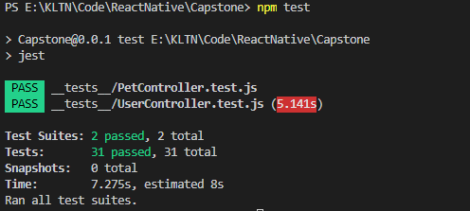

Figure 66 - Unit test with jest

### 5.3.2. System testing

Detail test cases will be described in **“Petdating_Test Case_ver01.xls”** file.

### 5.3.3. Acceptance test

Acceptance Testing is a level of the software testing process where a system is tested for acceptability. The purpose of this test is to evaluate the system's compliance with the business requirements and assess whether it is acceptable for delivery. But our project will use the Check Lists as a substitute for Acceptance testing.

The content of the Checklist is shown in the table below

|  |  |  |  |
| --- | --- | --- | --- |
| No | Checklist | Yes | No |
| General | | | |
| 1 | Text does not have grammatical and spelling errors. | √ |  |
| 2 | All buttons are functional. | √ |  |
| 3 | All mandatory fields are validated and indicated by asterisk (*) symbol. | √ |  |
| 4 | All error messages are displayed using red color. | √ |  |
| 5 | All "Delete" functions ask for confirmation. | √ |  |
| GUI and usability | | | |
| 6 | Screen design follows the standard of the project. | √ |  |
| 7 | Waiting icon appear for waiting display data. | √ |  |
| 8 | Color red is used for all error messages. | √ |  |
| 9 | Project state is displayed and colored with appropriate state | √ |  |
| 10 | Design style is friendly and easy to use | √ |  |
| 11 | The text easy to understand. Don't use slang, acronyms, and abbreviations. | √ |  |
| 12 | The static text is clear, concise, and meaningful. | √ |  |
| 13 | The screen designed to fit with multiple screen size. | √ |  |

### 5.3.4. Defect Log

Excel and GitHub are used to manage bugs:

* When a bug is found, testers change the status and assign for developer.
* Developers fix bugs and change status of bugs to resolve.
* If the bug is fixed then tester change the status to close, otherwise will be re-open again to fix.

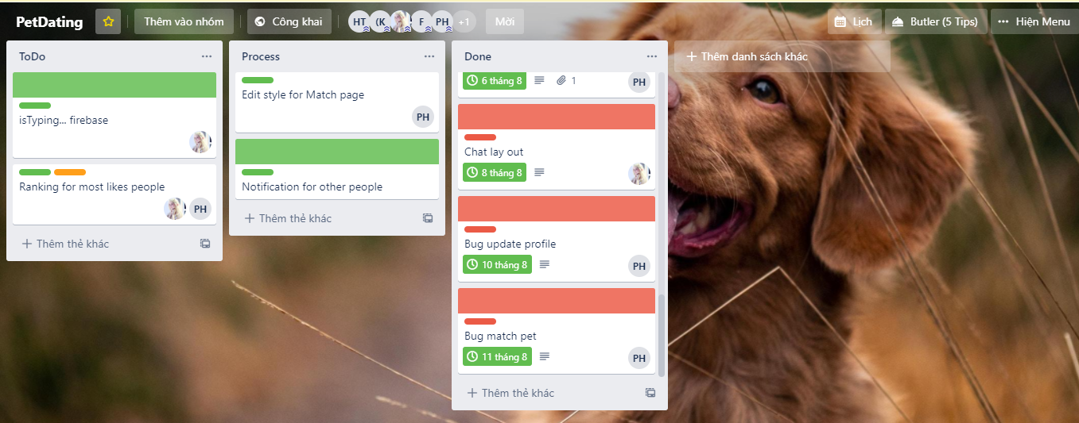

Figure 67 - Defect logs with Trello

## 5.4. Test Report

### 5.4.1. Unit test

|  |  |  |  |  |
| --- | --- | --- | --- | --- |
|  | Function Name | Number of test case (Estimate) | Pass | Fail |
| 1 | validateUser | 8 | 8 | 0 |
| 2 | convertToAge | 11 | 11 | 0 |
| 3 | ValidatePet | 12 | 12 | 0 |
| Total | | 31 | 31 | 0 |

### 5.4.2. Integration and system tests

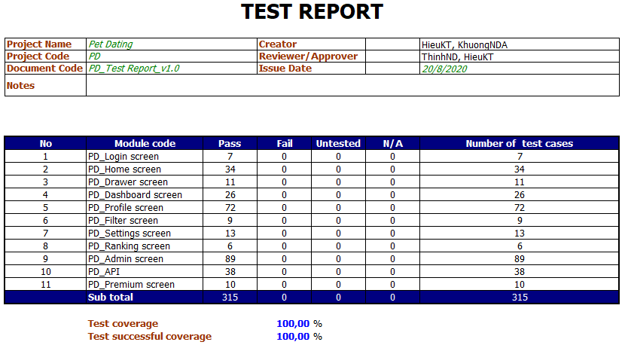

Figure 68 - Integration and system test report

# CHAPTER 6: USER MANUAL

## 6.1. Development and deployment guidelines

### 6.1.1. Development guideline

#### 6.1.1.1. Environment for development

☞ Laptop Dell Inprison

⮚ Integrated development environment:

• Visual Studio Code version 1.48.2

⮚ Node.js version 12.8.1

⮚ XAMPP 7.3.12

⮚ React-native-cli version 2.0.1

☞ Android Phone with Android 7.0

#### 6.1.1.2. Setup development environment

##### 6.1.1.2.1. Install Visual Studio Code

• Go to URL: <https://code.visualstudio.com/>, click on “Download” button, the Download page appears, choose the Windows package ( 32 bit or 64 bit, depends on the system ), the Save pop-up appears, click Save button to start download the installation file

Double click the file **“VSCodeUserSetup-x64-1.41.0.exe”** to start install Visual Studio Code



Figure 98 - Interface of Visual Studio Code

• Start using Visual Studio Code by opening it from Desktop

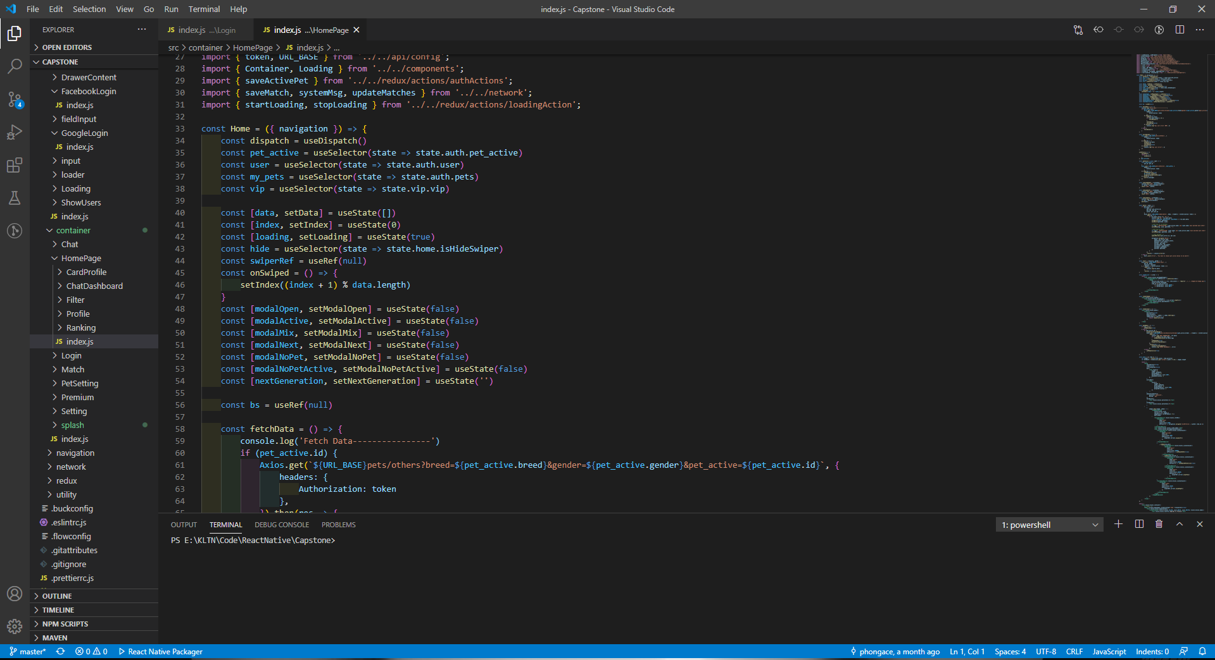

Figure 99 - Interface of Visual Studio Code

##### 6.1.1.2.2. Install Node.js version 12.8.1

• Go to URL:<https://nodejs.org/en/download/releases/>, choose the 12.8.1 version and click Download, the Index page of the corresponding version appears, choose the [node-v12.8.1-win-x64.zip](https://nodejs.org/download/release/v10.16.3/node-v10.16.3-win-x64.zip) hyperlink, the Save pop-up appears, click Save button to start download the installation folder.



Figure 100 - Nodejs setup folder

Extract the folder **“node-v12.8.1-win-x64.zip”**

• Open the folder, double click the file **“node.exe”** to start install Nodejs.

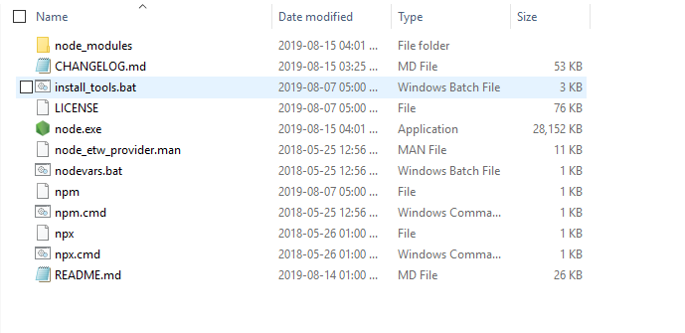

Figure 101 - Nodejs setup folder after extracting

• After the setup file running completely, check if Nodejs was installed successfully by opening Command Prompt and running the command “node -v”

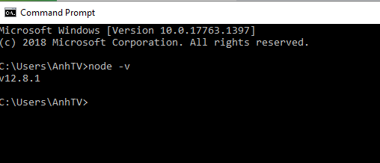

Figure 102 - Nodejs was installed succesfully

##### 6.1.1.2.3. Install react-native-cli version 2.0.1

• Open Command Prompt and running the command “*npm install -g react-native-cli*”



Figure 105 - Command for installing expo-cli

• After the command running succesfully, check if expo-cli was installed successfully by running the command “*react-native -v*”

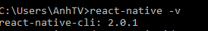

Figure 106 - expo-cli was installed successfully

### 6.1.2. Deployment guideline

#### 6.1.2.1. Environment for deployment

☞ Heroku.com

☞ Google Firebase with following services:

⮚ Authentication

⮚ Realtime Database

#### 6.1.2.2. Setup deployment

##### 6.1.2.2.1. Setup hosting on Heroku.com

• Go to <https://heroku.com> to create an account

• Go to <https://heroku.com> to create app

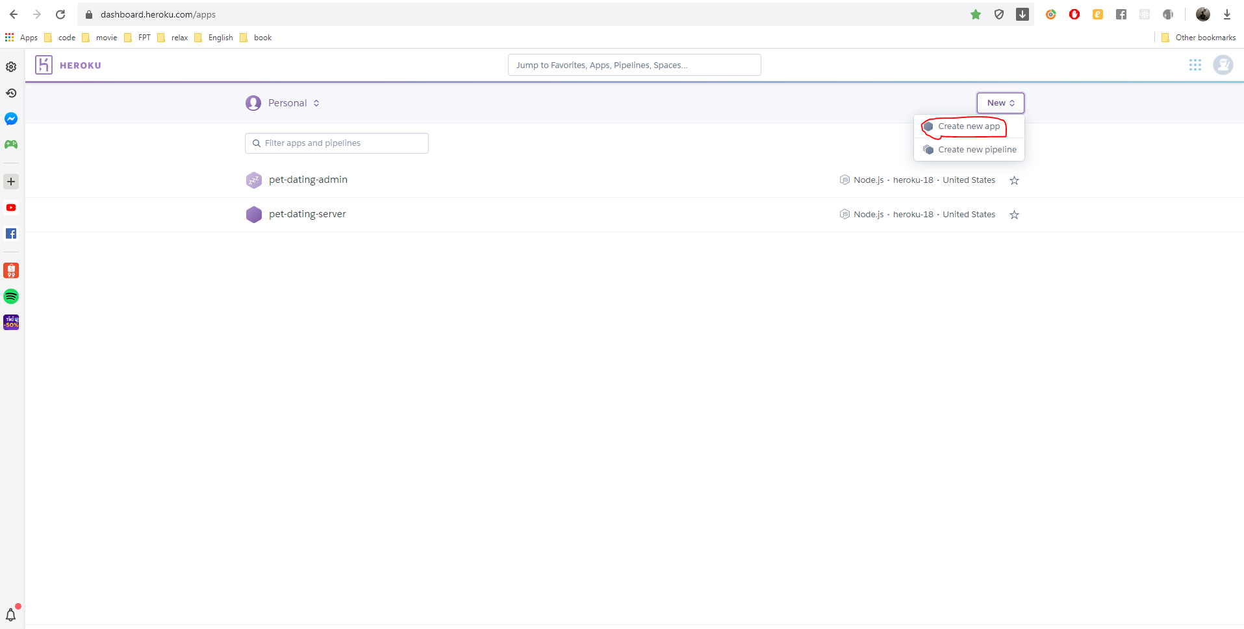

Figure 109 - Create application interface on Heroku.com

• Enter app name and press Create app button

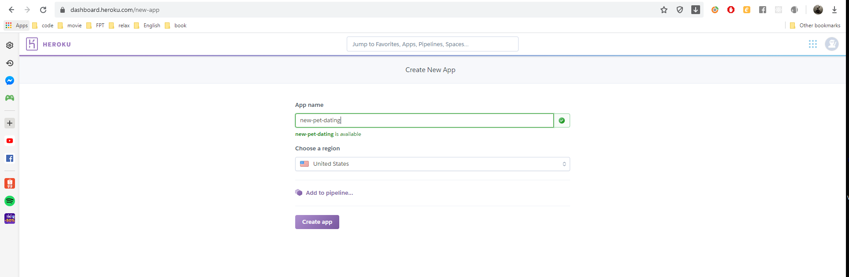

Figure 110 – create app interface

• Enter app name and press Create app button and do follow guideline to setup Heroku environment

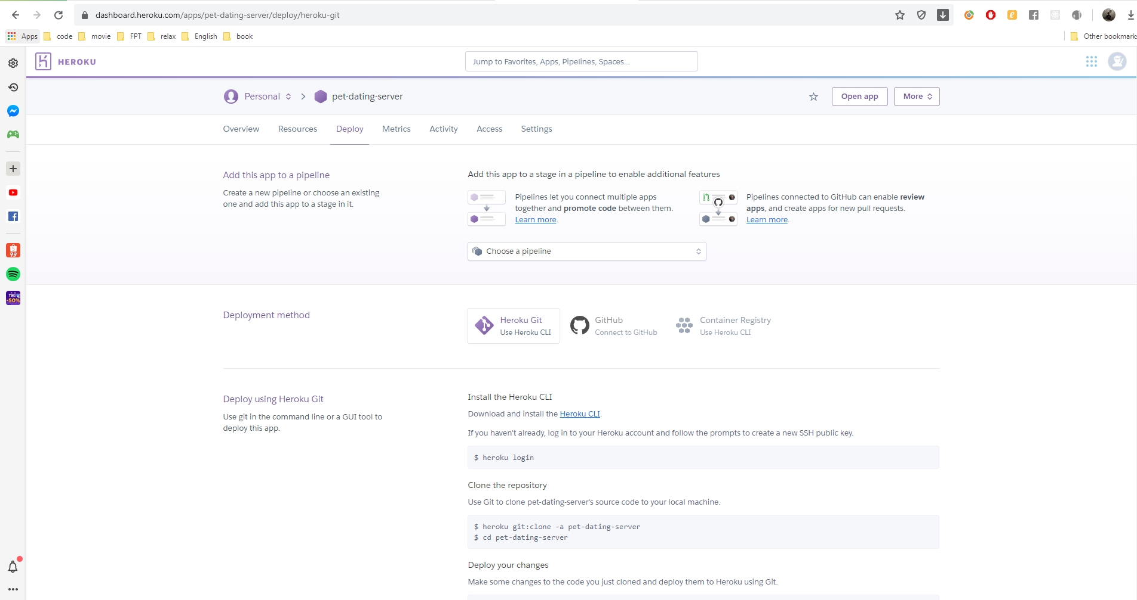

Figure 111 – deploy interface

• Go to folder contain source code, open command line and enter ‘git push heroku master’

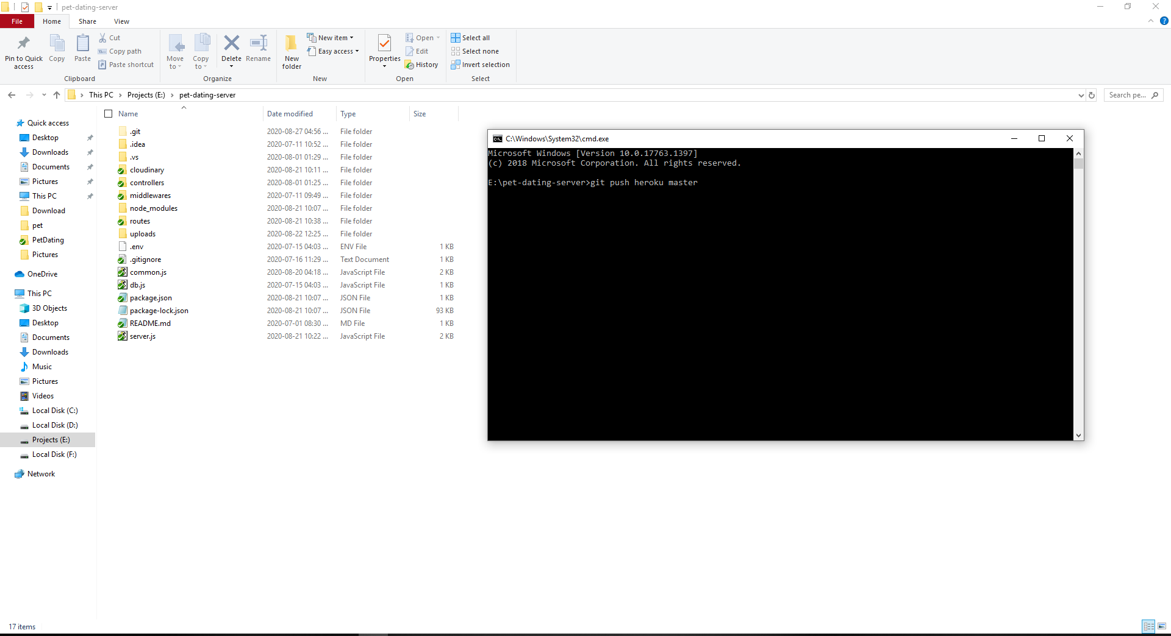

Figure 112 – deploy command line

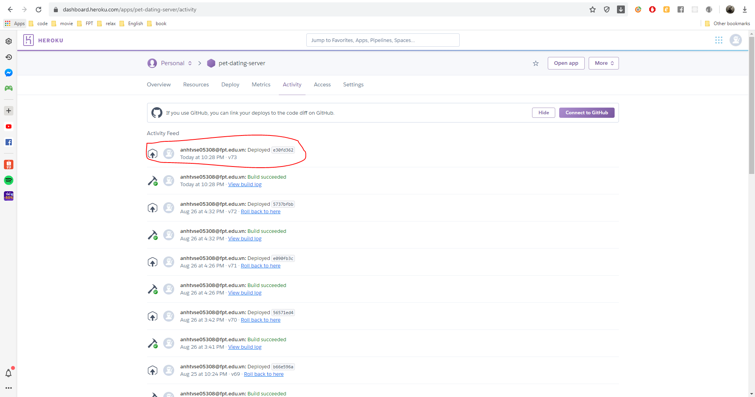

Figure 113 – result interface

##### 6.1.2.2.2. Setup services of Google Firebase

• Go to <https://console.firebase.google.com/u/0/> and signing in with Google account

• Click Add project to create a project with Firebase console

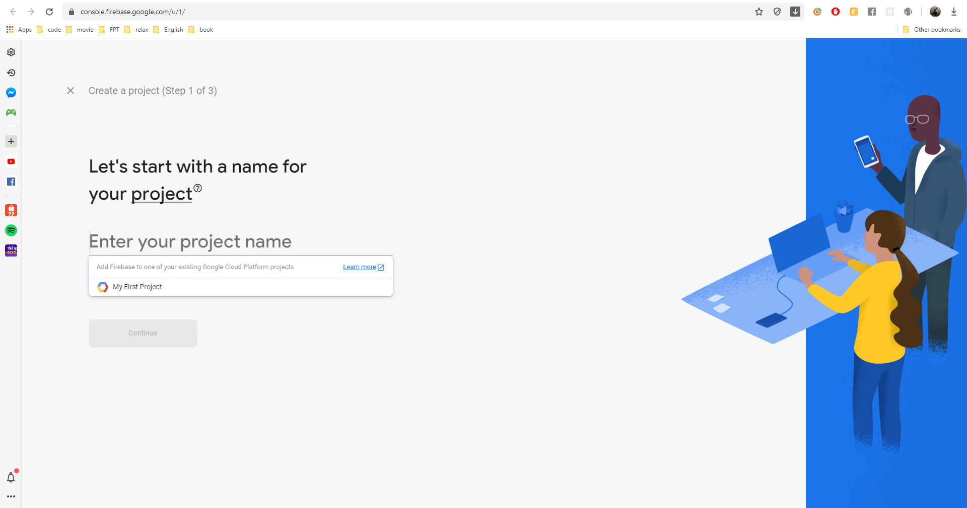

Figure 114 - Create project interface

• From the sidebar menu, click Authentication

• Switch to Sign-in method tab, in the Sign-in providers section, switch Disable to Enable on Google and Facebook

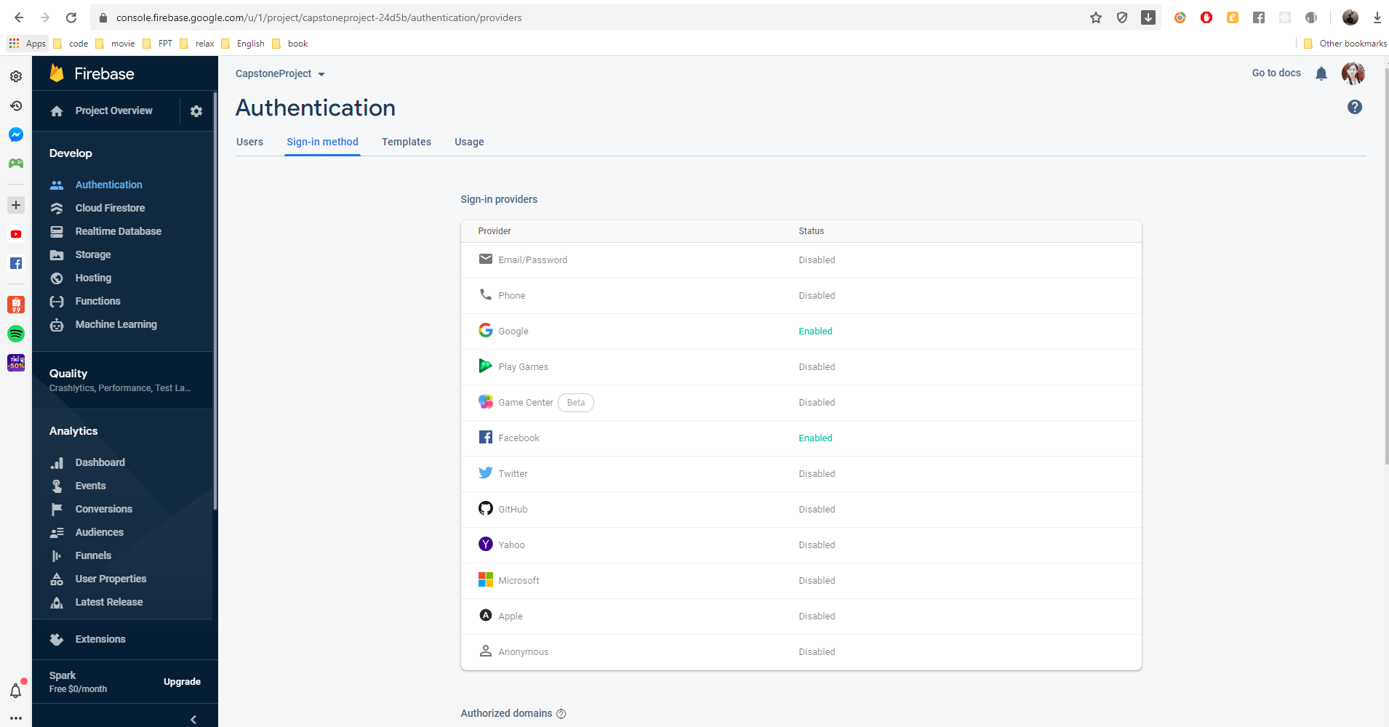

Figure 115 - Sign-in method set up interface for database

• From the sidebar menu, click Database

• Go to Realtime Database section and click Create database button

• Choose option “Start in locked mode”, then click Enable button

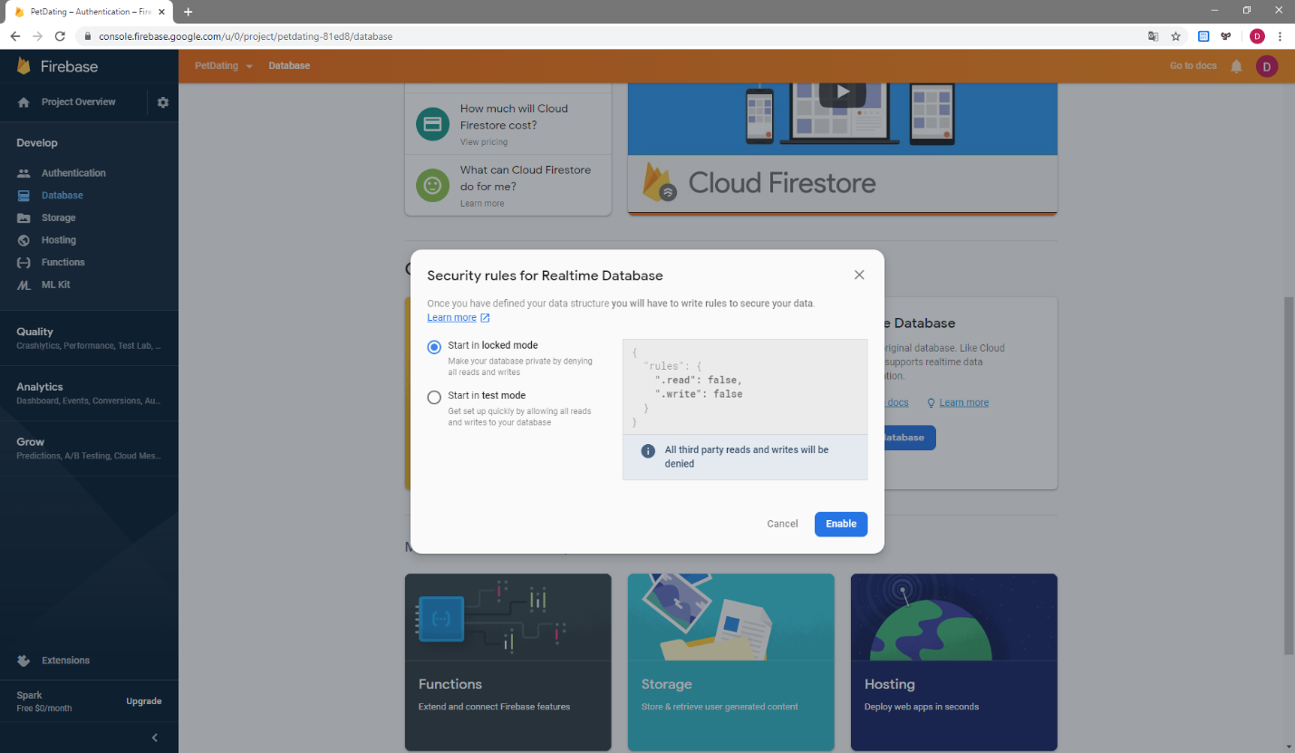

Figure 116 - Create database interface

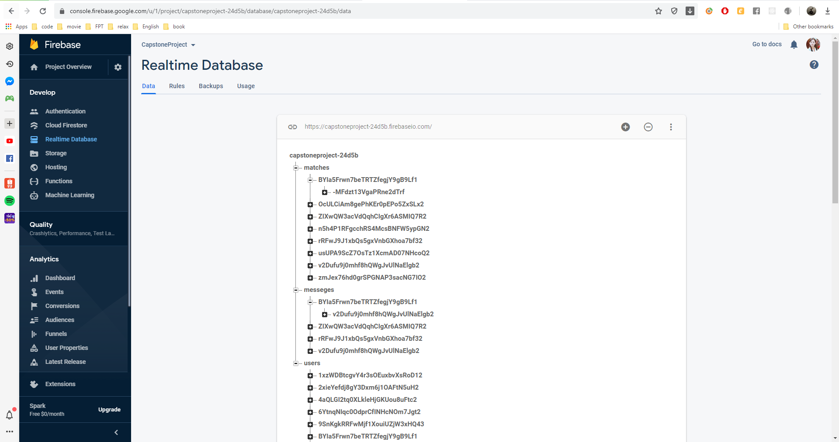

Figure 117 - Realtime Database interface

## 6.2. User guideline

### 6.2.1. Login, Logout

#### 6.2.1.1. Login

• Open app

• Choose “LOGIN WITH GOOGLE” or “LOGIN WITH FACEBOOK”

• Fill in with Google or Facebook information 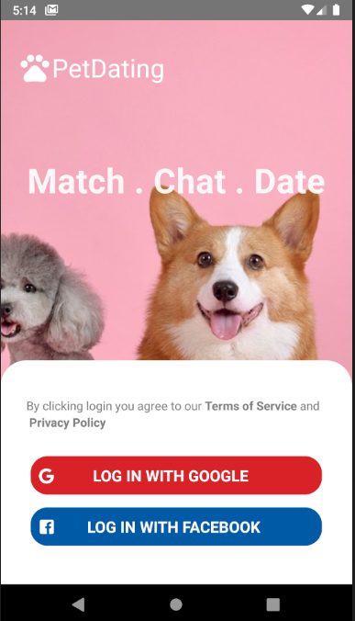

Figure 65 - Login interface

#### 6.2.1.2. Logout

• Switch to Option tab

• Press “Sign out”

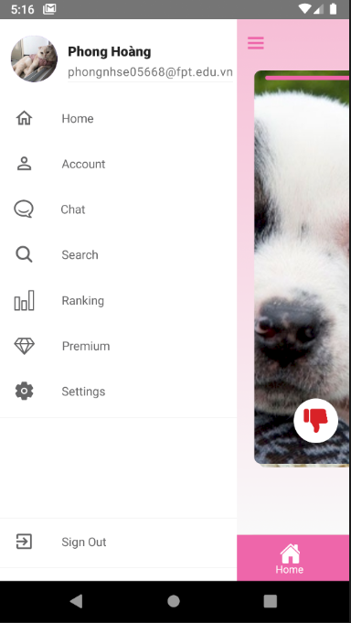

Figure 66 - Logout option in Option tab

### 6.2.2. Home page

* After logging in, home screen will appear

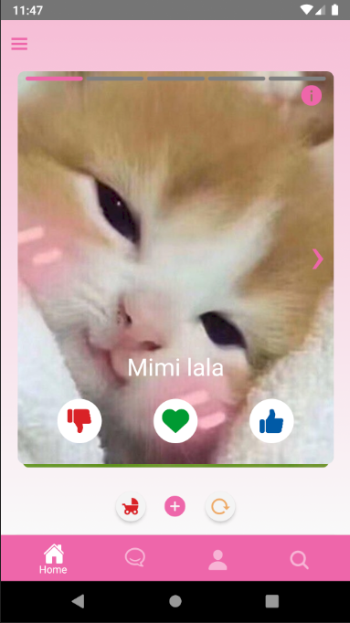

Figure 67- Home page

### 6.2.3. Pet’s profile

* Press “i” in the upper right corner of the card to enter the profile
* Here will display information about the pet and its owner

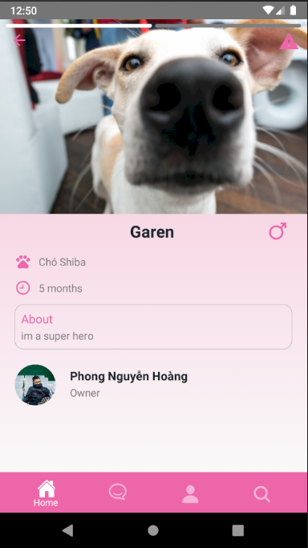

Figure 68- Pet’s profile

### 6.2.4. Report

* Press the button in the top right corner to report this pet

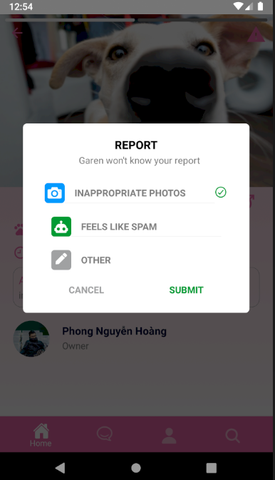

Figure 69- Report pet

### 6.2.5. React pet

* Press Like, Nope and Match underneath the card to interact with the pet on the screen
* After the interaction is completed, it will switch to a new pet

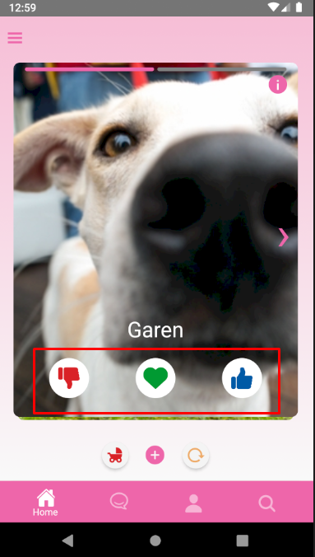

Figure 70- React pet

### 6.2.6. Rollback

* If you want to return to the pet you have just finished interacting with, press roll back (Premium only)

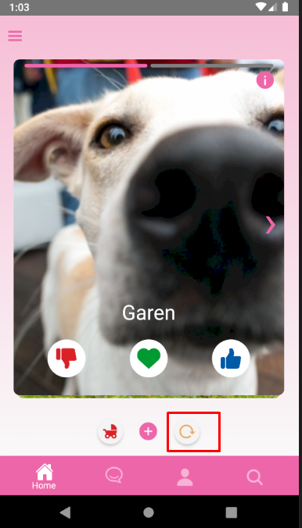

Figure 71- Rollback

### 6.2.7. Next generation

* If you want to see pictures of children that your pet and other people's pets, press next generation (Premium only)

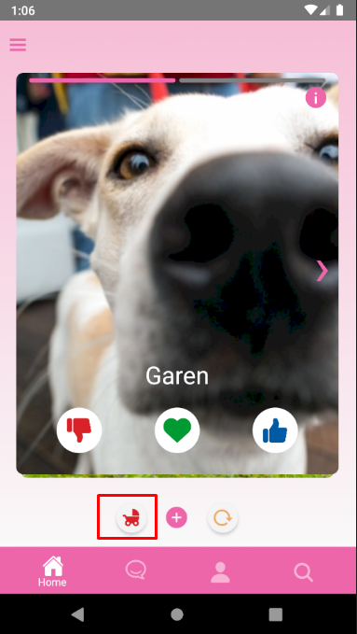

Figure 72- Next generation

### 6.2.8. Edit user’s information

* Edit your personal information
* Fill information in text field

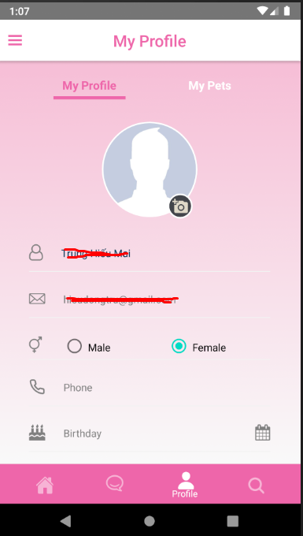

Figure 73- Edit profile

### 6.2.9. Add new pet

* Press “Add a new pet” to add a new pet for yourself

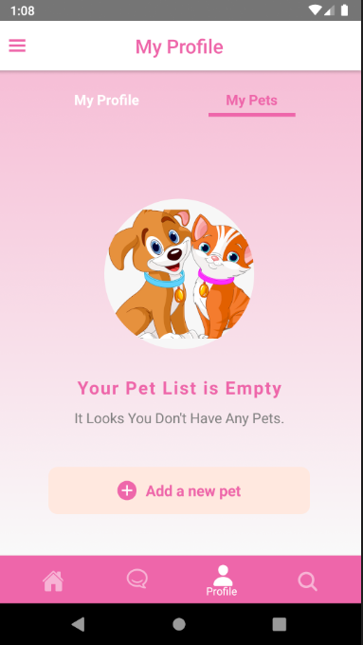

Figure 74- Add new pet

### 6.2.10. Pet’s information

• Fill all needed information, and press “Submit” to create a new pet

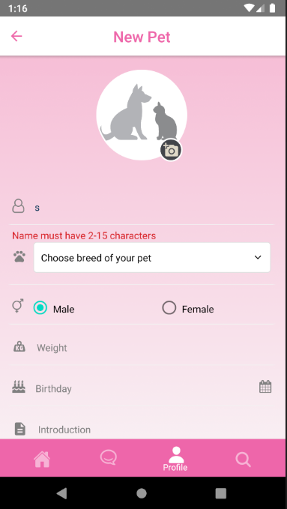

Figure 75- Pet’s information

### 6.2.11. Find

* Drag the slider and click “Find” to find users with a radius of 1 to 100 km

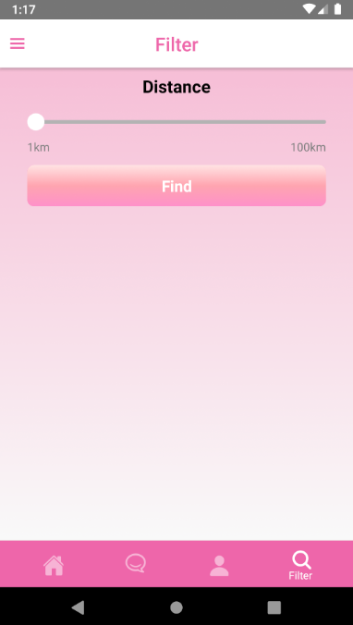

Figure 76- Find nearly

### 6.2.12. Chatting

* You can send message to everyone you matched
* 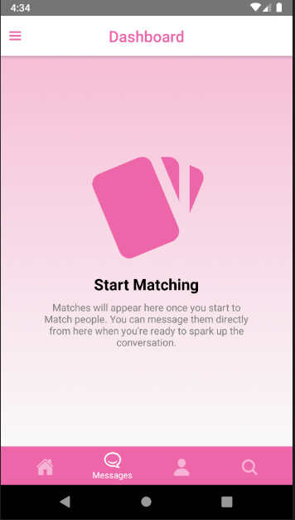

Figure 77- Chatting

### 6.2.13. Ranking

* Press “Ranking” to see top 10 matched and liked

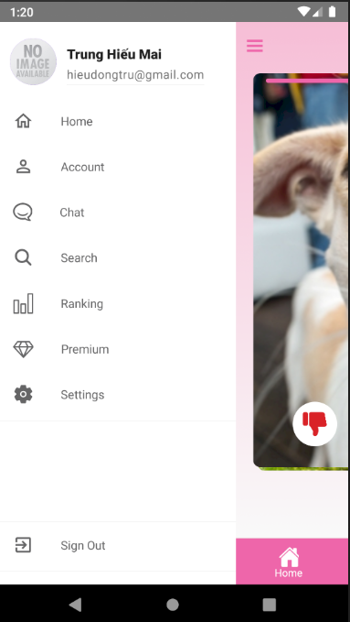

Figure 78- Ranking in menu

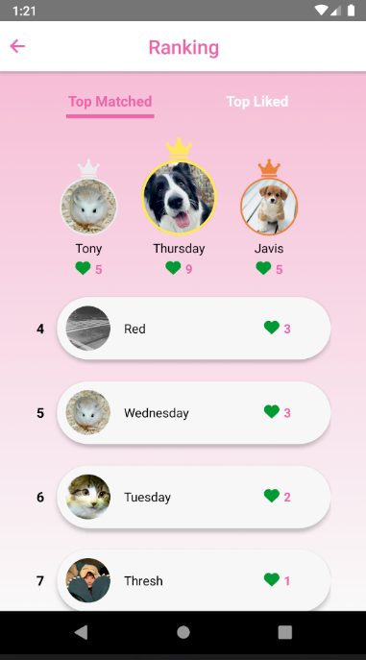

Figure 79- Matching rank

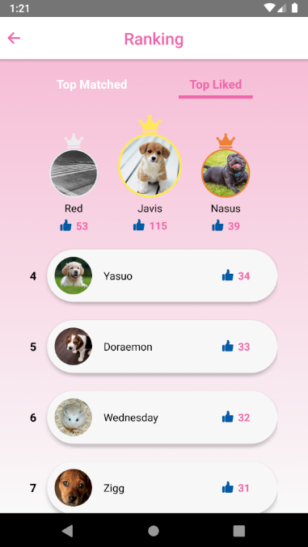

Figure 80- Top like ranking

### 6.2.14. Premium

* Press “Upgrade Premium” to upgrade your account from regular to premium to unlock all the features

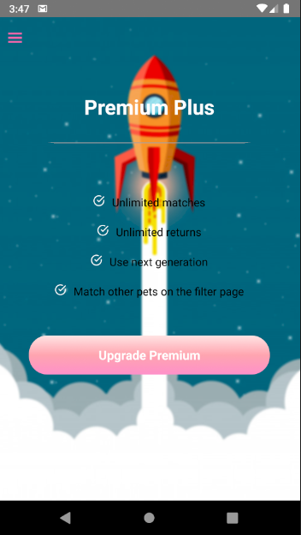

Figure 81- Upgrade Premium

* Press “Use Premium” 1 in 2 to choose which method you want to pay for premium upgrades

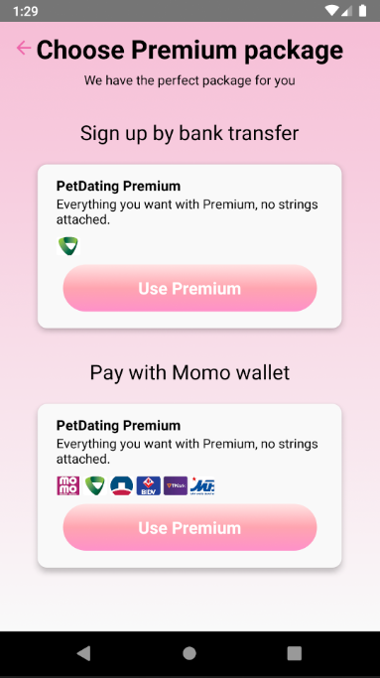

Figure 82- Plans to pay

* Choose 1 in 3 plans to pay for an upgrade
* Click on send photo to resend the invoice photo you paid to us
* When you choose invoice photo completed, the “Upgrade Premium” button will appear and press it to send us invoice photo to confirm

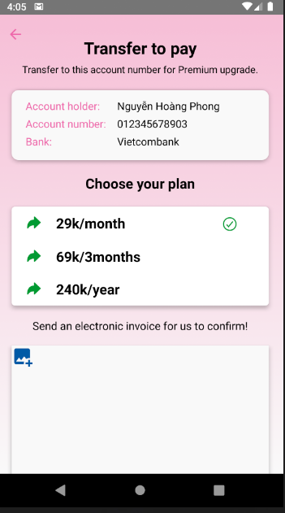

Figure 83- Confirm by image

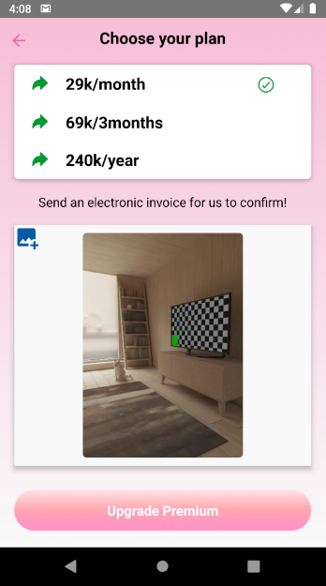

Figure 84- Confirm by image

### 6.2.15. Settings

* Press “Settings” to use the features like Hide Profile, Feedback and Delete Account

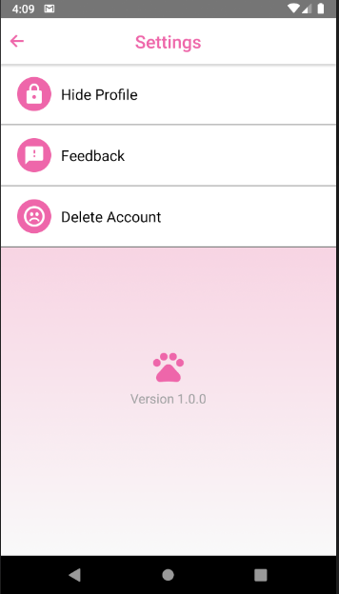

Figure 85- Setting

#### 6.2.15.1. Hide Profile

* Click on checkbox to hide other pets and nobody can see you on this app anymore

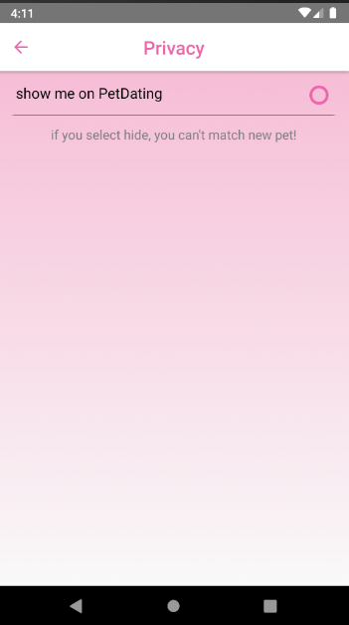

Figure 86- Hide account

#### 6.2.15.2. Feedback

* Choose 1 of 3 reasons or submit content you want to report to us by press “Submit”

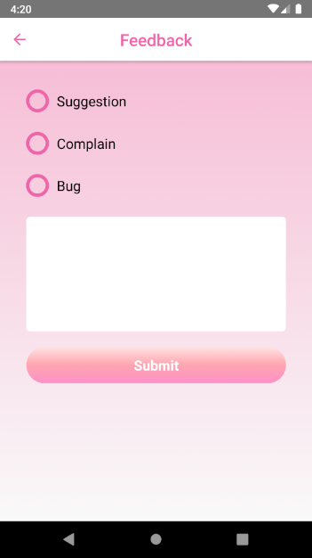

Figure 87- Send feedback

#### 6.2.16.3. Delete Account

* Press “PAUSE MY ACCOUNT” to keep remain your account and just hidden your account
* Press “Delete My Account” to delete your account

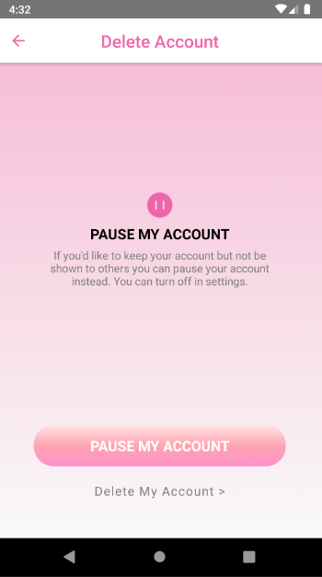

Figure 88- Delete account